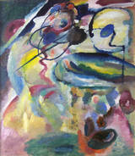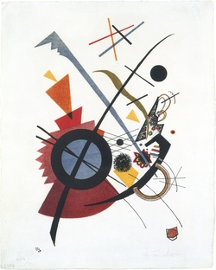

Wassily Kandinsky *Picture with a Circle (Bild mit Kreis), 1911*. Wassily Kandinsky *Violett* 1923

**Lesson Name:** 1” abstract enlargements

**Historical Reference**: Wassily Kandinsky -(December 1866 – 13 December 1944) was a [Russian](http://en.wikipedia.org/wiki/Russia) [painter](http://en.wikipedia.org/wiki/Painting), and art [theorist](http://en.wikipedia.org/wiki/Theorist). He is credited with painting the first modern [abstract](http://en.wikipedia.org/wiki/Abstract_art) works.

**Vocabulary:**

Abstract- Abstract art can be a painting or sculpture (including [assemblage](http://arthistory.about.com/od/glossary/g/a_assemblage.htm)) that does not depict a person, place or thing in the natural world - even in an extremely distorted or exaggerated way. Therefore, the subject of the work is based on what you see: color, shapes, brushstrokes, size, scale and, in some cases, the process. Abstract art began in 1911 with such works as Picture with a Circle (1911) by the Russian artist Wassily Kandinsky (1866-1944).

**Materials:** black construction paper in make 1” viewfinder, printed out images from photo trip, 9” x 12” canvas panels, acrylics paint, paint brushes, paint trays, pencils, t-square, white chalk pencil.

**Goals:** Students will learn to look at the world around them from a different view. Students will also practice and improve their painting techniques.

**Procedure:** Students will go on a photography field trip and be instructed to shoot pictures of anything school appropriate that interest them.After reviewing and discussing this lesson plan, students will be given a sheet of black construction paper, a pencil and a t-square. They will measure a 4” x 6 “ rectangle on the paper on cut it out. Then they will measure and mark off 1” in from all four sides. Next they will connect their marks to create a 1” border around the edge of the rectangle. Next they will erase a 1” segment from opposite corners of the rectangle. This should make the border now appear to be made up of two “L’s”. The students will then check with the instructor to make sure his/her “L’s” are correct and then cut them out. Then using the t-square and white chalk pencil, they will mark off every half inch on the INSIDE edge of the “L”s”. The students will then put the two “L’s” together to form a 1” x 1.5” rectangle. Students will tape their viewfinder together in this position. They will then scan through their field trip images and look for interesting non-representational compositions. They should use their viewfinders to frame the image the eventually choose. They should print out the image that they choose and keep it in their folders. Next they will be given a 9” x 12” canvas panel and they will use pencil to sketch their abstract composition onto the panel. Then they will use acrylic paint to add color and depth to their compositions.

**Evaluation:** Students will have a group critique of their abstract enlargement projects and discuss how successful the projects turned out. They will also discuss what could be done to improve the techniques used. Students will also write a self-evaluation of their work in their journals.