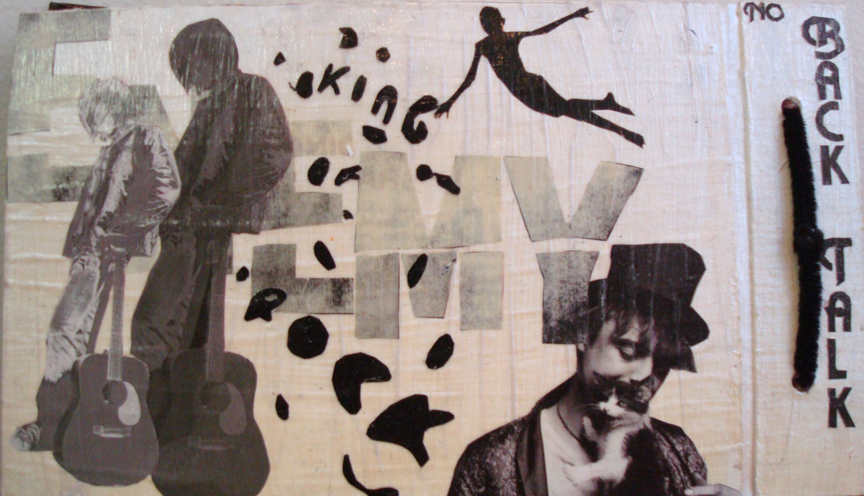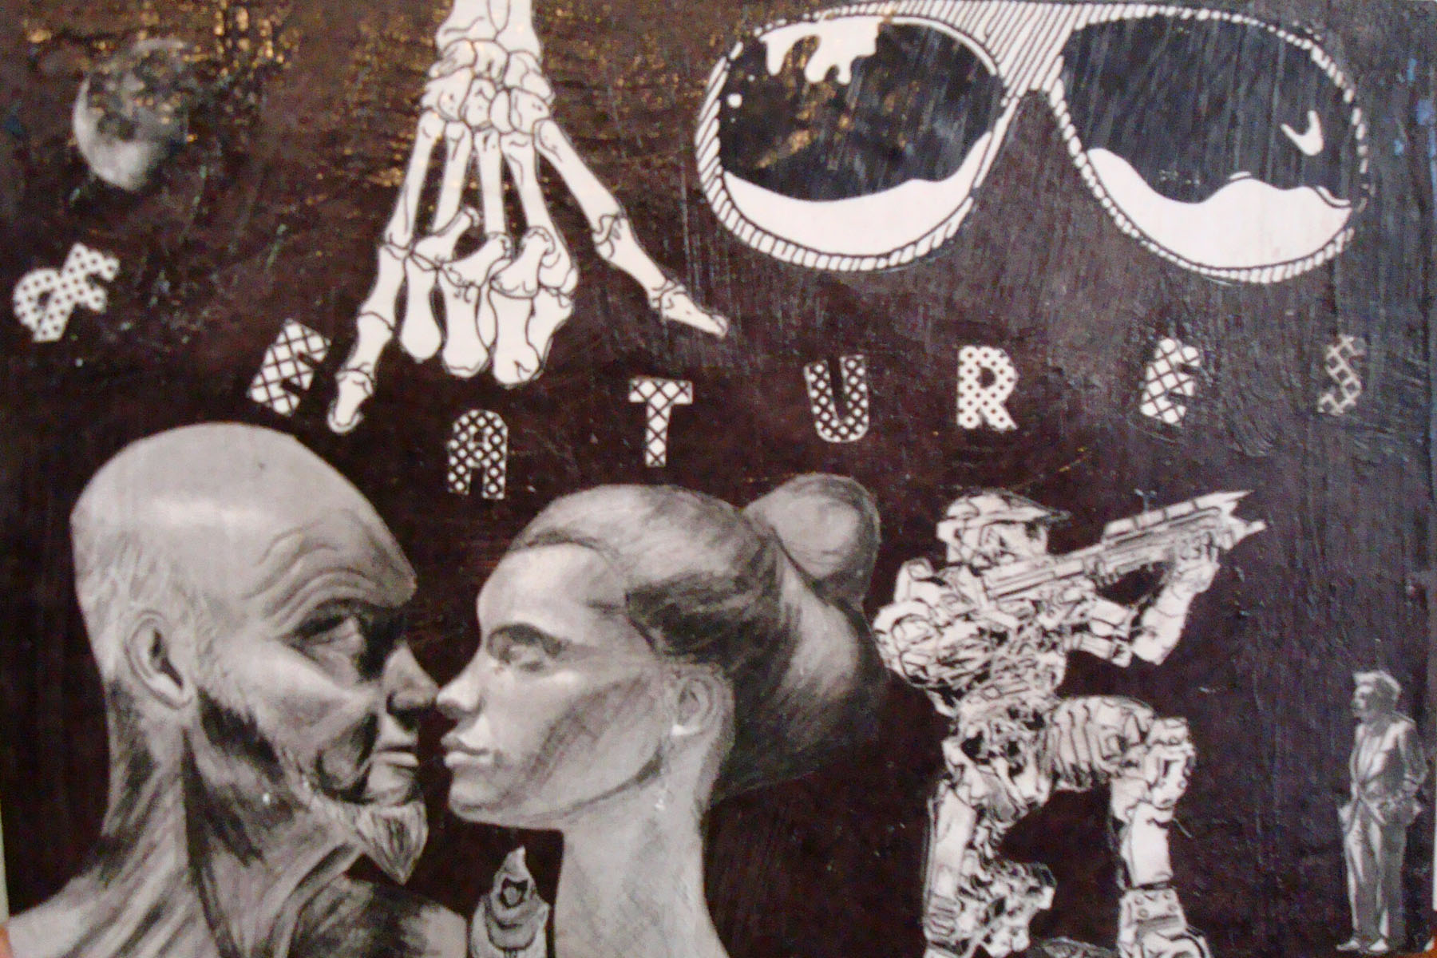
Lesson Name: Journal Making
Historical Reference: Romare Bearden (September 2, 1911 – March 12, 1988) was an American artist and writer. He worked in several media including cartoons, oils, and collage.
Vocabulary:
Collage- Collage- A picture or design created by adhering such basically flat elements as newspaper, wallpaper, printed text and illustrations, photographs, cloth, string, etc., to a flat surface, when the result becomes three-dimensional, and might also be called a relief sculpture / construction / assemblage. Most of the elements adhered in producing most collages are "found" materials. Introduced by the Cubist artists, this process was widely used by artists who followed, and is a familiar technique in contemporary art. "Collage" was originally a French word, derived from the word coller, meaning "to paste."
Materials: Two Cardboard journal bases( pre-cut holes), Spirial binders, paper to fit inside cardboard bases (also pre-cut holes), collage materials such as colored/patterned paper, cloth scraps, ribbon, paint, gel medium, paint brushes, scissors, and glue.
Goals: Students will create a personalized place where they will be asked to sketch and write journal entries evaluating themselves on the work that they will create in class this year.
Procedure: After students have reviewed this lesson plan, they will be given two pieces of cardboard to decorate using collage techniques. They will be required to cover all four sides of the cardboard with a self-guided theme. Students will then assemble their journals by placing the pre-cut paper in between the two cardboard covers and threading a spiral binder through the pre-punched holes in both the paper and cardboard covers.
Evaluation: Students will have a group critique of their journal projects and discuss how successful the collages turned out. They will also discuss what could be done to improve the techniques used. Students will also write a self-evaluation of their work in their journals.

Assessment Rubric
Student Name: | Class Period:
Assignment: Journal Project | Date Completed:
Circle the number in pencil that best shows how well you feel that you completed that criterion for the assignment. | Excellent | Good | Average | Needs Improvement | Rate Yourself | Teacher’s Rating
Criteria 1 – Completion- How well did you cover all for sides of the journal? No empty areas? | 10 | 9 – 8 | 7 | 6 or less
Criteria 2 – Name-Was the name made in a way that expressed the student’s personality and is it legible? | 10 | 9 – 8 | 7 | 6 or less
Criteria 3 – Self-expressive? Was the project expressive of the artist’s personality | 10 | 9 – 8 | 7 | 6 or less
Criteria 4 – Effort: took time to develop idea & complete project? (Didn’t rush.) Good use of class time? | 10 | 9 – 8 | 7 | 6 or less
Criteria 5 – Craftsmanship – Neat, clean & complete? Skillful use of the art tools & media? | 10 | 9 – 8 | 7 | 6 or less
Total: 50 x 2 = 100 (possible points) | Grade: |  |  |  |  | Your Total | Teacher Total

Student Comments:

Teacher Comments:

