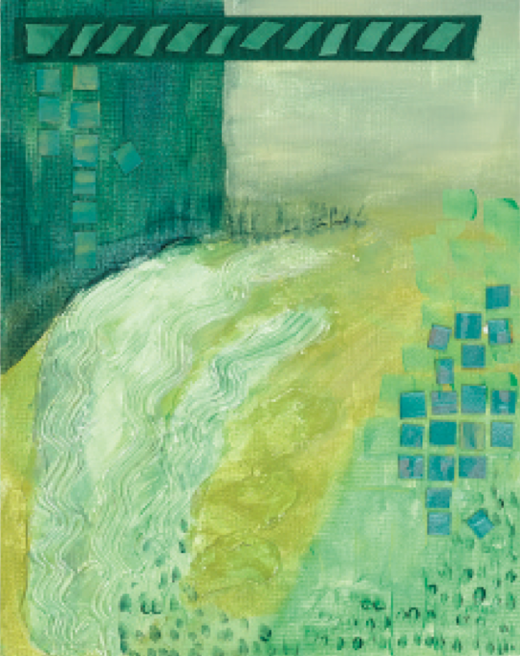

Lesson Name: Monochromatic Painting- (above: Mean Green)
Historical Reference: Adolph Frederick Reinhardt ("Ad" Reinhardt) (December 24, 1913 – August 30, 1967) was an Abstract painter active in New York beginning in the 1930s and continuing through the 1960s. Most famous for his "black" or "ultimate" paintings, he claimed to be painting the "last paintings" that anyone can paint. He believed in a philosophy of art he called Art-as-Art and used his writing and satirical cartoons to advocate for abstract art and against what he described as "the disreputable practices of artists-as-artists".
Vocabulary:
Abstract expressionism- is an American post–World War II art movement in American painting, developed in New York in the 1940s. Technically, an important predecessor is surrealism, with its emphasis on spontaneous, automatic or subconscious creation. Abstract art clearly implied expression of ideas concerning the spiritual, the unconscious and the mind.
Value - An element of art that refers to luminance or luminosity— the lightness or darkness of a color.
Hue- In painting color theory, a hue refers to a pure color—one without tint or shade
Tint-In color theory, a tint is the mixture of a color with white, which increases lightness.
Tone- Tone is the mixture of a color with neutral grey.
Shade- Shade is the mixture of a color with black, which reduces lightness.
Neutral grey- Grey made with simply white and black. Absolutely no colored tint to warm or cool the color.
Primary colors- Red, Yellow and Blue. These are the colors that all other colors can be mixed from. They cannot be created by mixing other colors.
Secondary colors- Purple, Orange, Green. A secondary color is a color made by mixing two primary colors.
Tertiary Colors: A tertiary color is a color made by mixing either one primary color with one secondary color, or two secondary colors.

Materials: 11X 14” canvas, acrylic paints, paintbrushes, paint trays, water dishes, and collage materials (magazines, string, ribbon, tile, handmade paper, etc.).
Procedure:
Discussion:
Is there such a thing as an all-black painting, all- green or all-red painting? Yes, there is! American artists around the 1950s turned from abstract expressionism to a movement labeling them colorists. Colorists painted with a monochromatic color palette using variations of one color. Their process was made easier with the introduction of acrylics and acrylic mediums in 1953. Painters like Barnett Newman, Morris Louis, Frank Stella and Ad Reinhardt created paintings in all black. They believed art was art and should be created without rules. This break in approach to art was not popular with art critics. The critics found that a closer look at the monochromatic paintings exhibited details and required more thought. Artists added texture and surface variations to enhance the monochromatic paintings. American colorists changed the artists’ image from that of realistic human behavior to the use of color for feelings. They worked to make color and color changes the total emphasis of their art.

1. Discuss monochromatic color and collage.
2. Students each get one canvas panel. They decide on color and paint the canvas panel with that color for background. As in “Mean Green,” start with green.
Using the Color Wheel as reference, students apply shades, tints and hues of the first color in painting areas of texture and color on the canvas. Experiment with adding colors to the left and right on the color wheel (analogous colors) to create different hues of the first color. Also, try adding white and black to adjust the tint. Always stay with the first basic color as the outstanding color. Continue to add texture.
3. Cut paper and fabric in shapes or designs. Use gel medium to apply.
4.The final step adds dimensional items. Consider breaking some items to create more detail pattern forms. Additional areas of paint may be added to tie the many monochromatic areas together.

Evaluation: Students will have a group critique of their monochromatic paintings and discuss how successful the paintings turned out. They will also discuss what could be done to improve the techniques used. Students will also write a self-evaluation of their work in their journals and fill out their grading rubrics.

Assessment Rubric
Student Name: | Class Period:
Assignment: Color Wheel | Date Completed:
Circle the number in pencil that best shows how well you feel that you completed that criterion for the assignment. | Excellent | Good | Average | Needs Improvement | Rate Yourself | Teacher’s Rating
Criteria 1 – Shows an understanding of monochromatic colors. (Did your painting mostly stick to the color you chose) | 10 | 9 – 8 | 7 | 6 or less
Criteria 2 – Incorporated texture well into the painting. | 10 | 9 – 8 | 7 | 6 or less
Criteria 3 – Shows an understanding of how to mix tints, shades and tones of colors. | 10 | 9 – 8 | 7 | 6 or less
Criteria 4 – Effort: took time to develop idea & complete project? (Didn’t rush.) Good use of class time? | 10 | 9 – 8 | 7 | 6 or less
Criteria 5 – Craftsmanship – Neat, clean & complete? Skillful use of the art tools & media? | 10 | 9 – 8 | 7 | 6 or less
Total: 50 x 2 = 100 (possible points) | Grade: |  |  |  | Your Total | Teacher Total
Student Comments:

Teacher Comments:

