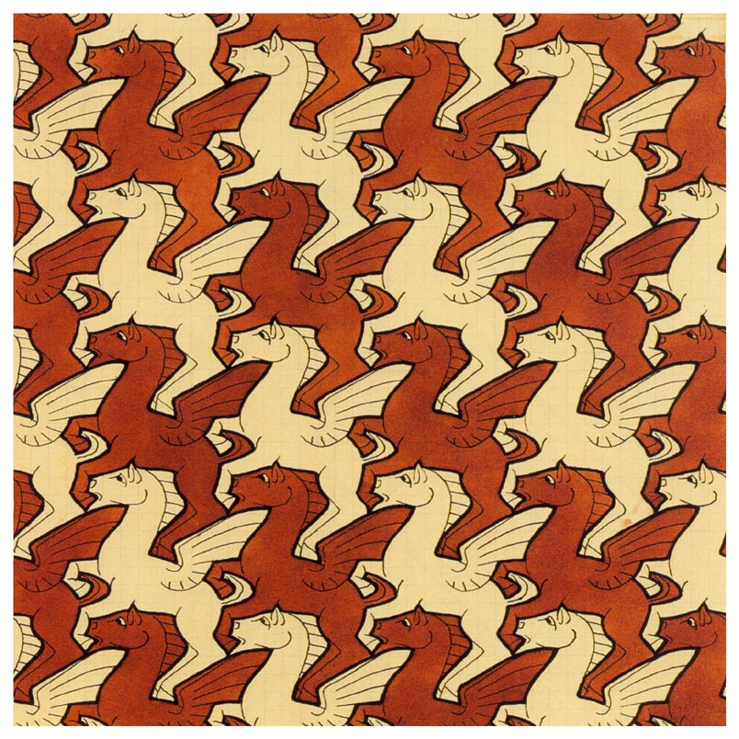
Lesson Name: Tessellations
Historical Reference: M.C. Escher-Maurits Cornelis Escher (1898-1972) is a graphic artist known for his tessellations. His art is enjoyed by millions of people all over the world. He created visual riddles, playing with the pictorially logical and the visually impossible.
Vocabulary:
Tessellation- A tessellation is created when a shape is repeated over and over again covering a plane without any gaps or overlaps.
Congruent- Coinciding exactly when superimposed.
Adjacent- Next to; neighboring.
Polygon- A closed plane figure formed by three or more line segments that do not cross over each other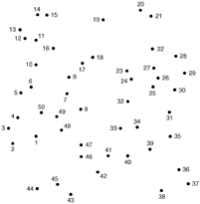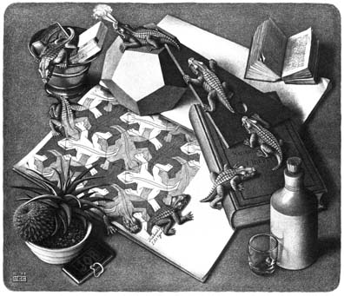
Regular polygon- A polygon whose side lengths are all the same and whose interior angle measures are all the same.
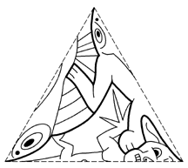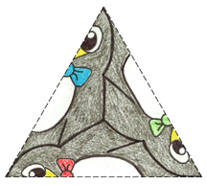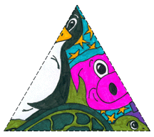
Reflectional Symmetry-Students can create a generating triangle for a tessellation with reflectional symmetry by drawing identical or distinct curves from the center of an equilateral triangle to its vertices. See above.
Rotational Symmetry-
Translational Symmetry-
Materials: Index cards, 8.5 X 11 white paper, pencils, scissors, markers, colored pencils, tape, stamp making blocks, carving tools, colored ink, ruler or t-square.
Goals: Students will gain a greater understanding of the geometric principals involved in create tessellations. They will also gain an appreciation for the artwork of M.C. Escher, master of tessellations.
Procedure: Students will review the definitions above and discuss the work of M.C. Escher. Then they will go to: http://britton.disted.camosun.bc.ca/jbescher3.htm on a computer and review the Pegasus animated gif found on that page to help improve their understand of the idea of translational symmetry. Then they will go to: http://www.shodor.org/interactivate/activities/Tessellate/ to help improve their understanding of translational symmetry and tessellations and to create their own digital tessellation. The students will then print out their digital tessellation and add details to the pattern. Students will be given a tessellation worksheet and asked to identify the polygon used to create each tessellation to test their understand of tessellations. Students will then be given a 3 x 5 inch note card. They will then cut two inches off one end of the card so that it is a perfect 3 x 3 inch square. Then they will cut a design out of one side of the square making to keep the corners in tact. They will then tape the cut out section directly across from the side it was cut out from. They will repeat this process on another side of the square. The shape created will be their template. The students will then use their ruler or t-square to create a three-inch grid on a piece of white paper. The students will use their grid as a guide for their template to be traced as many times as needed to fill the space. Students will then color in and add details to their tessellations. If time permits, students will create additional tessellations from other polygons such as triangles or hexagons. They will design their template as before with a different base shape. They will then transfer their design to a stamp-making base and carve their design out of the materials. They will then use their stamp to crate a tessellation using different colored inks to enhance their designs.
Evaluation: Students will have a group critique of their tessellations and discuss how successful the designs turned out. They will also discuss what could be done to improve the techniques used.

