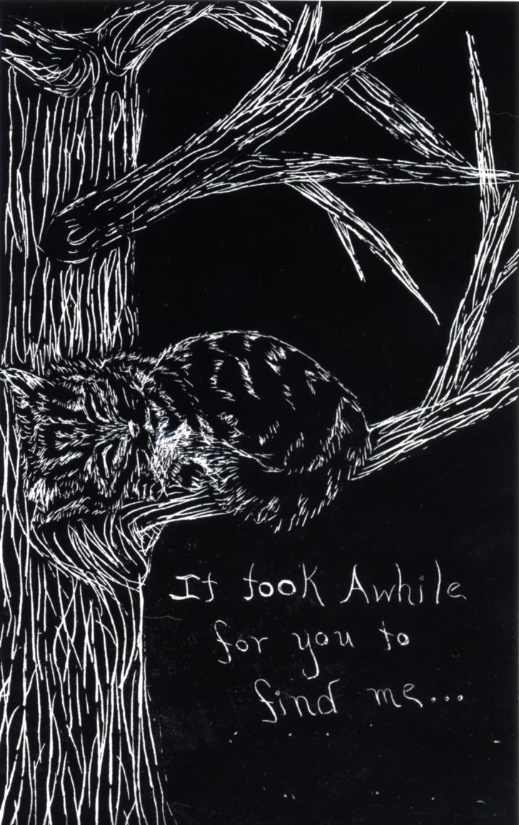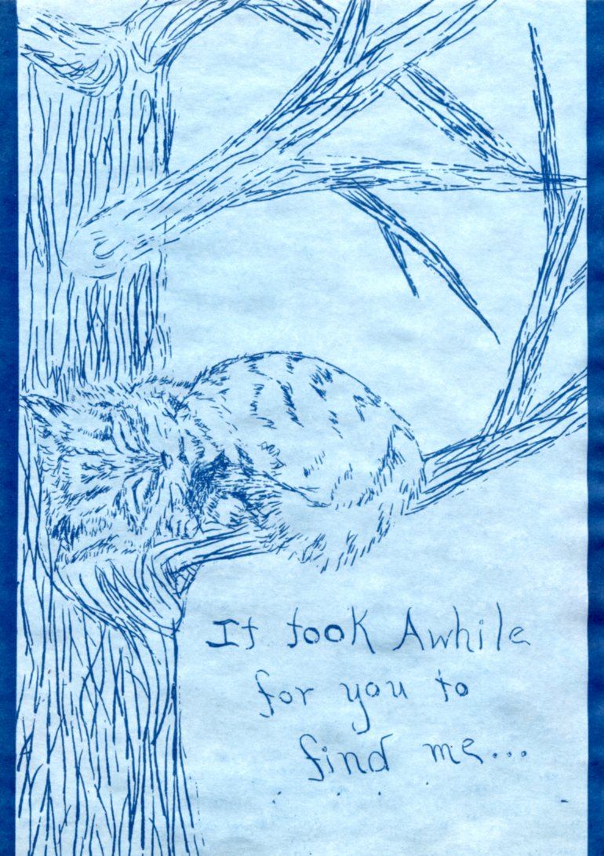

**Lesson Name**: Scratch art/ Blue print Drawings

**Historical Reference**: Sir [John Herschel](http://en.wikipedia.org/wiki/John_Herschel), a friend of Anna Atkins, invented the [cyanotype](http://en.wikipedia.org/wiki/Cyanotype) photographic process in 1842. Within a year, Atkins applied the process to [algae](http://en.wikipedia.org/wiki/Algae) (specifically, [seaweed](http://en.wikipedia.org/wiki/Seaweed)) by making cyanotype [photograms](http://en.wikipedia.org/wiki/Photogram) that were [contact printed](http://en.wikipedia.org/wiki/Contact_print) "by placing the unmounted dried-algae original directly on the cyanotype paper"

**Vocabulary:** Reductive drawing- There is a type of drawing called “reductive.” You start out by covering the entire sheet with charcoal or ink, then use different erasers or scratching tools to take out what doesn’t belong. It creates a different style of picture that’s very effective.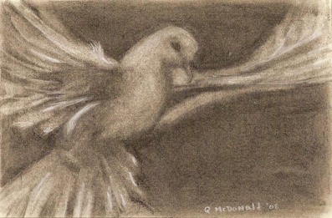

Positive Print- Denoting a print or transparency showing the brightness values as they are in the subject.

Negative- Noting an image in which the brightness values of the subject are reproduced so that the lightest areas are shown as the darkest.

Printmaking- Printmaking is the process of making [artworks](http://en.wikipedia.org/wiki/Work_of_art) by [printing](http://en.wikipedia.org/wiki/Printing), normally on [paper](http://en.wikipedia.org/wiki/Paper). The process is capable of producing multiples of the same piece, *which is called a 'print'*. Printmaking is not chosen only for its ability to produce multiple copies, but rather for the unique qualities that each of the printmaking processes lends itself to.

Photography- The process or art of producing images of objects on sensitized surfaces by the chemical action of light or of other forms of radiant energy, as x-rays, gamma rays, or cosmic rays.

Cyanotype- A process of photographic printing, used chiefly in copying architectural and mechanical drawings, that produces a blue line on a white background.

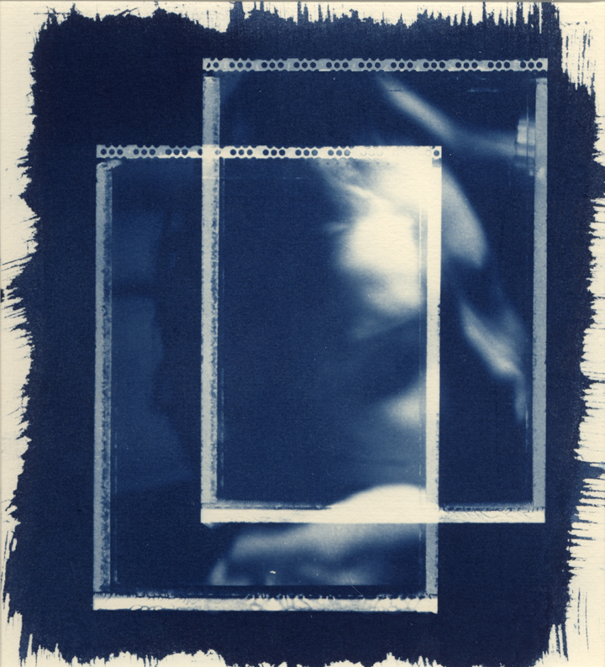

Contact printing- A contact print is a photographic [image](http://en.wikipedia.org/wiki/Image) produced from [film](http://en.wikipedia.org/wiki/Photographic_film): sometimes from a film [negative](http://en.wikipedia.org/wiki/Negative_(photography)); sometimes from a film positive or an object in direct contact with light sensitive materials. The defining characteristic of a contact print is that the photographic result is made by exposing through the film negative or positive onto a light sensitive material that is pressed tightly to the film.

**Materials:** Blue print light sensitive paper, scratch art film, wooden stylus, plain white paper, contact printing frame, shallow tray for soaking images, drying area, paper or journal for early sketches, pencil or charcoal and eraser, clear film, markers, crayons or colored pencils.

**Goals:** Students will learn about how negatives are used in certain printmaking processes to create positives. Students will also practice their drawing skills.

**Procedure:** Afterreviewing their lesson plans, students will begin by choosing a living thing that has an interesting texture. They will then sketch their chosen subject in their journals (They may use the internet to find photo references for their subject). Next they will cover a 5” X 7” piece of white paper with charcoal and try to recreate their sketch by erasing the areas that should be lighter. This will reinforce the idea of reductive drawing. Then the students will be given a 5” x 7“ piece of scratch art film. They will then do their best to recreate their drawing a third time by placing the film ink side up on top of a white piece of paper, and using a wooden stylus to remove the ink in the areas that should be light. This in itself is a work of art that will be expanded upon after it is used as a negative. The students must remember that anything that they scratch away will be blue instead of white in the final product. Also if they choose to use any lettering in their images, they must remember to write backwards (as if looking in a mirror). When they have finished their negatives, they then place them on top of a piece of blue print light sensitive paper. They will put both pieces of paper inside of the contact- printing frame, making sure that the blue side of the paper is facing up and the negative is sandwiched on top of the blue paper evenly. Next, they will expose the paper in the frame to direct sunlight for two minutes. Then they will remove the paper from the frame and submerge it in a water bath for one minute. Then they remove the paper any lay it out flat to dry. The image will darken as it dries. The blue paper print is now complete, but the negative can still be enhanced. The negative can once again be placed on a white sheet of paper, this time with a piece of clear acetate over top of the image. Permanent markers, crayons, or colored pencils can then be used to color areas that are scratched white. Then the acetate can be removed and placed behind the negative. The finished piece can be displayed on a window and mimics stained glass.

**Evaluation:** Students will have a group critique of their scratch art “negatives” and their blue print images and discuss how successful the drawings turned out. They will also discuss what could be done to improve the techniques used.