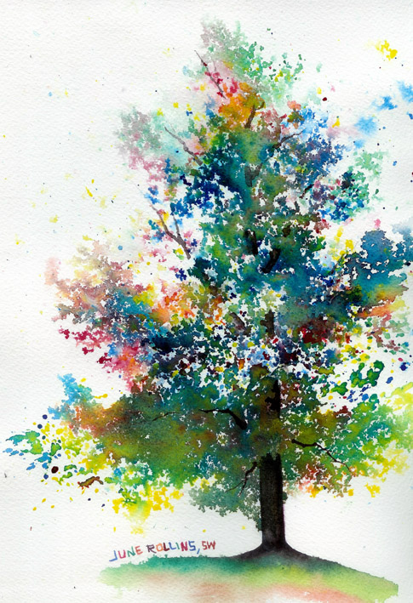

Watercolor Tree

Historical Reference(s): **Paul Cézanne**-1839–1906) was a French artist and [Post-Impressionist](http://en.wikipedia.org/wiki/Post-Impressionist) painter whose work laid the foundations of the transition from the 19th-century conception of artistic endeavor to a new and radically different world of art in the 20th century. Cézanne can be said to form the bridge between late 19th-century [Impressionism](http://en.wikipedia.org/wiki/Impressionism) and the early 20th century's new line of artistic enquiry, [Cubism](http://en.wikipedia.org/wiki/Cubism). Both [Matisse](http://en.wikipedia.org/wiki/Matisse) and [Picasso](http://en.wikipedia.org/wiki/Picasso) are said to have remarked that Cézanne "is the father of us all." **June Rollins & Masha Dyans**- contemporary watercolor artists working in this whimsical style.

Essential Question (Motivation, Engagement question(s): How do you control the mixing of watercolor paints mix on paper? What effects can be created using this technique?

Learning Objective(s): Students should come to a greater understanding of the primary and secondary colors. They should also gain experience in the watercolor technique of combining colors on the paper rather than on a palette.

Materials: Watercolor paper, watercolor paints, round paintbrushes, rolling pin (optional), water containers, spray bottles & palette knives (optional).

Vocabulary: Impressionism is a 19th-century [art movement](http://en.wikipedia.org/wiki/Art_movement) that originated with a group of Paris-based artists. Their independent [exhibitions](http://en.wikipedia.org/wiki/Art_exhibition) brought them to prominence during the 1870s and 1880s, in spite of harsh opposition from the conventional art community in France. The name of the style derives from the title of a [Claude Monet](http://en.wikipedia.org/wiki/Claude_Monet) work, *Impression, soleil levant* ([Impression, Sunrise](http://en.wikipedia.org/wiki/Impression,_Sunrise)), which provoked the critic [Louis Leroy](http://en.wikipedia.org/wiki/Louis_Leroy) to [coin](http://en.wikipedia.org/wiki/Word_coinage) the term in a [satirical](http://en.wikipedia.org/wiki/Satire) review published in the Parisian newspaper [*Le Charivari*](http://en.wikipedia.org/wiki/Le_Charivari).

Impressionist painting characteristics include relatively small, thin, yet visible brush strokes, open [composition](http://en.wikipedia.org/wiki/Composition_(visual_arts)), emphasis on accurate depiction of light in its changing qualities (often accentuating the effects of the passage of time), ordinary subject matter, inclusion of *movement* as a crucial element of human perception and experience, and unusual visual angles. The development of Impressionism in the [visual arts](http://en.wikipedia.org/wiki/Visual_arts) was soon followed by analogous styles in other media that became known as [impressionist music](http://en.wikipedia.org/wiki/Impressionist_music) and [impressionist literature](http://en.wikipedia.org/wiki/Impressionism_(literature)).

Adaptations/Modifications: Once the students have attempted to use the technique modeled in class to make a tree, they will be able to modify the project by using the technique on a subject matter of their choosing.

Mini Lesson: I will model the technique used to mix watercolor paint on paper using the primary colors. I will show them how to use a rolling pin and a watery paintbrush to tap color onto the paper without the brush making contact with the page. Then I will show them how a controlled spraying their painting will blend the colors on the paper. Using a previously dried example, I will then show them how to use a brush to add in the tree trunk, branches and ground.

Group Practice: First we will discuss what the primary colors are and what colors combine to create the secondary and tertiary colors. Then we will discuss famous watercolor artist such as Paul Cezanne and the contemporary watercolor artist Masha Dyans.

Independent Practice: The students start out with the primary colors, red, yellow and blue. They begin by misting their paper and tapping in first the yellow watercolors, then red, then blue. They will attempt to tap the colors in a shape that gives the impression of a tree. After that they will gently spray their paintings with a water bottle and watch the colors mix together on the paper.

Exit cards/Journaling/Portfolio: Students will have a group critique of their watercolor trees and discuss how successful the paintings turned out. They will also discuss what could be done to improve the techniques used. Students will also fill out a self-assessment form (see below) and write an additional self -assessment in their journals that addresses more specifically what they found most rewarding or challenging about this project.

Homework: The student’s homework will be to snap a few pictures of subjects that they believe would make successful watercolor paintings using the technique they learned in this lesson.

Assessment/Reflection:

|  |  |  |  |  |  |  |  |
| --- | --- | --- | --- | --- | --- | --- | --- |
| **Assessment Rubric** | | | | | | | |
| **Student Name:** | | | | | | **Class Period:** | |
| **Assignment: Watercolor Tree** | | | | | | **Date Completed:** | |
| Circle the number in pencil that best shows how well you feel that you completed that criterion for the assignment. | | Excellent | Good | Average | Needs Improvement | Rate Yourself | Teacher’s Rating |
| Criteria 1 – Color tapping- How well did you plan and execute the tapped in colors of your tree? | | 10 | 9 – 8 | 7 | 6 or less |  |  |
| Criteria 2 – Controlled Spray- How well did you control the sprayed water to further the impressionistic aesthetic of your image? | | 10 | 9 – 8 | 7 | 6 or less |  |  |
| Criteria 3 – Color – How successful was your color mixing? Did they mix in an interesting way or turn muddy?” | | 10 | 9 – 8 | 7 | 6 or less |  |  |
| Criteria 4 – Effort: took time to develop idea & complete project? (Didn’t rush.) Good use of class time? | | 10 | 9 – 8 | 7 | 6 or less |  |  |
| Criteria 5 – Craftsmanship – Neat, clean & complete? Skillful use of the art tools & media? | | 10 | 9 – 8 | 7 | 6 or less |  |  |
| Total: 50  x 2 = 100  (possible points) | Grade: |  |  |  |  | Your Total | Teacher Total |

Student Comments:

Teacher Comments: