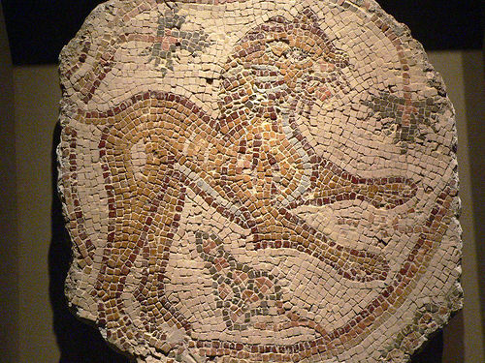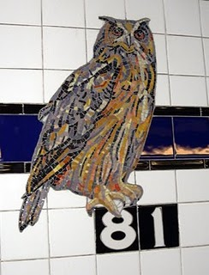

Syrian Mosaic floor fragment 6th century 81st street B,C subway stop

**Lesson Name:** Mosaic tile projects

**Historical Reference**: **History of Ancient Mosaic Art** Mosaic art dates back thousands of years. Ancient Sumerians used mosaics in their culture as shown in a mosaic panel depicting a battle, including the current Sumerian king in a chariot, which dates back to about 2000 BCE.

Ancient Egyptians also left remnants of their mosaic art. Like the Sumerians, many existent Egyptian mosaics included depictions of royalty, perhaps because only the royalty could afford to commission the artwork. Egyptians used mosaics to decorate walls and floors, as well as architectural features like pillars.

**Vocabulary:**

Mosaic is the [art](http://en.wikipedia.org/wiki/Art) of creating images with an assemblage of small pieces of colored [glass](http://en.wikipedia.org/wiki/Glass), stone, or other materials. It may be a technique of [decorative art](http://en.wikipedia.org/wiki/Decorative_arts), an aspect of [interior decoration](http://en.wikipedia.org/wiki/Interior_decoration), or of cultural and spiritual significance as in a [cathedral](http://en.wikipedia.org/wiki/Cathedral). Small pieces, normally roughly [cubic](http://en.wikipedia.org/wiki/Cube), of stone or glass of different colors, known as [*tesserae*](http://en.wikipedia.org/wiki/Tesserae), (diminutive *tessellae*), are used to create a [pattern](http://en.wikipedia.org/wiki/Pattern) or picture.

**Materials:** Glass and tile pieces, wheeled glass nippers, tile nippers, Running Pliers for stained glass, tile glue, grout, paint, journals for sketching, pencils, colored pencils or markers, Repositionable Clear Con-Tact® Cover paper, sponges, containers for mixing grout, MosaicStone cement, wooden sticks for mixing grout, plastic bags for safe tile/glass cutting, Krylon Crystal Clear, 4 ¼ “ hexagon shaped coaster molds, plastic gloves, mastic, notched trowel.

**Goals:** Students will learn about the ancient art of mosaic. They will create their own pieces that they can take with them and create a mural that will be part of the school for years to come.

**Procedure:** After reading and discussing this lesson plan, the students will be given a brief demo on how to safely cut and handle tiles and glass. Then they will be given a demo on how to design, glue and grout mosaics. The students will then be asked to sketch a design that they would like to make in their 4 ¼ “ hexagon shaped coaster mold. They must color their sketches. After they have completed their colored sketches, they will pick tiles and glass in the colors that they have incorporated into they sketches. Then they will cut the tiles or glass if need be, in order to get the shapes that they need to create their designs. Next they will be given a piece of clear contact paper that they will cut into a 4 ¼ “ hexagon using a template provided by the instructor. Next they will place their contact paper sticky side up on top of their design. Then they will arrange their cut glass and tile pieces FACE DOWN on the contact paper. When they have completed their design, they will place it face down into the plastic mold. Next they will be given a cup and some dry MosaicStone cement. They will add water and mix with a wooden stick. Paint may be added to the cement if so desired. Then they will their coaster mold with the cement. They will let the cement dry over night and remove their coasters the following class period. Finally they will peal back the contact paper and reveal their finished coasters.

The next step in this project is for the students to design a wall mural for the student lounge. Students will be asked to design a 1’ W X 9’ H mural that features the words The Smith School. The art teacher and the principal will judge designs. The winning design will be the template for a mosaic mural that all of the classes will work on. The winning design will be transferred onto 1’ x 9’ paper by the winning artist and then the design will be broken up into 6 pieces so that every class will be responsible for one section. Students will work as a class to cut tiles and glass into appropriate sizes for their section of the mural. They will then tape a mesh screen on top of their section of the mosaic and begin gluing tesserae to their proper places in the design. They must be sure not to leave more than 1/8” between pieces to insure grouting stability. When all of the screens are completed, they will be hung on the wall using mastic and a notched trowel. An adult will do the highest areas, but the students can install the lower areas. When the mastic dries, the mosaic will be grouted. Again the highest areas will be done by a teacher, and the lower by the students.

**Evaluation:** Students will have a group critique of their mosaic coaster and their mosaic mural projects and discuss how successful the projects turned out. They will also discuss what could be done to improve the techniques used. Students will also write a self-evaluation of their work in their journals.