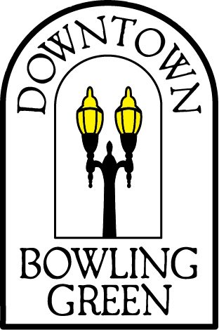
A Cut Above
A Taste of Amish Deli
Aardvark Screen Printing & Embroidery
Ace Hardware
Applied Imagination
Art-a-site!
Beckett’s
Belleville Brothers Market
Ben’s
Biggby Coffee (BG Only)
Blush- A Bridal Boutique
Broadwing Tattoos & Body Piercings
Busy Thimble
Calico, Sage, & Thyme
Call of the Canyon Café
Cameo Pizza
Cameron’s Comics and Stuff
Changes on Mane
City Tap
Clazel Entertainment
Cookie Jar and More
Coyote Beads & Jewelry
Cycle Werks
Easy Street Café
Eden Fashion Boutique
Eric’s Ice Cream Factory (BG only)
Everyday People Cafe
Finders Records
Flatlands Coffee
For Keeps
For Keeps Home Gallery
Gallery Salon & Spa

Get Inspired Nutrition
Golden Vanity
Grounds for Thought
Hal’s Barber Shop
Healing Sapphire Massage
Hines Insurance Agency
Homeworks Inc.
Kabob-It
Kaleidoscope
Kermit’s Restaurant
Lahey’s Appliance & TV
Mainstreet Antiques
McKenzie’s Flower Basket
Mini Mall Beauty Salon
Mister Spots
Mode Elle Fashion BoutiqueMurder Ink Tattoos
Naslada Bistro
Old Mill Barber Shop
Panera Bread
Pisanello’s Pizza
Qdoba Mexican grill
Reverend’s Bar & Grill
Rock’Em Sock’Em Retro
Sam B’s Restaurant
Stone’s Throw Tavern & Grill
Sutter’s Hallmark
Sutter’s Frame & Art Gallery
Thayer BG Dealerships *
Trotters Tavern
Two Foxes
Waddington Jewelers & Engraving
Wave Hair Salon
Wizard Graphics
WC Hospital Gift Shop*

