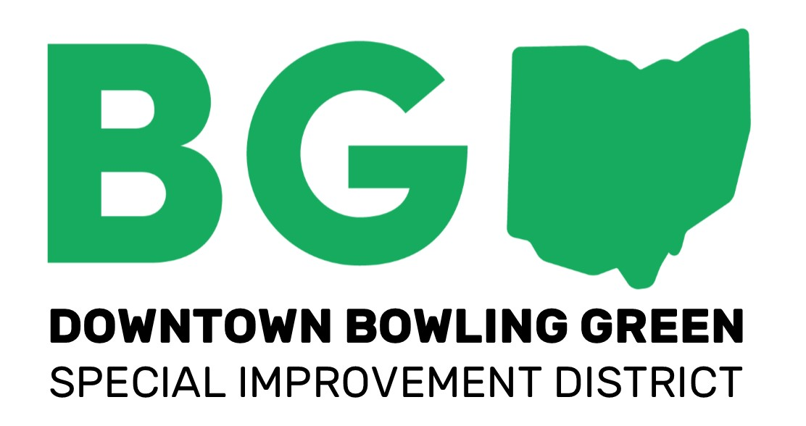
A Cut Above
Aardvark, A Three Cord Company
Ace Hardware (BG)
Applied Imagination
Art-a-site!
Beckett’s
Belleville Brothers Market
Ben’s
Biggby Coffee (BG Only)
Blush- A Bridal Boutique
Broadwing Tattoos & Body Piercings
Busy Thimble
Call of the Canyon Café
Cameo Pizza
City Tap
The Clay Pot
Cookie Jar Bowling Green
Coyote Beads & Jewelry
Cycle Werks (BG)
Easy Street Café (BG)
Eden Fashion Boutique
Eric’s Ice Cream Factory (BG)
Everyday People Cafe
Finders Records
Flatlands Coffee
For Keeps
For Keeps Home Gallery
Gallery Salon & Spa
Get Inspired Nutrition
Golden Vanity
Grounds for Thought
Hal’s Barber Shop
Healing Sapphire Massage
Hines Insurance Agency
Homeworks Design Company
Inspect UR Gadget
Kabob-It
Kaleidoscope Jewelry & Gifts
Kermit’s Restaurant
Lahey’s Appliance & TV
McKenzie’s Flower Basket
Mini Mall Beauty Salon
Mister Spots
Mode Elle Fashion Boutique
Murder Ink Tattoos
Net-Pro
Old Mill Barber Shop
Pisanello’s Pizza
Qdoba Mexican grill
Reverend’s Bar & Grill
Rock’Em Sock’Em Retro
Sam B’s Restaurant
The Stacked Deck
Sterling’s Amish Deli
The Stone’s Throw Tavern & Grill
Sutter’s Hallmark Frame & Art Gallery
Thayer Chevrolet
Thayer Chrysler, Dodge, Jeep, Ram
Thayer Ford
Thayer Honda
Thayer Nissan
Thayer Toyota
Trotters Tavern
Waddington Jewelers & Engraving
WC Hospital Gift Shop*

