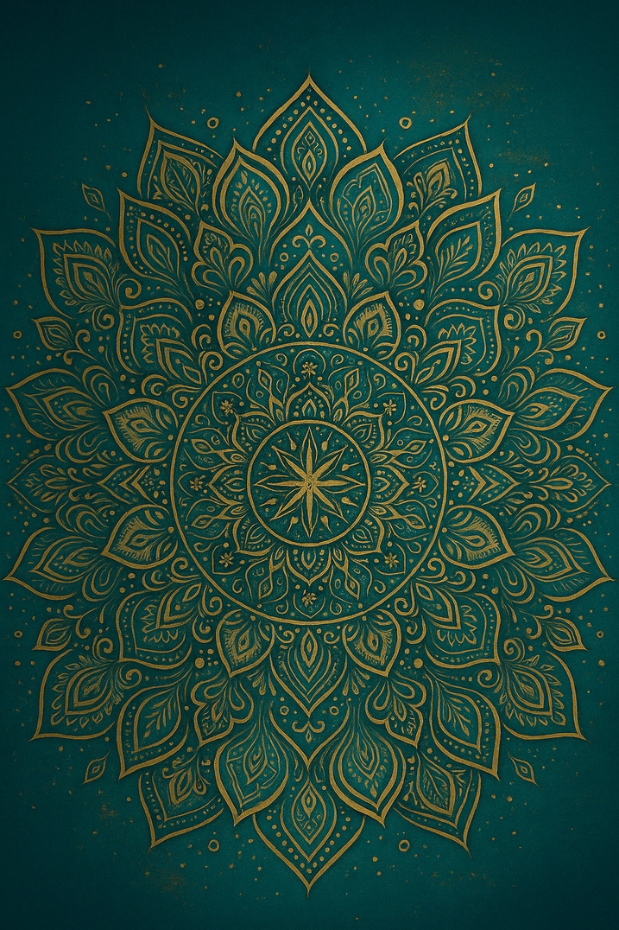

THE AWAKENING WOMAN’S
STARTER PACK

Beginning Your Becoming

INTRODUCTION

The Awakening Woman’s Starter Pack is a sacred guide designed to support you during the exact moments when awakening feels overwhelming, confusing, or emotionally intense. It was created to support you as you step boldly into your awakening journey.
This is not a workbook.
This is a remembrance, a coming home to the woman you were always meant to be.
Awakening does not happen in a straight line, it rises in waves.
Certain moments, emotions, and triggers are actually invitations into deeper truth.
Each step in this guide is written to meet you in those exact moments.

~ 1 ~
INSIDE THESE PAGES, YOU’LL EXPLORE FIVE CORE PILLARS OF AWAKENING:

1. Hearing the whispers of your body
2. Understanding your ego as a protector
3. Reconnecting with your inner child
4. Grounding into divine guidance
5. Reclaiming your home identity with clarity and power

~ 2 ~
HOW TO USE THIS GUIDE:

Choose a quiet moment where you can be present with yourself.
Move through each step slowly, there is no rush.
Let your body respond first, then let your mind catch up.
Write down anything that rises: sensations, memories, emotions, insights.
Return to this guide anytime you feel disconnected or uncertain.

This is your beginning.
This is your becoming.
This is you, awakening.

~ 3 ~
STEP 1 — THE FIRST WHISPER

Your body speaks before your mind understands. It communicates through sensation, tension, expansion, or emotion. Awakening begins when you learn to listen.

PRACTICE:

Place one hand on your heart and one on your belly.
Breathe slowly.
Ask:“What are you trying to tell me?”
Write whatever rises without judgment.

Use this when:
- your chest feels tight
- your stomach drops
- you feel “off” but don’t know why
- you’re overwhelmed, overstimulated, or disconnected
- you can’t find the words for what you feel
This step helps you hear the body before your mind starts creating stories.

~ 4 ~
STEP 2 — THE EGO IS NOT THE ENEMY

Your ego is not sabotage, it is protection. It is your wounded inner child's voice trying to keep you safe using tools that once worked but no longer align with who you are becoming.

REFLECTION:

Ask: “What fear are you trying to protect me from right now?”
Let the truth rise gently.

Use this when:

- Fear rises fast
- you feel defensive
- You’re procrastinating or self-sabotaging
- you feel like you’re “not ready” or “not enough”
- your thoughts are loud and protective

This step helps you decode fear rather than obey it.

~ 5 ~
STEP 3 — INNER CHILD MIRROR MOMENT

Your inner child remembers what your adult self has forgotten, gf and she is waiting to be seen.

VISUAL PRACTICE:

Picture your younger self standing before you.
Ask her: “What do you need from me today?” Let her speak.
Respond softly: “I am here now. I have you.”
This creates safety, the foundation of awakening.

Use this when
  - you feel rejected, abandoned, or unimportant
  - You’re triggered by someone’s tone or behaviour
  - old wounds rise unexpectedly
  - you feel small, unseen, or misunderstood
  - emotional sensitivity takes over

This step reconnects you to the part of you that needs safety, not shame.

~ 6 ~
STEP 4 — CHRIST-LED GROUNDING

Awakening is not meant to be walked alone. Divine guidance is available when you slow down enough to feel it.

INVOCATION:

“ God, walk with me as I walk with myself.
Anchor my steps.
Clarify my path.
Restore what fear has hidden.
Show me who I truly am.”
Let this grounding be your daily reset.

Use this when:
- you feel lost or directionless
- you’re doubting yourself
- you’re spiraling mentally or emotionally
- you need guidance bigger than your own mind
- you want to reconnect with truth, clarity, and divine presence
This step brings you back into spiritual alignment and remembrance.

~ 7 ~
STEP 5 — IDENTITY RECLAMATION

Identity is not found, it is claimed.

JOURNAL PROMPT:

Complete the sentence:
“ Today, I choose to become the woman who _____________________________.”
Repeat it until your body believes it.
This is your shift. Your activation. Your becoming.

Use this when:
- you’re stepping into something new
- you feel yourself slipping back into old patterns
- you want to anchor a new timeline
- you’re ready to claim a new level
- you want to shift your frequency fast

This step locks in who you are becoming — not who you were.

~ 8 ~

INTEGRATION

Integration is where everything settles, where awareness becomes embodiment.

Take a slow breath.
Let your shoulders drop.
Place your hand on your heart.
Allow this next sentence to meet you:

“I am becoming the woman I was always meant to be.”

This is not perfection, it is remembrance.
Return to it whenever you need to come home to yourself.

~ 9 ~

NEXT STEPS

If this guide opened something inside you, if it softened you, awakened you, or reminded you who you are, then you are entering a new chapter of your life.

Your next steps may be:

• Staying connected through my inner circle
• Exploring 1:1 awakening sessions
• Deepening your healing through mentorship
• Walking with me through my upcoming books, including
“My Ego Is My Amigo”

Before you close this guide, say:

“I am not lost.
I am not behind.
I am right on time for my awakening.
I am the one my lineage has been waiting for.”

This is your becoming.
And you are ready for it.
~ 10 ~

