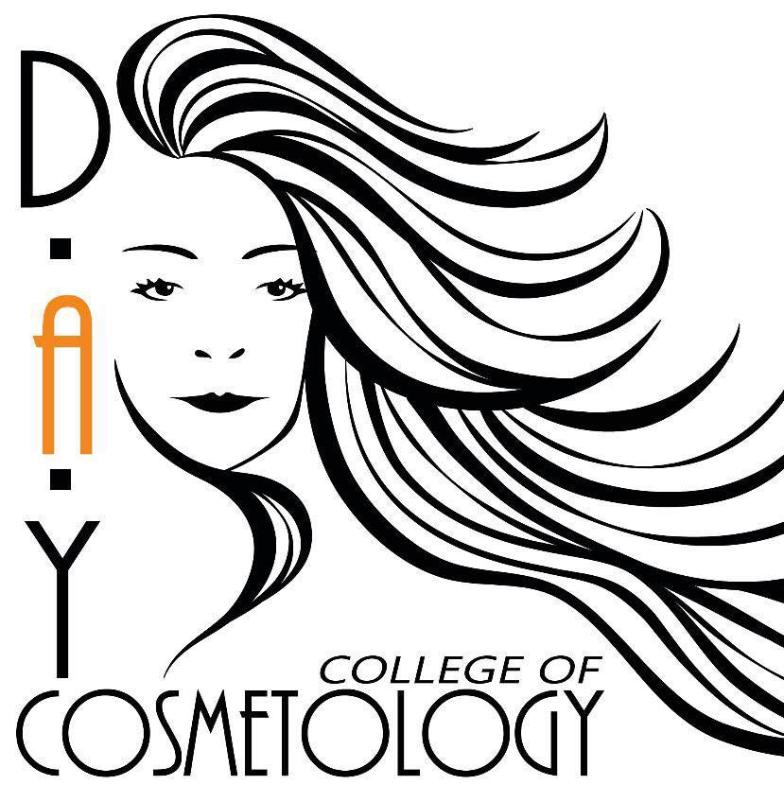

MISSION STATEMENT
D.A.Y College of Cosmetology is committed to helping you achieve a career that not only is rewarding but will empower, uplift, validate and ultimately build self-esteem in not only you but the men and women that become your clients, your friends, and your family away from home. Our goal is to help you become confident in your work and build a career that will last a lifetime. We are committed to providing high quality and relevant training for the students here at D.A.Y College of Cosmetology. We will help each individual student accomplish the highest level of training that this career offers as well as the confidence you need to graduate and start building your own clientele.

General Information

- Students must be 16 years of age or older.
- Students must have a high school diploma/GED or be actively enrolled in high school.
- Cosmetology/Nail Student’s Dress Code: Black pants with any color D.A.Y shirt or black scrubs. The student will need to purchase their choice of a black stylist vest. D.A.Y College of Cosmetology will provide the student with a name tag that is required to be worn at all times.
- Esthetics Dress Code: Black Scrubs with name tag.
- 1,500 hours of instruction and practice will be required to graduate for cosmetology.
- 600 hours of instruction and practice will be required to graduate for the nail program.
- 750 hours of instruction and practice will be required to graduate for the esthetics program.
- While attending D.A.Y College of Cosmetology you will be allowed to observe operations in an operating salon with instructor’s approval.

D.A.Y College of Cosmetology
Esthetics Course

Full time – 32 hours a week for 6 months (23 weeks)
Part time – 20 hours a week for 9 months (37 weeks)

Esthetics Curriculum
Full time students: Class begins at 9:00 am. Theory from 9:00 am-10:00 am followed by a 15 minute break. Practical work begins at 10:15 am. Lunch is to 12:00pm-1:00pm unless otherwise engaged with a client. Practical work resumes from 1:00pm-4:30pm.
Night-time students: Theory from 4:00pm-5:00pm. Practical from 5:00pm-8:00pm.

General Hours Required
General – (150 clock hours) Sterilization, Sanitation, Bacteriology, Professional Ethics, Salesmanship, State Law.

Chemical – (150 clock hours) Skin Conditions, Disorders, Nutrition, Aging Factors, Product Ingredients, Waxing, Lash & Brow Tinting.

Physical – (450 clock hours) Massage Movements & Manipulation, Masks & Packs, Facial Treatments with Machines, Skin Analysis & Consultation, Application of All Products, Color Psychology, Makeup & Corrective Makeup.

Graduation
Upon completion of 750 hours and curriculum testing, students will have the opportunity to invite their family and friends to their graduation ceremony. Before receiving their diploma, all requirements must be completed, and all student loans must be paid in full.

School closings
Should in-climate weather arise one of the following schedules will be implemented.
Snow day: Classes will be canceled. Office will be closed.
Delayed schedule: Day school will be on a one- hour delay. Classes will meet from 9:30 am until 1:00 pm. This will count as a full day. Night school will operate on a regular schedule unless weather conditions deteriorate during the day.
WBBJ TV CHANNEL 7 will be notified of closings or delays.

Cheating
Students are expected to do their own work.
1st offense- Clock out for the day receiving 0’s.
2nd offense- Week expulsion receiving 0’s.

Cancellation Policy
All payments due 30 days after the financial agreement is signed. If a student should complete the course early, full payment will be required before release of requirements to the state board of cosmetology. If for any reason a student decides to terminate their agreement the student has 7 days from the date the agreement is signed to receive full refund, minus $1000 (nonrefundable) for expense of supplies (kit, books, and nametag). Should the student terminate their contract, the student is responsible to continue all payments for a year after terminating their contract.
Harassment Policy
DAY will not permit any type of harassment of instructors, students, clients, etc. Any harassment reports will be thoroughly investigated and could be grounds for suspension or expulsion.

Grounds for Termination
Not following attendance policy. Not following the conduct code. Not following the dress code.

Course Materials
Milady Standard Textbooks of Esthetics, and Esthetics kit.
D.A.Y COLLEGE OF COSMETOLOGY
21 A Meridian Springs Dr. Jackson, TN 38301
Application Agreement

Date _______________ Full Name ________________________________ SS# __________________
Address _____________________________________ City___________________ State ___________
Zip ___________ Home Phone ________________________ Cell Phone ________________________
Email ____________________________________ Date of Birth ___________________
Employer Name _____________________________ Employer Address _________________________
Work Phone # ___________________ Spouse Name ________________________________________
Emergency Contact Name and Phone Number ______________________________________________
Do you live with your parents? ___________ Do you have a high school diploma or GED? ___________
Have you ever attended Cosmetology school? ___________ Expected start date __________________
Fathers Name ________________________ Address ________________________________________
City ____________________ State ________ Zip _____________ Phone # _______________________
Mothers Name _______________________ Address ________________________________________
City _____________________ State _________ Zip _____________ Phone # _____________________
Full Time _____________ Part Time ___________ Nights ____________
Cosmetology ______________ Nails _______________ Esthetics _______________
$100.00 Non-Refundable Enrollment Fee is due upon signing agreement. This will include t-shirt, name tag, etc.
I certify that the statements on this application are complete and true.
Student Signature __________________________________ Date __________________________
Parent/Legal Guardian Signature _______________________________ Date ________________
D.A.Y. College Signature ________________________________________Date_____________

D.A.Y College of Cosmetology
Attendance Policy

- Students are allowed only 1 excused & 1 unexcused absences per month. If student exceeds this amount, he/she is suspended for one week.

- If student is excessively late (8 or more unexcused) within 4 months, he/she will be suspended for one week.

- Each excused absence or late must be approved by the owner or instructor prior to absence.

- Failure to communicate about excessive absences within 30 days may result in being withdrawn from D.A.Y College of Cosmetology.

- Excused absences include:
- Personal Illness (Must provide doctors note)
- Illness of immediate family member
- Death of a family member
- Religious observations
- Extreme weather conditions
- Work related

- Job Shadowing is limited to 1 excused day per week and form must be filled out and approved by an instructor or owner.

Student Signature __________________________________ Date __________________________
Parent/Legal Guardian Signature _______________________________ Date ________________
D.A.Y. College Signature ________________________________________Date_____________

D.A.Y College of Cosmetology
New Rules as of 2/4/2021

- Attendance: Students are allowed only 1 excused & 1 unexcused absences per month. If student exceeds this amount, he/she is suspended for 1 week.
- Theory: Student must be signed in by 9:00 a.m. After 9 a.m. classroom doors will be shut & student will not be allowed to sign in until theory is over at 10 a.m.
- Appearance: Look Professional!
- Lunch: 11:00 a.m. – 12:00 p.m. or 12:00 p.m. – 1:00 p.m. Student only gets one hour, which includes going to supply store for yourself.
- Sanitation: The sign in sheet will be with one of the instructors. Before student can sign out sanitation will be checked.
- Communication: Student must tell an instructor when he/she will be absent/late.
- Practical Sheets: Student must show instructor his/her work when it is completed. Every service left blank will count for 5 minutes off time. Always have client sign a Chemical Service Sheet!
- Stealing is prohibited in this school!
- Student must wash color bowls/bottles completely.
- Classroom tables are to be kept clean of books, purses, drinks, etc.
If student’s belongings are left on table after theory, you will be clocked out.
- If student has bathrooms for sanitation, make sure they are stocked with toilet paper and paper towels and take out the trash.

Student Signature: ________________________________________
School Signature: _________________________________________
Date: ____________________

D.A.Y College of Cosmetology
Student Financial Agreement for Esthetics
21 A Meridian Springs Dr.
Jackson, TN 38301

Name: ______________________________________
Phone: ____________________ Address: ________________________________________________
Email Address: ___________________________________________

Full Time 8:30 AM - 4:30 PM ____
Nights 3:00 PM – 8:00 PM ____
Part-Time ____
Payment Options:
____ $6,000 ~ $1,000 down, $625 each month for 8 months.
____ $6,000 ~ $2,000 down, $500 each month for 8 months.
____ $6,000 ~ $3,000 down, $375 each month for 8 months.
____ $5,800 ~ Cash Price Discount

Cancellation Policy
All payments due 30 days after the financial agreement is signed. If a student should complete the course early, full payment will be required before release of requirements to the state board of cosmetology. If for any reason a student decides to terminate their agreement the student has 7 days from the date the agreement is signed to receive full refund, minus down payment (nonrefundable) for expense of supplies (kit, books, and nametag). Should the student terminate their contract, the student is responsible to continue all payments for a year after terminating their contract.

Late Payment Policy
Students who are 5 days past their due date cannot clock hours until their monthly payment has been made. A $25 late charge will apply.
*State Board records will not be released until full payment is made*
*Student agrees to not have excessive tardiness or absences*
*Must have good attendance. If student should take longer than 8 months $375 will be charged for each additional month she/he attends*

Student Signature __________________________________ Date __________________________
Parent/Legal Guardian Signature _______________________________ Date ________________
D.A.Y. College Signature ________________________________________Date____________
D.A.Y College
Indulge in your enrollment benefits now!

Haircuts, Blowouts, Beard & Bang Trims

FREE!

All Other hair Services Using School Product

40% OFF!

All Nail Services

50% OFF!

All Hair Services Using Your Own Purchased Products

60% OFF!

School Hours: 8:30 A.M. – 8 P.M.
(Tuesday-Friday)

D.A.Y College of Cosmetology

21 A Meridian Springs Dr. | Jackson, TN 38301 | 731.608.8881 |http://daycollegeofcosmetology.com

