Destination Divas Transportation is committed to being the industry leader in providing outstanding value and service to all customers. We hope our customers feel safe and satisfied with our services.

If you need to make a complaint, please contact the City of Dallas

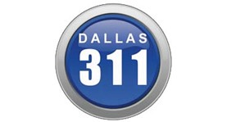

Call Center Operations
The 311 Call Center operates 24/7 and is staffed by Customer Service Representatives who are trained to receive calls from residents, actively listen to their concerns and, based upon their situation, determine which service request(s) would best suit their needs. The Customer Service Representatives are also responsible for educating citizens about departmental website navigation, the 311 App, and sometimes direct citizens to non-City related organizations for assistance. It is our intention for 311 to be a “one-stop shop” type of call center addressing all concerns on one call. Our goal is to leave a lasting impact on residents, assuring them that the City of Dallas is working to resolve their concerns and improve the overall quality of life for Dallas residents.
By Phone
Simply call 3-1-1 when inside Dallas city limits
You may also access Dallas 3-1-1 by calling (214) 670-3111 from any location

Online
Visit - Dallas 311 Request a Service

Complaints – Office of Inspector General
Visit - Inspector General Complaints

