
WELCOME
PACKET
STUDENT

PREPARED BY
OLIVIA BRANTLEY
REIKI MASTER TEACHER
KUNDALINI REIKI MASTER TEACHER
FOUNDER OF GET BALANCED

HEALING ARTS ACADEMY
HOLISTIC HEALER + APOTHECARY

PRACTITIONER

Table of Contents
- Welcome Letter
- About Your Teacher
- What Reiki Is
- Course Overview
- What to Expect in Class
- What to Bring
- How to Prepare Energetically
- Attunement / Placement Guide
- After-Care Instructions
- Classroom Policies & Etiquette
- Student Responsibilities
- Pre-Class Journal Prompts
- Recommended Reading
- Reiki Lineage Chart
- Student Acknowledgment Page
- Contact & Support

Welcome Letter
Dear Student,
Welcome to this sacred journey.
If you are reading these words, it is because something deep within you — your higher self, your intuition, or the quiet voice of Spirit — has guided you here. Reiki is never an accident. It is a calling. A remembering. A gentle awakening of the healer that already lives within you.
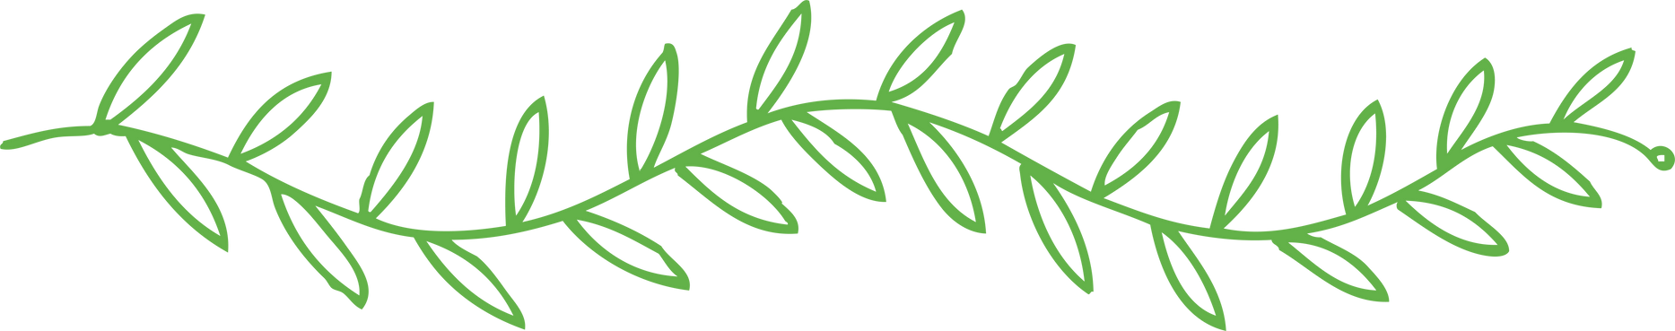
This course is not simply a class you attend. It is an energetic initiation — a doorway that opens you to healing, to intuition, to spiritual alignment, and to the ancient wisdom your soul has always carried.
As we move through this training together, you may experience: awakening sensations in the hands, emotional clearing, heightened intuition, stronger connection to your guides, a softening of the heart, and a deeper sense of peace.
Thank you for trusting me to guide you. I honor your journey and hold space for your awakening.
With love and light,
Olivia Brantley
Reiki Master/Teacher
Get Balanced Reiki Healing Center | Apothecary

About Your Teacher
From the time Olivia entered this world, she carried the quiet knowing that she was meant to help others heal. This calling first led her into the medical field, where she dedicated years to caring for people physically. But deep within, she felt called to support people on a deeper energetic and emotional level.
Her search led her to Reiki — a modality that awakened something ancient inside her. She felt a sense of remembrance, a spiritual pull to learn, heal, and evolve. As she progressed, she discovered that true healing asks us to release what no longer serves us, even when it’s difficult.
Teaching is new to Olivia, but not new to her spirit. She was led to this path through dreams and intuitive guidance, showing her that she was meant to lead, heal, and guide others.
Her mission is simple: to help every student discover the healer within themselves.

What Reiki Is
Reiki is a Japanese healing technique that channels universal life force energy through the hands. It supports physical, emotional, mental, and spiritual healing. Reiki is gentle, safe, non-invasive, and deeply restorative.

Course Overview
Reiki I: Self-healing, hand positions, energy basics.
Reiki II: Symbols, distance healing, advanced techniques.
Reiki Master: Master symbol, deeper intuition, energetic expansion. Reiki Teacher: Learning how to attune and teach future practitioners.

What to Expect in Class
Guided meditations
Hands-on practice
Energy anatomy lessons
Intuitive exercises
Journaling
Attunements
Group discussions
Supportive spiritual atmosphere.
What to Bring
Journal and pen
Water
Comfortable clothing
Snacks/light meal
Any crystals you'd like to charge
An open heart and mind

How to Prepare Energetically
Drink water before class
Avoid alcohol
Eat lightly
Set an intention
Reflect quietly before arriving

Attunement / Placement Guide
Attunements are sacred energetic activations that open your channel to Reiki energy. You may feel warmth, tingling, emotions, visions, or deep peace. All experiences are valid.

How to Prepare Energetically
Drink water before class
Avoid alcohol
Eat lightly
Set an intention
Reflect quietly before arriving

Attunement / Placement Guide
Attunements are sacred energetic activations that open your channel to Reiki energy. You may feel warmth, tingling, emotions, visions, or deep peace. All experiences are valid.
After-Care Instructions
Drink extra water
Rest
Ground yourself
Journal any shifts
Practice daily self-Reiki
Allow emotions to move gently

Classroom Policies & Etiquette
Phones silent
No recording attunements
Respect confidentiality
Be present and respectful
Honor all students’ experiences

Student Responsibilities
Arrive on time
Engage with the class
Complete practice assignments
Communicate openly
Practice self-Reiki consistently

Pre-Class Journal Prompts
- Why do I feel called to Reiki now?
- What am I ready to release?
- How do I want Reiki to support my life?
- What does healing mean to me?

Recommended Reading
Reiki: The Healing Touch – First & Second Degree Manual
Advanced Reiki Training (ART) / Reiki Master Manual
Author: William Lee Rand
Reiki I Student Handbook — Get Balanced Reiki Academy
Author: Master Teacher Olivia Brantley
Reiki II Student Handbook — Get Balanced Reiki Academy
Author: Master Teacher Olivia Brantley
ART (Advanced Reiki Training) Student Handbook — Get Balanced Reiki Academy
Author: Master Teacher Olivia Brantley
Reiki Master Teacher Handbook — Get Balanced Reiki Academy
Author: Master Teacher Olivia Brantley

Reiki Lineage Chart
Mikao Usui → Chujiro Hayashi → Hawayo Takata → William Lee
Rand → Cynthia Daniel → Olivia Brantley → You

Student Acknowledgment Page
I acknowledge that I have received, read, and understand the Reiki Student Welcome Packet and agree to uphold the guidelines within.
Student Signature:
Date:

Contact & Support
Instructor: Olivia Brantley
Email: olivia.chambers@getbalancedreiki.com
Website: www.getbalancedreiki.com

