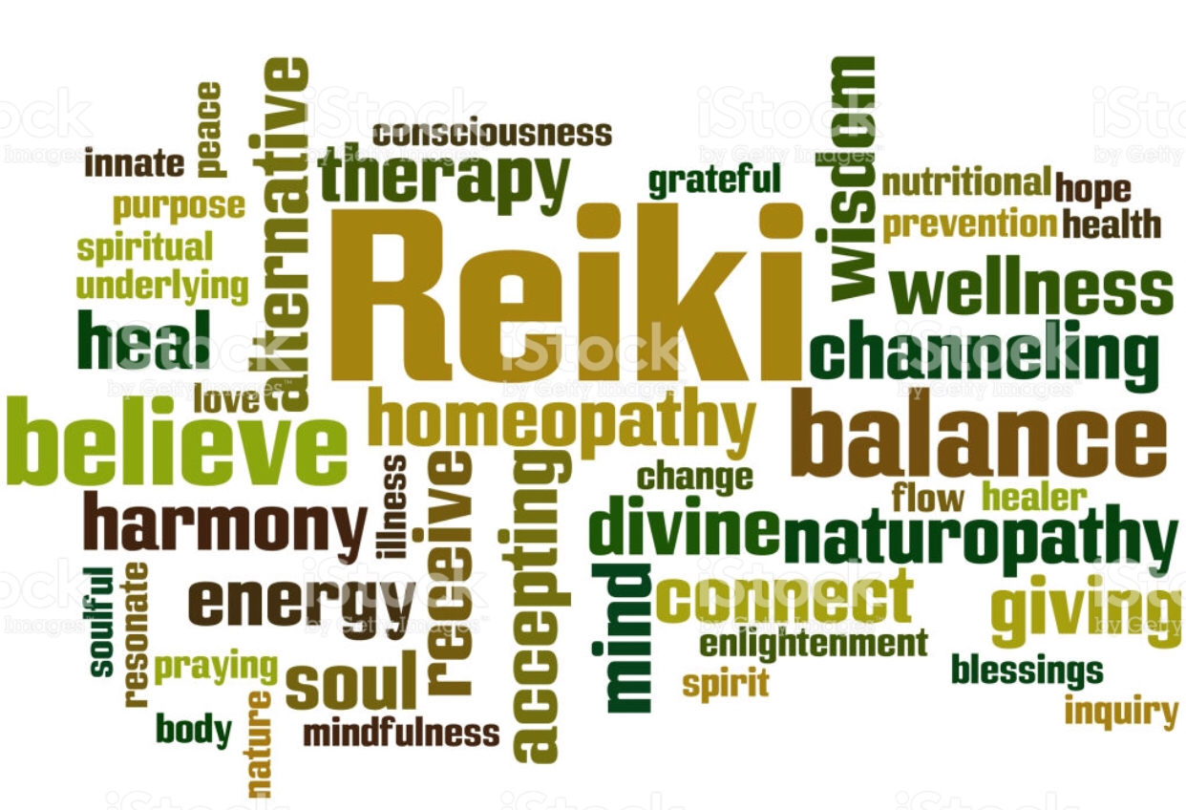

**Get Balanced Reiki**

**Informed Consent for Reiki Treatment**

**Personal Information**

|  |  |  |  |  |  |
| --- | --- | --- | --- | --- | --- |
| Last Name | | First Name | | | Middle Initial |
| Date of Birth | Sex | Home Number | Cell Number | | |
| Email | | | | | |
| Referred By | | | | | |
| Address | | | | | |
| City | | State | | Zip Code | |

|  |
| --- |
| Please note that my Reiki practice is generally a hands-on healing practice. While there is a protocol of hand positions, I also work intuitively as to where to place my hands and which hands positions to use. My hands will rest lightly on your body and there is no manipulation of your body. If, at any time, you are uncomfortable, I can switch positions, or use the floating hands method.  There is no difference in the benefit experienced by the placement of my hands on your body versus floating my hands over your body. Should you desire to alternate positions during the treatment, please feel free to ask me to do so. |
| **Special requests or comments for hands-on or floating**  *e.g. Please use hand- on entire body, please use floating hands over pelvis* **______________________________________________________________________________________**  **____________________________________________________________________________________________________________________________________________________________________________**  **____________________________________________________________________________________________________________________________________________________________________________**  **______________________________________________________________________________________**  **___________________________________________________________________________________________________________________________________________________________Initial____________** |

**Reiki Treatment Positions (Hands-on or Floating)**

**Before your session, please read over and initial each the following indicating your understanding:**

**______ What is Reiki?**

The Usui System of Reiki Healing is a palms-on healing practice. Reiki is an ancient laying-on-of-palms healing technique that uses the Universal life force energy to balance the subtle energies within our bodies and to heal. Reiki practitioners act as a conduit or channel through which Reiki energy travels. The intended result of receiving Reiki is a balanced physical, mental, emotional, and spiritual being. Reiki is being used today in clinics and hospitals all over the world to support health, wellness and transition.

**______ What happens during a Reiki treatment?**

During a Reiki treatment, you will lay fully clothed on a massage table, covered in a blanket if you choose, listening to soothing music. Your Reiki practitioner will lay their hands on your body in a series of hand positions to deliver Reiki energy. A Reiki treatment generally covers first your head then the front of your body and finally the back of your body. If the reclined position is uncomfortable, Reiki can be performed while you sit in a chair or on a stool.

**______ What does Reiki feel like?**

Reiki tends to feel warm and profoundly relaxing. You may feel the hands of the Reiki practitioner become hot or tingly. Some people describe a floating sensation and some see colors or shapes during the session. Some people fall asleep. Some experience emotional release. There is no expected experience- Reiki treatment is unique for each individual who receives it.

The most common results of Reiki treatment include:

* Perceived reduction in stress
* Increased relaxation
* Enhanced sense of balance, centeredness and calm.

**______ What are the benefits of several sessions?**

Just like meditation, or movement arts, the effects of Reiki are cumulative. While one session can work wonders, repeated, regular Reiki treatments can invite significant improvement. As an example: if you exercise for an hour, you will receive benefit. If you exercise every day for a month, the results will be much more profound. Reiki works similarly – regular sessions support well-being in every way.

**______ Can Reiki “cure” me?**

Reiki is a complementary medical art that works well alone as well as in concert with other treatments. Healing is often the result of gentle shifts in awareness, release of emotional patterns, achievement of new understanding, and daily practice. Reiki is not a **replacement for traditional medical treatment.**

*I understand that Reiki is a relaxation and stress reduction technique. I acknowledge that treatments administered are only for the purpose of helping me relax and to relieve stress. Reiki practitioners do not diagnose conditions, nor do they prescribe substances or perform medical treatment, nor interfere with the treatment of a licensed medical professional and are not licensed by the state of California. I further understand that Reiki treatment received from practitioners at Sage Wisdom Institute are not to be construed as a substitute for medical examination, diagnosis or treatment. It is recommended that I see a licensed health care professional for any physical or psychological ailment I may have.*

*I also understand that Reiki is an energetic healing methodology, which involves the laying on of hands. I understand that I will be fully clothed during the session, and experience a series of hand positions on and/or above my body.*

*Having read, completed and understood the foregoing, I request to receive Reiki treatment. I understand that my practitioner is providing Reiki treatment for me at my request, and is not responsible for the outcome of the Reiki session. I agree to hold Sage Wisdom Institute harmless for any intended or unintended result.*

Signed: ___________________________________________________________

Print Name: ________________________________________________________

Date: _____________________________________________________________