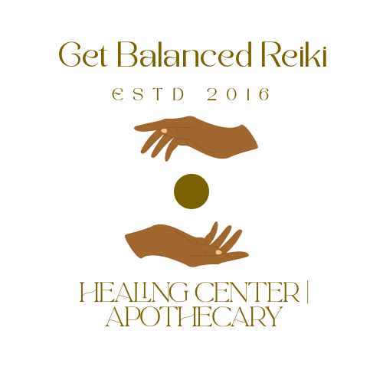

Get Balanced Reiki Healing Center | Apothecary
Reiki Client Consent Form
Client Name: ____________________________
Date: ____________________________
Phone: ____________________________
Email: ____________________________

Understanding Reiki
Reiki is a gentle, non-invasive energy healing technique that supports the body’s natural ability to restore balance and harmony. It promotes relaxation, reduces stress, and encourages emotional and energetic healing. Reiki is complementary to medical care and not a substitute for professional medical advice, diagnosis, or treatment. Clients are encouraged to continue all prescribed medical care.

What to Expect During a Session
During a Reiki session, you may experience sensations such as warmth, tingling, deep relaxation, or emotional release. You may also feel calm or simply more centered. You will remain fully clothed throughout the session and may pause or stop at any time.

Distance Reiki Acknowledgment
☐ I understand that for distance Reiki sessions, energy is transmitted remotely. No physical contact occurs, but the same healing intention and energy principles apply.

Client Consent and Acknowledgment
☐ I understand that Reiki practitioners do not diagnose conditions, prescribe substances, or perform medical treatment.
☐ I understand Reiki is for relaxation and stress reduction.
☐ I understand Reiki is not a substitute for medical or psychological care.
☐ I understand I am responsible for my own health and well-being.
☐ I consent to receive Reiki treatment from Get Balanced Reiki Healing Center | Apothecary.
☐ I release the practitioner from any liability for intended or unintended effects of the session.

Confidentiality
All information shared during sessions is kept strictly confidential, except when disclosure is required by law.

Signature
Client Signature: ____________________________ (Type full name to sign digitally)
Print Name: ____________________________
Date: ____________________________
Practitioner Signature: ____________________________
Date: ____________________________
Get Balanced Reiki
Healing Center | Apothecary
Website: www.getbalancedreiki.com
Email: olivia.chambers@getbalancedreiki.com

