A Guide to Helping a Unique Child Thrive: Understanding Behavior & Adjusting Family Engagement - Session 4
Kristin Robison, MOT, OTR/L
www.secrettohappy.com


Low Threshold High Threshold

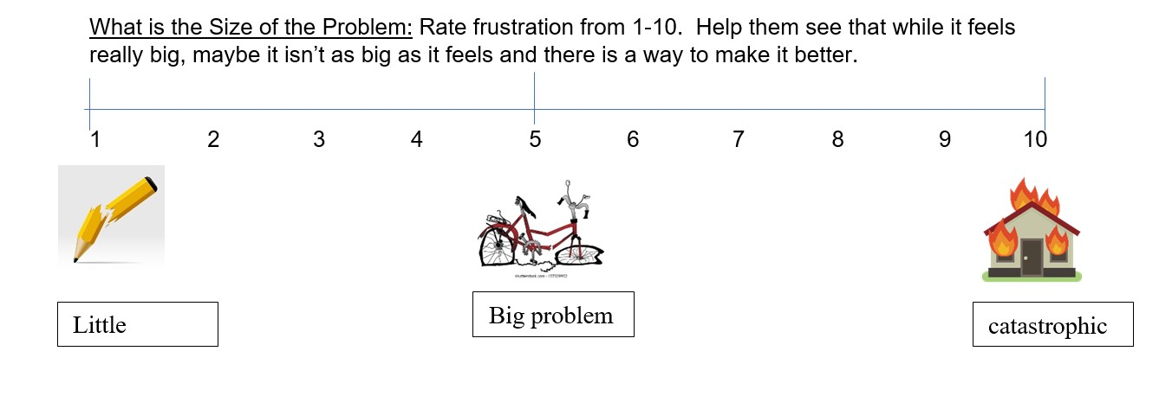
Movement is one of our best tools!
- Endorphins are released: energetic, motivated and happy
- The more signals our brain sends and receives, the more efficient the synapses within the brain are for later learning
- The more senses used during play/learning, the easier it is for our brain to store and retrieve information for later and more efficient use
- Exercise 3x/week, 20 min (sweating) is same as a therapeutic dose of anti-depressants
Specific Behaviors and Strategies to Try
- Task Initiation- starting anything
- -Warm up activities with movement, music, muscles
- -Chunk work and build in motivators
- -Set a timer and turn activity into a game
- -Turn sand timer over and work until the timer is out of sand
- -Make it fun
- -Sing a “work” song that ends when work ends
- -Snacks, gum or drinking something-the mouth is like the computer terminal to the brain
- -Expectations… are they appropriate?
- Listening Issues
-Use very few words: first/then
-Provide a visual with your instruction
-Go slow and WAIT (7-10 sec)
-Be aware of surrounding noise/distractions
-Build in breaks or movement opportunities
-Use fidget or suck/chew while listening
-Dynamic sitting options (lying on stomach, standing)
- Ideation: This gives them the idea of what TO DO and creates clear expectations.
- -USE AS FEW WORDS AS POSSIBLE
- -USE VISUALS- real life pictures in first/then format
- -Won’t get stuck on the behavior we don’t want to see
For example:
  - “Don’t hit” vs. “Gentle hands”
  - “No computer” vs. “Let’s look at the book” or “First book, then computer”
- Trouble with Changes in Routine: Kids who depend on structure and predictability for
self-regulation melt with change.
-Prepare them through picture schedules then WAIT
-Distract during walk: find the letter “g”, game of “I Spy” or count the yellow things
-Incorporate heavy work
-Visual timers help kids see how long they have until their next transition
-Sporadic special events (birthday parties, assemblies at school) may not be appropriate for them
-Allow for the child to have some control (choice board)
-Social story that shows how to transition or act with change
-Structure: If your child knows the general sequence of the events in their day, they can better anticipate and prepare for it

- Calming Down
- -Sensory Features: calming music Turn down lights
- -Body work: deep breathing, heavy work
- -Model Calm: Foster calmness by speaking with a low volume and pace, have a quiet body
- -Images: Picture prompt of quiet body
- Frustration
-Recovery may become focus versus engagement/participation
-Refrain from talking the child through the moment
-Allow for a break or change in scenery before problem solving
-Picture prompts and simple “first/then” commands
-Try to create environments that are organized, clutter free, dim lights with calming/quiet music
- Frustration with work or production
-Allow extra time to process
- -Teach deep breathing
- -Make sure it is the “just right challenge”
- -Take turns doing some of the work
- -Use technology to aide in work
- -Break up activities that are difficult or multi-stepped with frequent rewards
- -Catch them finding success: even little moments
- Aggression
- -Deep pressure into shoulders, bear hugs
- -Time in a different space, dark corner with different textures
- -Fidgets that allow you to squeeze
- -Use muscles: heavy work
- Self-Injury
- -Deep pressure (replacement)
- -Distraction toward movement or heavy work
- -Replace behavior: if they are biting, give them something oral. If they hit head, give heavy input into shoulders
- -Consistent, simple and immediate jargon, consequence, reinforcement
- Meltdowns
- -Don’t talk it out in the moment: fight/flight
- -Consider sensory aspects of space
- -Remember communication
  - Have they expressed their needs?
  - Simplicity with communication: steps, jargon
- -Build in control for the child
- -Rock in a chair or hammock: linear movement is calming
- -Put your head lower than your heart: bring down blood pressure
- Tantrums- see handout for how to deal with a tantrum episode

- Creating Moments for Communication, Family Time, Connection
-Love Tank: Fill their tank before expecting anything in return, giving criticism, pushing them to perform or conform
-Bucket Filling: How can you make someone feel good? What fills your own bucket?
-How did you fill someone’s bucket today?
-What could you do tomorrow to make someone smile?
-Did someone fill your bucket? How?
-How was your day?
  - What is something you did today that was BRAVE?
  - What is something you did today that was KIND?
-Mealtime (or any shared moment) should be a time for connection
-opportunity to share thoughts, feelings, and ideas, even if food isn’t involved.
-Your energy influences theirs—model the behavior you want to see.
-Identify what motivates your child to create an effective reinforcement system
-forced-choice menu or inventory (see attached examples)
-See the strengths: Table of Awareness
-changes how you are looking at a situation, wiring, and behavior
- helps you find tools and strategies to support maladaptive behaviors
BEHAVIORS/WIRING | STRENGTHS | GOALS
Impulsive | Eager to help, enjoys being independent | Listen to all steps of instruction or use a strategy to remember steps and complete on their own
Excitement and zest for life (almost puppy-like; fun and positive) | Positive, creative, kind and empathetic, excited with new activities | Find strategies that help decrease interruption when someone talks
Limited attention span | Engaged and is often listening even when it doesn’t look that way, often asks for help | Use tools to increase follow-through with homework or chores
Difficulty reading peers and adjusting to their non-verbal cues. Often engaged in peer arguments and are frequently getting in trouble | Enjoys peers and likes to make others laugh. Doesn’t seek extra attention, but does enjoy it | Learn to wait, observe, plan and then execute. May need help with any of these steps

-5 Steps to a Meaningful Apology: We all make mistakes, and sometimes our reactions as adults don’t meet the needs of our child. When that happens, it’s important to acknowledge it and move forward. Never be afraid to apologize, but when you do, take the opportunity to express how you wish you had responded. This shows your child that you’re working to adjust and that next time, you may handle the situation differently.
- Acknowledge the mistake: Say, "I am sorry for..." and clearly state what you did.
- Take responsibility: Own your actions by saying, "I made a mistake..." or "I overreacted because..."
- Explain how you'll do better: Share a plan for change, e.g., "Next time, I will..." (be specific about what you will start or stop doing).
- Ask for forgiveness: Give the other person space to respond.
- Express gratitude: Thank them for listening or for helping you find a better way to handle things in the future.
***this process helps your child learn the skills to own their behavior and understand it so they can problem-solve how to prevent it from happening again***

IEP and 504 Special Education Process:
-Referral for special education evaluation.
-Evaluating child's eligibility for special education services.
-Scheduling the IEP Meeting.
-Developing the initial IEP.
-Providing special education and related services.
-Monitoring the child's progress.
-Reviewing the child's IEP and performing reevaluation as needed
IEP and 504 “Must Knows”:
-Parents can call an IEP/504 meeting at any time
-Advocacy groups are available to support families, the team and IEP process (Nevada PEP….NVPEP.org)
-Parents are equal members of the IEP team
-Part of IDEA law is the Least Restrictive Environment (LRE)- services are provided in the general education setting with children who are not disabled, to the greatest extent possible. The type of classroom is based on your child’s needs not the type of disability.
-The school and family are on the same team to find what is best for a child in the school setting

