Name: ______________________________________________Date: _____3/11/25____________
Choice for Today- This is the fun stuff for HARD WORK!

Rules:
- _____________________________________________________
- _____________________________________________________
- _____________________________________________________

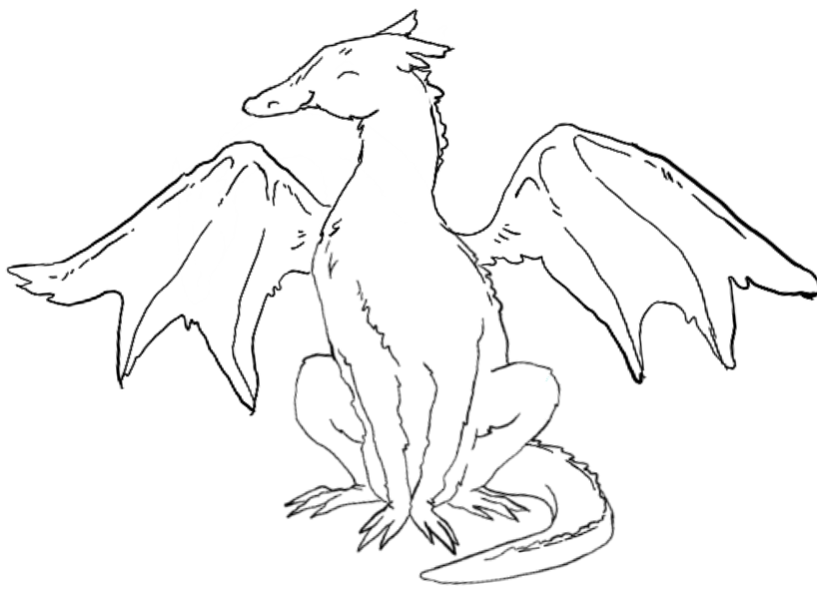

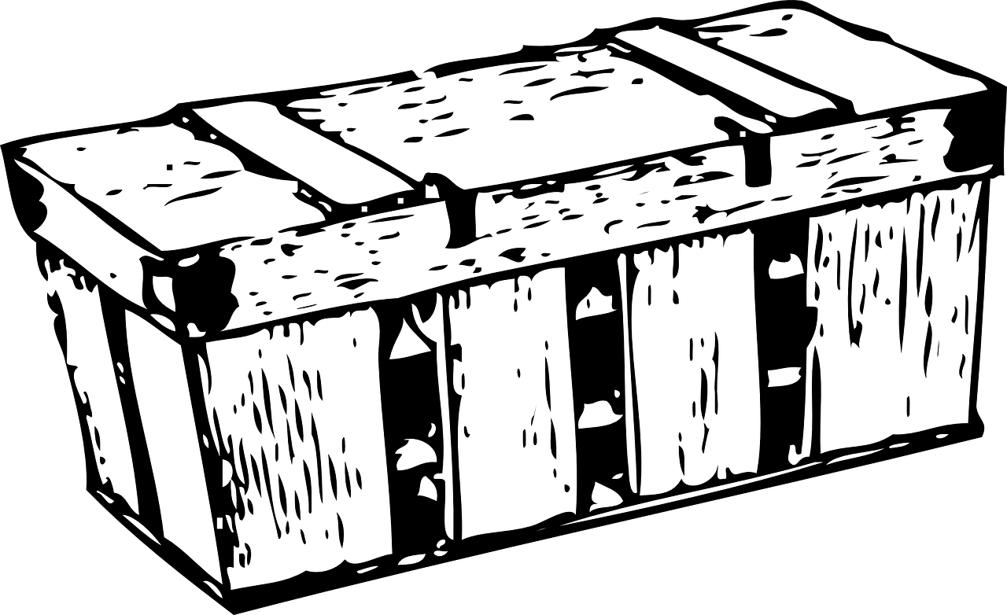
WIZARDS BOX

Positive Behavior System: Instructions for Use of the Dragon and Wizard Visual
This can help build appropriate behaviors at school by starting at home and making it achievable especially at first. (Maybe give warnings, easy time intervals, etc).
This is how it works:
1. Identify positive goals or rules you want to see
    - Use my tools when I am upset (breathing, different space, break)
    - Gentle hands
    - Inside voice
2. Choice of the day: the reinforcer the child gets when the Dragon has changed color to ALL Green
**this reward is specific to dragon training and is only effective if used ONLY for this task
3. Lines next to the dragon, indicate an interval of time (get up, get dressed, breakfast, get on bus) and this depends on child’s ability, coping strategies, response to this system, etc
4. Wizard Chest: any time intervals that weren’t successful are put in the chest so the child can see which rules were not followed during that time, but not all is lost… the wizard can help make this easier tomorrow

