Name: ______________________________________________Date: _______________
Reward:

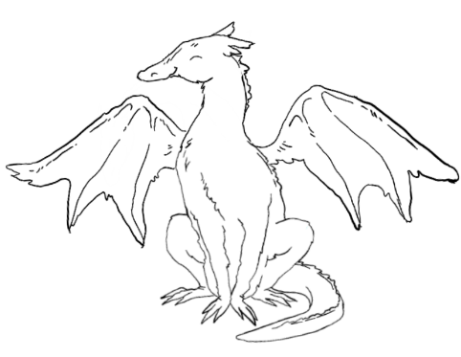
Rules:
- _____________________________________________________
- _____________________________________________________
- _____________________________________________________

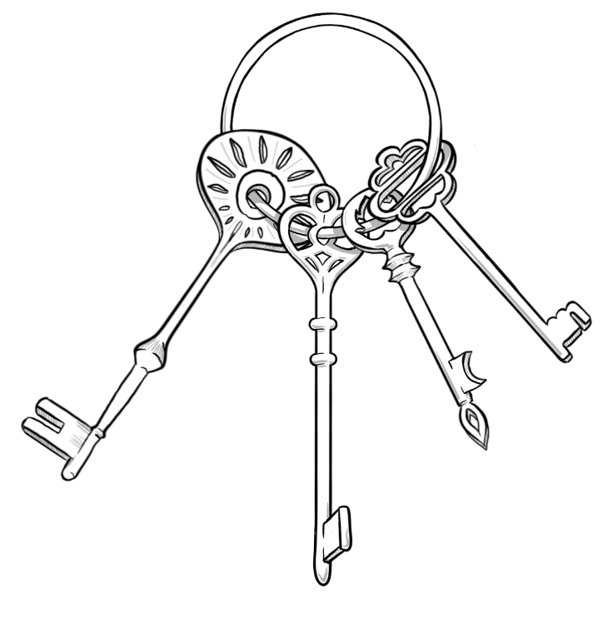

For every ______ minutes(s) that you follow the rules, color in a key to unlock the secrets to training YOUR dragon!

KEYS TO UNLOCK THE SECRET TO DRAGON TRAINING- Dragon Key Visual
- Discuss the reward with your child and write it in the designated box.
- Review the rules using positive language, focusing on what you want to see.
- Remind your child about dragon training—consider showing them their certificate for being a master dragon tamer.
- Display pictures or a short list of tools and strategies that you and your child can use to train their dragon.
- Determine the time period for working on this behavior. Younger children benefit from shorter time frames, so consider using smaller rewards more frequently.
- Specify the duration for assessing whether your child followed the rules—longer time frames should correspond with bigger rewards.

