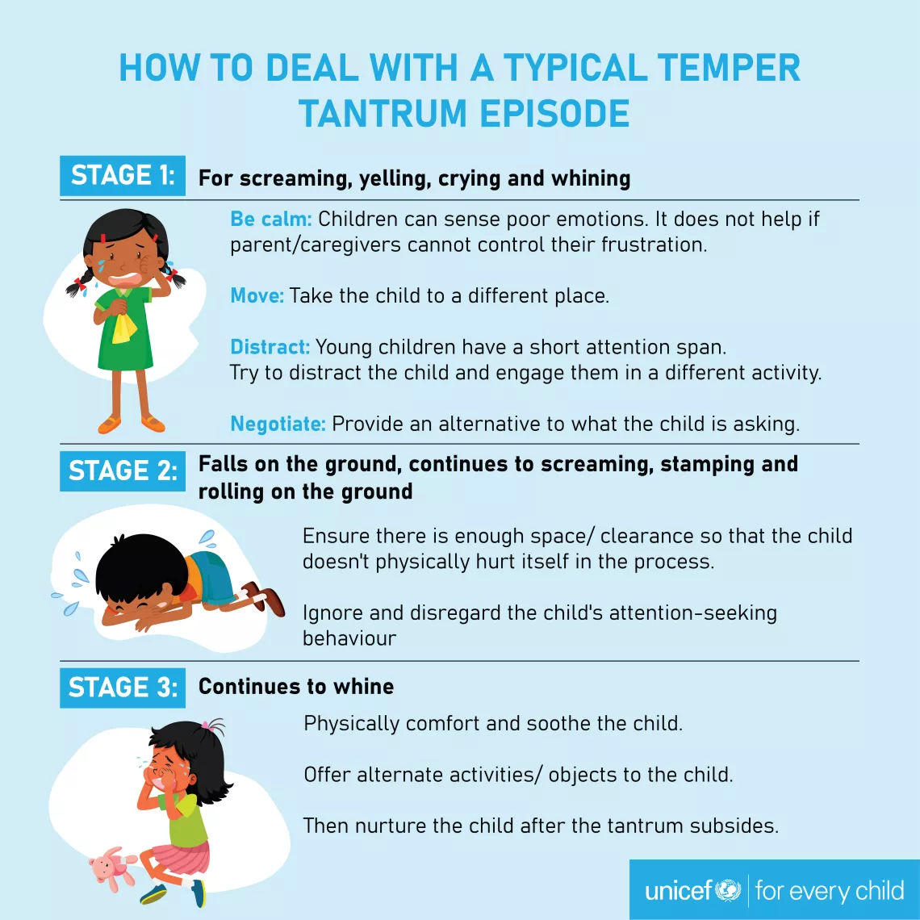

- Discuss expectations before going in public
- Have a positive reward plan- hand them a puzzle piece when you catch them being good
- Build in control for minor things: do you want a banana or apple?
- Be aware of other issues: tired, hungry, sleepy, thirsty, cranky
- Stand your ground and don’t give in or it will get worse next time. Don’t be afraid to use your most powerful weapon: the exit.
- \
- Distract before behavior deteriorates by keeping them busy: push the cart, play I SPY, fidgets
- Remind yourself that tantrums don’t mean you are a bad parent
- Remember to gauge YOUR emotions and responses: you are the rock they depend on for regulation so be calm, use low volume, move slowly, and breathe

