Morning Routine  Get up | 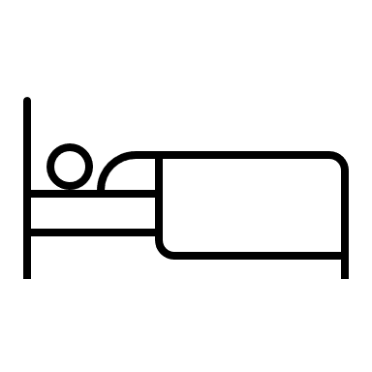
Get dressed- animal walk to closet, jump, stretch | 
Reward (tv with breakfast? Workout with parent?)
Breakfast- look for the blue, this is where we eat today | 
Walk to Bus- lunge walks, animal walks | 
WHY WE USE A VISUAL SCHEDULE
-Increases communication because we can SEE what is coming and adjust, problem-solve, or role play
-Increases focus because the break/reward is visible and kids see their progress and can cross things off
-Decreases anxiety because kids see what is coming so we can help support areas of potential difficulty
-Easy way to see where to build in sensory and movement into schedule
Reminders for Success:
-First thing to talk about is FUN! This is the motivator (dopamine)
-Use colors for different activities and for rewards
-Have the child help with the planning of this schedule
-Talk about how the schedule went at the end of the day
-Did they feel good? Anything need to change?
-Did they use tools when they were struggling?
-Don’t forget to schedule exercise, doctor appts, time with friends
-Plan for tomorrow with what you learned from today
Afternoon Routine
Walk from Bus home- jump, animal walks
Snack- Look for blue, this is where you eat | 
Reward (screen time 10 min. , dragon den with music)
Homework/Quiet Time/Reading- look for orange, this is where you work | 

Evening Routine  Wash hands for dinner | 
Set the table, bring food to the table | 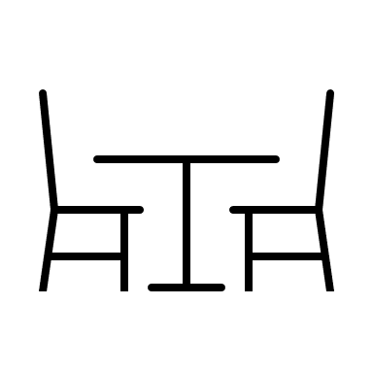
Dinner time-where are we eating tonight? Look for Blue | 
Reward (tv or game 15 min? Workout with parent?)
Brush Teeth | 
PLAN FOR TOMORROW
Bedtime

