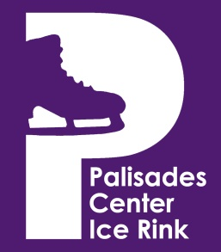

**Covid-19 Safety Protocols & Health Measures**

Our No.1 priority is to keep our participants, guests, tenants, and staff healthy while providing exceptional on-ice programming. To do this, we are taking many steps to keep everyone safe. Remember we are all in this together and we need your help to keep everyone safe.

PCIR strictly adheres to all CDC, New York State, and Rockland County Health Department guidelines and mandates

· Please do not enter this facility, if you’re feeling or showing symptoms of any communicable disease

· High-risk customers are encouraged not to enter the facility

· Dedicated cleaning and disinfecting of bleachers, player benches, rest rooms, and common areas with new Electrostatic Foggers containing virus-killing Botanical Disinfectant Solution

· Only 1 parent or guardian per program participant is allowed inside the facility

· Hand sanitizer has been placed throughout the facility

· Facility square footage is sufficient to allow social distancing

· Rink capacity has been reduced to adhere to state guidelines, 25 players allowed on ice.

· All employees are subject to health checks including temporal thermometer scans prior to entering the facility

· All employees are to wear gloves and facemasks (as mandated) and will be required to wash or sanitize their hands regularly

· Vending service has been suspended and showers are closed

· Customers will enter through the LEFT front doors and exit through the RIGHT front doors

· All customers are required to wear masks in the building. Masks are not required for skaters when on the ice, but coaches must wear masks on the ice.