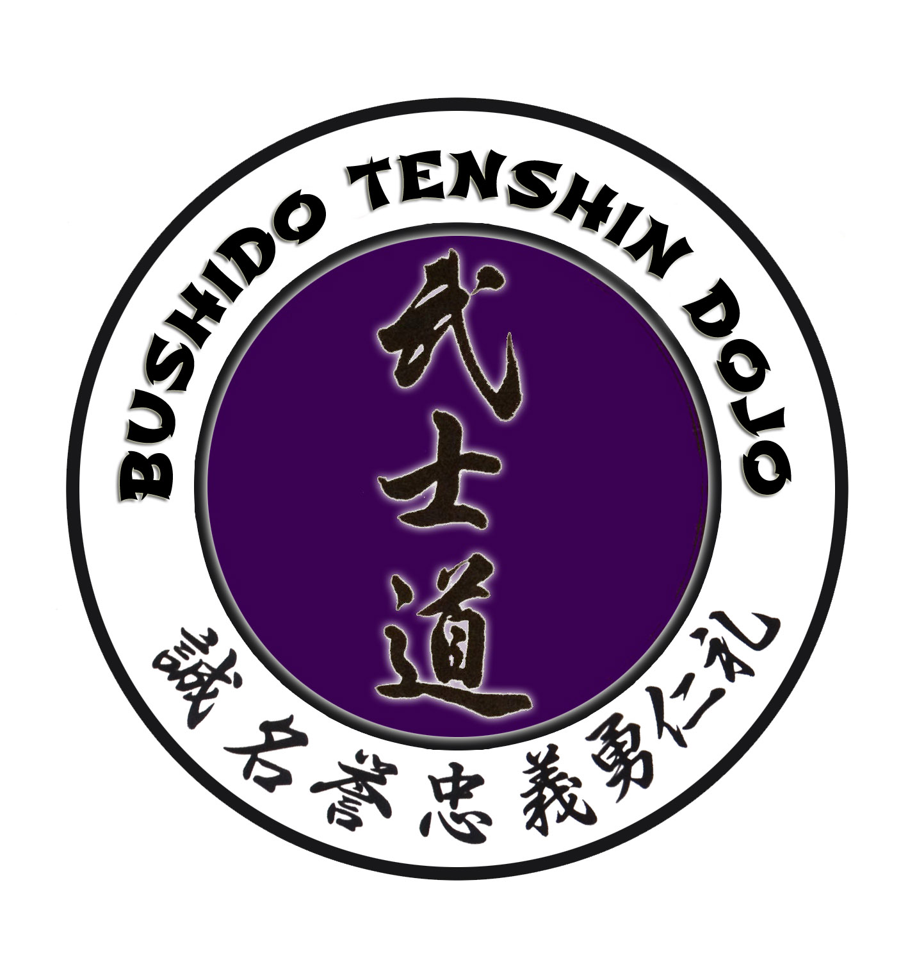

BUSHIDO TENSHIN AIKIDO KIDS TESTING REQUIREMENTS

12TH KYU (Ju Ni) YELLOW BELT 1-3 MONTHS 30 HOURS OF TRAINING

ATEMI KAO-TSUKI MUNE-TSUKI SHOMENUNCHI YOKOMENUCHI KO-YOKO
KIHON UKEMI MAE UKEMI MAE SUTEMI USHIRO UKEMI (tachi & swariwaza) & USHIRO SUTEMI
GERI WAZA MAE GERI YOKO GERI MAWASHI GERI USHIRO MAWASHI GERI
TAI SABAKI TENKAN TAI NO TENKAN IRIMI SHIKKO KATATE DORI TENKAN KATATE DORI TENKAN KOKYUNAGE

11TH KYU (Ju Ichi) ORANGE BELT 3 MONTHS 30 HOURS OF TRAINING. ALL PREVIOUS TECH.

KATATE DORI SURIAGE TENKAN SHOMENUCHI SURIAGE & SURIAGE TENKAN KAO-TSUKI SURIAGE & SURIAGE TENKAN
KOSA DORI TENKAN KATA DORI SOTO KIRI TENKAN YOKOMENUCHI SURIAGE & UKENAGASHI TENKAN
MAE GERI SURIAGE RYOTE DORI KOKYU DOSA

10TH KYU (Ju) BLUE BELT 4 MONTHS 50 HOURS OF TRAINING

MUNETSUKI KAITEN NAGE SHOMENUCHI IKKYO ( OMOTE / URA ) SHOMENUCHI IRIMINAGE (OMOTE / URA) RYOTEDORI TENCHINAGE KATATE DORI SHIHOUNAGE ( OMOTE / URA ) RYOTE DORI KOKYU DOSA
^{RANDORI 2 UKE KATE DORI}

9TH KYU (Ku) GREEN BELT 4 MONTHS 40 HOURS OF TRAINING

SHOMENUCHI SURIAGE KOTEGAESHI KATATE DORI IRIMINAGE ( OMOTE / URA KOSA DORI IKKYO ( OMOTE / URA ), KATATE DORI TENKAN KOKYUNAGE YOKOMENUNCHI KOTEGAESHI MAE GERI (KICKING TECHNIQUE)
( RANDORI) 2 UKE RYOTE DORI KOKYU DOSA

8TH KYU (Ha chi) GREEN BELT WITH BLACK STRIP 5 MONTHS 50 HOURS OF TRAINING

KATAKE DORI IKKYO (OMOTE & URA), KATAKE DORI SAYUNAGE KATAKE DORI SHIHOUNAGE (OMOTE & URA) YOKOMENUCHI SAYUNAGE KOSA DORI KOTEGESHI ), KATATE DORI TENKAN KOKYUNAGE
MAE GERI (KICKING TECHNIQUES) ( RANDORI) 2 UKE

7TH KYU (Shi Chi) PURPLE BELT 5 MONTHS 50 HOURS OF TRAINING

KATATE DORI SHIHONAGE OMOTE & URA KATATE DORI SURIAGE KOTEGESHI TENKAN
KATATE DORI KAITENNAGE OMOTE & URA SHOMENUCHI KAITENNAGE
MUNETSUKI KOTEGESHI MUNETSUKI SAYUNAGE MAE GERI (KICKING TECHNIQUE)
^{RANDORI 2 UKE}

6TH KYU (ROKO) PURPLE BELT WITH BLACK STRIP 6 MONTHS 60 HOURS OF TRAINING

YOKOMENUCHI IRIMINAGE YOKOMENUCHI IKKYO OMOTE & URA
YOKOMENUCHI NIKYO OMOTE & URA KOSA DORI NIKYO OMOTE & URA KATATE DORI NIKYO OMOTE & URA

5TH KYU (Go) RED BELT 6 MONTHS 60 HOURS OF TRAINING

USHRIO RYOTE KATATE DORI SHIHOUNAGE USHRIO RYOTE KATATE DORI SAYUNAGE USHRIO RYOTE KATATE DORI IKKYO OMOTE & URA USHRIO RYOTE KATATE DORI KOTEGESHI USHRIO RYOTE KATATE DORI KOKYUNAGE

4TH KYU (Shi) RED BELT WITH BLACK STRIP 7 MONTHS 70 HOURS OF TRAINING

SHOMENUCHI IKKYO, NIKYO, SANKO & YONKYO OMOTE & URA
YOKOMENUCHI IKKYO, NIKYO, SANKO & YONKYO OMOTE & URA

3TH KYU (San) BROWN BELT 7 MONTHS 70 HOURS OF TRAINING

SUWARIWAZA SHOMENUCHI IKKYO, NIKYO, SANKO & YONKYO OMOTE & URA
SUWARIWAZA YOKOMENUCHI IKKYO, NIKYO, SANKO & YONKYO OMOTE & URA

2ND KYU (Ni) BROWN BELT WITH BLACK STRIP 8 MONTHS 80 HOURS OF TRAINING

SUWARIWAZA MUNETSUKI KOTEGAESHI SUWARIWAZA KATATE DORI SHIOUNAGE
SUWARIWAZA MUNETSUKI KIATENNAGE
SUWARIWAZA YOKOMANUCHI SHIHOUNAGE

JUNIOR BLACK BELT UNDER THE AGE OF 16 1 YEAR AFTER 1ST KYU

SHOMENUCHI IKKYO, NIKYO, SANKO & YONKYO OMOTE & URA
SUWARIWAZA SHOMENUCHI IKKYO, NIKYO, SANKO & YONKYO OMOTE & URA

JIYU WAZA 3TECHNIQUES FROM ACH ATTACK
TECHNIQUES REQUESTED BY CHIEF INSTRUCTOR JOHN ARAUJO SHIHAN

