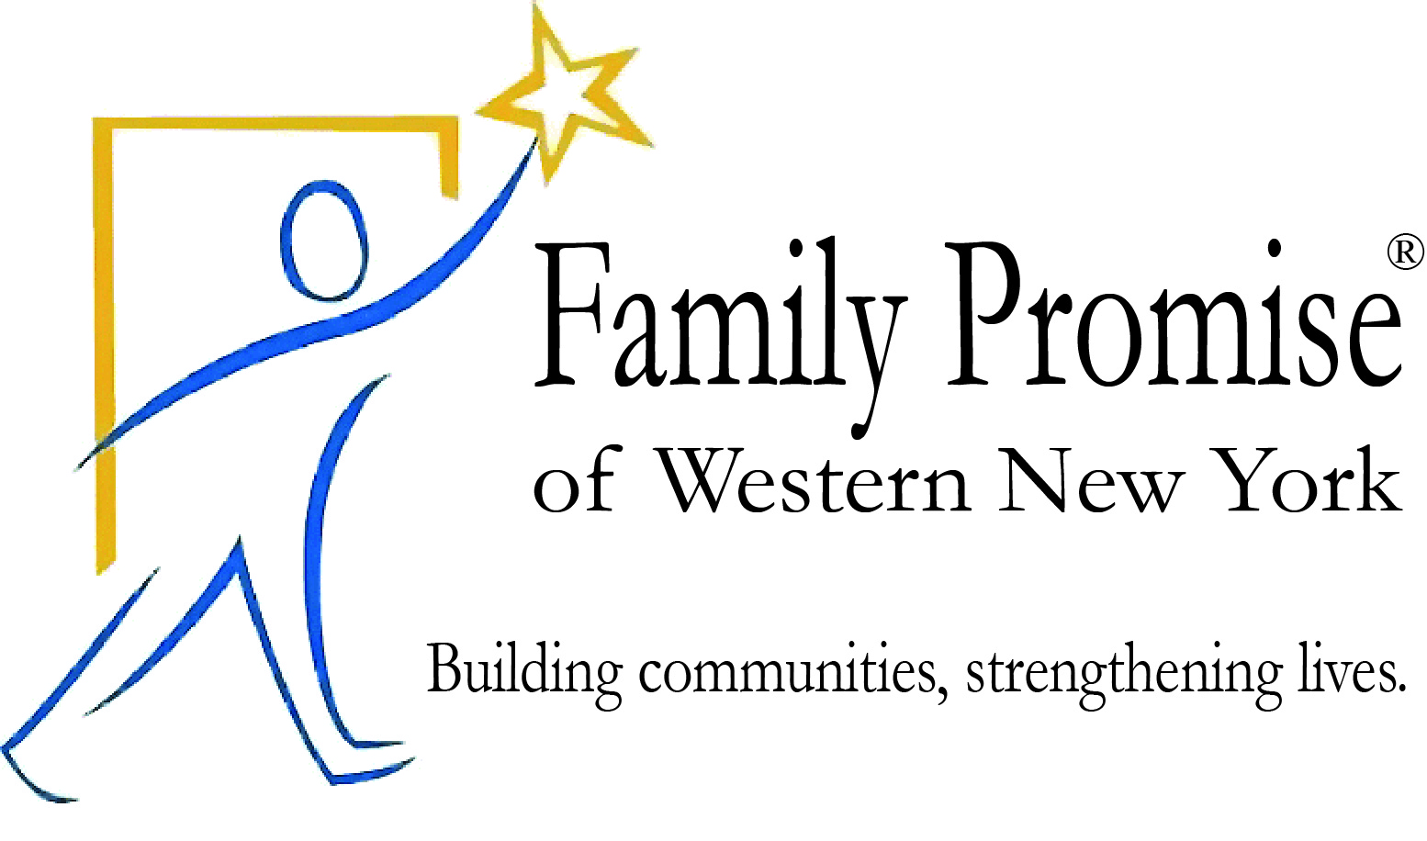

75 Hickory St.
Buffalo, NY 14204
Phone: 716-771-3007
Website: www.fpwny.org

Executive Director Job Description

Objective
To direct Family Promise of WNY (FPWNY), an emergency homeless shelter program for families with children in Erie County. The Executive Director is responsible for coordinating all program components for the effective provision of services to the program clients (guests).
Responsibilities
- Manage a network of host congregations, volunteer coordinators and volunteers.
- Provide leadership and direction to staff and volunteers daily.
- Oversee case management of the guest families, including tracking guests’ progress and providing data and reports to the Board of Trustees.
- Maintain operations at the Family Resource Center.
- Manage scheduling and any other logistical matters.
  - Organize and schedule safe transportation for the guest families.
  - Coordinate the schedule of host congregations and keep all parties informed.
- Communicate regularly with the referring and supporting agencies; maintain a close relationship with the Erie County Department of Social Services Homeless Division.
- Actively participate with the relevant provider groups and agencies.
- Conduct volunteer trainings as needed, including training all new host congregations.
- Plan and lead quarterly volunteer coordinator meetings.
- Keep current with state and federal employment laws and regulations.
- Maintain records on affiliate operations.
- Perform office administrative duties such as bi-monthly payroll, compliance with income tax obligations, handling A/R and A/P, ensuring the organization is properly insured, etc.
- Provide monthly data and financial reports to the Board of Trustees.
- Orchestrate fundraising events with support of Board, staff and volunteers.
- Prepare grant applications.
- Prepare annual reports for Family Promise.
- Hire and supervise staff under Board guidance, including caseworker, administrative support and van driver.
- Manage daily expenses within the latest approved budget.
- Manage other operational duties as instructed by the Board.
- Work with the Board President to plan Board meetings. Work with and support Board Committees as required.
- Represent FPWNY to the public and to the media.
- Additional duties, as assigned by the board of trustees.

Accountability
The Executive Director reports to the FPWNY Board through the Board President.
Qualifications
The successful candidate for Executive Director should be enthusiastic and passionate about helping families experiencing homelessness and should demonstrate strong interpersonal skills.
Education & Experience
- Four-year college degree
- Three years of experience in nonprofit management and coordination of volunteers
Skills
- Leadership: Ability to make decisions, solve problems, delegate tasks and responsibilities, and consult with Family Promise®, Board members, and local partners.
- Organization: Ability to effectively prioritize and handle multiple tasks simultaneously.
- Communication: Ability to make effective written and oral presentations, including speaking to large groups.
- Interpersonal: Ability to work effectively with a wide range of people.
- Counseling: Ability to work effectively with clients in a social service setting.
Working Hours
The Director works a 40-hour week. After-hours and on weekends, the Director is on call for emergencies. Calls originate from the volunteer coordinators or board members, as needed.
Salary range: $35,000 - $40,000, depending on skills and experience

Interested candidates should submit their resume and cover letter to resume@fpwny.org by Friday, August 11th. Review of submissions will begin immediately.

