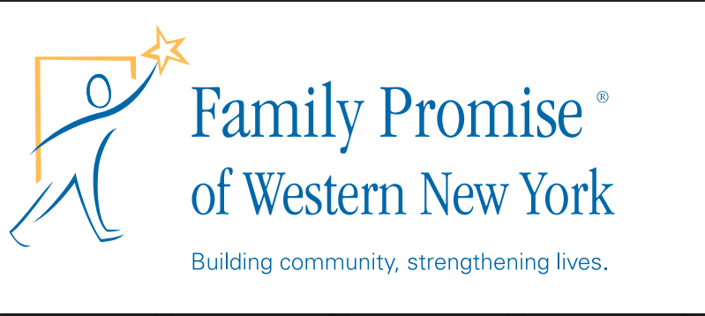
75 Hickory Street
Buffalo, NY 14204
Phone: 716-771-3007
www.fpwny.org

Volunteer Interest Sheet
Thank you for your interest in supporting the homeless children & families we serve!
Family Promise of WNY is powered primarily by volunteers -
we cannot do what we do without your help!

Name: _____________________________ Today’s Date:________________

Email: ________________________ Phone Number: _______________

Address: ___________________________________________________________

Congregation Affiliation (if any) ___________________________________________

Please check ALL volunteer roles that interest you and we’ll be in touch!

- Bring a hot dinner to our day center and eat with our families _____

- Become an advocate for Family Promise at your faith community _____

- Offer a 3-hour weekend hospitality shift at our Day Center _____

- Drive our Saturday morning grocery shuttle or be a substitute van driver _____

- Serve as an Office Angel at our Day Center _____

- Apply for our Board of Trustees or serve on a board committee _____

- Volunteer for a weekend or overnight hospitality shift somewhere in our network _____

- Organize a Donation Drive or plan a fundraiser _____

- Help keep our Day Center (organize donations, vacuum, clean the fridge, etc.) _____

- Join our “Fairy Dust” team to help deep clean spaces when families depart _____

Training is required for volunteer slots which involved direct engagement with our guests.

Please indicate Your Availability:
Monday | Tuesday | Wednesday | Thursday | Friday | Saturday | Sunday

