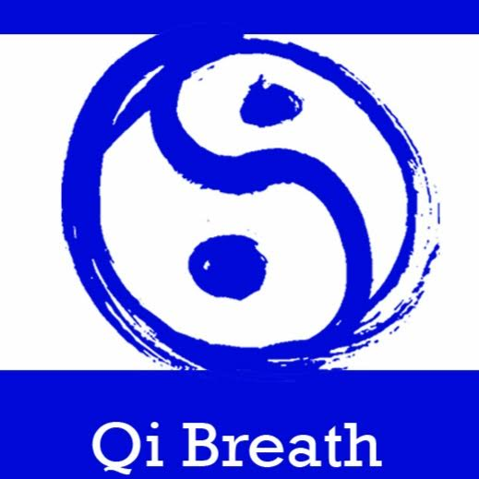

Qi Breath Arts Media Consent and Release Form

You agree and understand the Session/Workshop may be filmed, photographed and/or recorded and that Monica Silva, the Guide shall have all rights in and to such film, photographs and/or recording, including the copyright therein.

The copyright shall include, but not be limited to, the right to use, re-use, publish, and re-publish and otherwise reproduce, modify, and display any such film, photograph and/or recording for educational and promotional purposes, including without limitation, audiotapes, audio CDs, DVDs, websites, video, or film or any other form of recorded images.

I________________________________________ hereby authorize (Qi Breath Arts) and its partners, agents, representatives, assigns, successors in interest and licensees, to photograph, audiotape, and/or videotape me and grant Qi Breath Arts and its partners the irrevocable right to use my photograph, audio recording, video recording, or any reproduction or modification thereof (the “Photograph,” “Audio,” and/or “Video”), in any manner or medium throughout the world an unlimited number of times in perpetuity in advertising, trade, promotion, exhibition, or any other lawful purpose

You grant Monica Silva, the Guide the right, without compensation to you, to film, photograph and/or record you while participating in the Session/Workshop and you waive any right which you now have or may have hereafter in any such film, photograph and/or recording. You agree to not record by audio, video, photographic or any other means, any portion of the Session/Workshop.

I understand that I will not receive any monetary compensation for the permissions I am granting herein. I hereby waive any right of inspection of approval of the uses to which the Organization may put the Photograph, Audio, and/or Video. I acknowledge the Organization will rely on this permission and hereby release and discharge the Organization from any and all claims and demands arising out of or in connection with the Photograph or the exercise of the permissions granted here, including any or all claims for libel, invasion of privacy, or emotional distress.

I understand that I cannot withdraw my consent after I sign this form and that this consent and release is binding on my heirs, legal representatives and me and assigns.

Please circle "Yes" or "No" for each of the following:

Yes No I grant permission for Photographs to be collected and used by the Organization.

Yes No I grant permission for Audio to be collected and used by the Organization.

Yes No I grant permission for Video to be collected and used by the Organization.

Participant Signature __________________________________ Date ______________________

Participant Address________________________________________________________________________________________________________________________________________________________________________________________

Participant Phone Number ( ) ________-________________

Participant Email Address __________________________________________________________________

if the individual named above is under 18 years of age, please complete the following:

I am the parent or legal guardian of the individual named above, and I hereby sign this Media Consent and Release on behalf of such individual in accordance with the statements above.

Guardian's Name _______________________________________________________________

Guardian's Signature _______________________________________ Date __________________________

Guardian's Address ________________________________________________________________________________________________

Guardian's Phone Number( ) ________-________________

Guardian's Email Address __________________________________________________________________