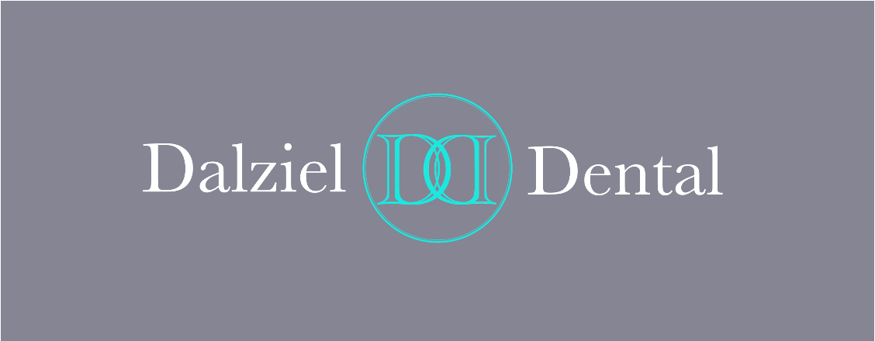
Dalziel Dental
Patient Information Leaflet

Dalziel Dental
1 Dalziel Street
Motherwell, ML1 1PJ
01698251331
dalzieldental@outlook.com

Welcome
At Dalziel Dental we aim to achieve the highest standards possible. Among the services we can provide are routine restorations; crowns, bridges and veneers; dentures; dental implants, hygiene and preventive advice and routine checkups.

New Patients
We provide dental care for adults and children, both under the NHS system and privately. Should you wish to join the practice please contact our receptionist, who will take some details and arrange an appointment for a new patient dental check. Once you have attended the practice and any necessary treatment has been completed we send a form electronically to the NHS which registers you as a patient at the practice. There may be periods when our diaries are especially busy and we decide it is best to stop taking on new patients so we can focus on providing timely treatment for our existing patients.

Dentists
Iain Ogilvie (male) BDS (Hons) Glasgow 2018 GDC no. 277160
Lewis Cowan (male) BDS (Hons) Glasgow 2018 GDC no. 277083
Anne-Marie Tobin (female) BDS Glasgow 1995 GDC no. 70501

Dental Nurses
We have a team of dental nurses who work both in surgery and on reception
Ashley Lyttle, Viktorija Burbaite, Stacey O’Donnell, Kelly Douglas, Amy Lyons

Opening Hours
Monday- Friday 9AM- 5PM (closed between 1-2PM)

Appointments
Telephone 01698251331 (preferred) or visit in person to make an appointment.
We attempt to contact all patients by email to remind them of their appointments the day before, however this is a courtesy and cannot be guaranteed. It is the patient's (or their guardian's) responsibility to make a note of the appointment and remember to attend.
If you are unable to keep an appointment, please try to give us at least 24 hours' notice. Please note that if you miss an appointment, without providing prior notice or give less than 24 hours notice, a charge of £1 per minute will be made.

Interpreters
NHS GG&C no longer provide an in person interpreting service for most dental appointments. Please let us know if you require an interpreter for your appointment and we will arrange telephone interpreting via Language Line.

Emergency and Out-of-hours Care
If you have a dental emergency, telephone us as soon as possible and ideally as early in the day as possible. During opening hours, you will be given an appointment in a time-frame that is appropriate to your needs. If you require emergency care, we will try to see you the same day. If you require urgent care, you will be given advice to help manage the symptoms and seen within 24 hours. If you have a dental emergency when the practice is closed, call NHS 24 on 111.

Charges
Any treatment offered (either NHS or private) will be estimated, discussed and agreed with you in advance, and you can request to be provided with a printed treatment plan.
NHS treatment is free for:
- everyone aged under 26
- people who are pregnant or have given birth in the last 12 months
- those with certificated exemption from patient charge because of income or receipt of certain benefits
Charges for common procedures under the NHS are as follows (guidelines only):
Examination £0.00
X-ray £5.84
Amalgam Filling from £13.48
Root canal treatment from £100.64

Access and Facilities
The practice does not have a car park, but on street car parking is available locally. There are 2 steps up to the entrance, however a movable ramp can be placed if required. If you have any concerns about accessing our services, telephone for advice.

Directions
We are located on Dalziel Street , close to the centre of Motherwell. It is approximately 9 minute walk from Motherwell train station, which also gives access to several bus services.

Practice Policies
The Practice has a number of policies to ensure that we provide the best possible care for our patients. All patient information is processed in line with the Data Protection Act 1998, and is treated with the strictest confidence.

Feedback
We welcome feedback from patients; please contact us with your views, either in person, by post or by email using the practice contact details in this leaflet. We hope that you are happy with the service we provide; however, if you have a complaint please contact our receptionist, who will inform you of our complaint's procedure.

Further Information
On NHS dental provision in the local area can be obtained via the NHS Lanarkshire website at https://www.nhslanarkshire.scot.nhs.uk/services/dental-services/ or by calling NHS Lanarkshire Health Board 01236 748 748.

