

**W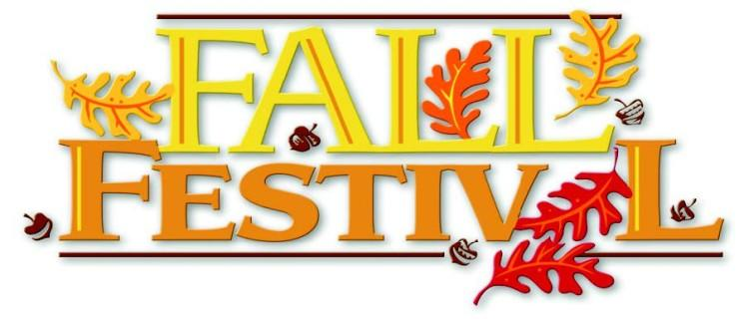ELCOME:** The Maysville Community Improvement Club welcomes you to our 55th annual Autumn Leaf Festival. We invite you to be a part of this northeast Georgia tradition. Each year about 5,000 visitors from around the region come to enjoy the beauty of the area as well as to participate in the festival.We apologize in advance, but this year we welcomed in new members. We had to completely change our vendor/booth numbers(map). We will try our best to make sure you are where you want to be and we all enjoy the Autumn Leaf Festival! Thank you all for everything! Please read the following information and send in the attached application by **August 29th, 2022** to take advantage of our discounted booth fee.

**TIME:**

**\*\* Festival hours**- Starting *Friday at 3:00 pm – 9:00 pm* and *Saturday 9:00 am - 9:00 pm.*

* + Rain or shine event. Vendors are required to be on site all hours and all days.
  + **Security will be provided Friday Night Only**!
  + Unattended vehicles left in the Festival area will be towed at owner's expense. **No vehicles** will be allowed in the Festival area during Festival hours. *All vehicles must be unloaded and removed by 1:00 pm on Friday, and 7:30 am Saturday.*

**VENDOR FEE:**

* + Entry fee for each 12 x12 craft space is **(Early Bird Special)** $65.00 **(on or before August 29th, 2022)**
  + **August 29th** the fee will be **$90.00**
  + Food Vendors fee is **$140.00** by **August 29th, 2022** After **August 29th, 2022** the fee will be **$165.00. (Food venders do not receive a refund)**
  + Children’s/Adult activities, games etc… fee is $150.00 (1 activity or game) - TWO (2) or more + (additional) $50.00 each activity.
  + An authenticity committee will check the booths at the Festival. There will be no yard sale or flea market type items allowed!
* ***NO ONE IS ALLOWED TO SELL SOFT DRINKS (SODAS), WATER ETC.* The Maysville Community Improvement Club is the only booth that will be selling those items listed above!**

**BOOTH SPACE:**

• **Booth spaces** are a 12’ x 12’ space. We ask when giving booth dimensions please BE EXACT! Placement is based on the measurements you provide for us. If measurements exceed more than booth length you must register and will be charged for an additional space.

• Each participant is responsible for their clean-up arrangements before leaving the festival. All areas must be left as found. Food vendors shall remove all used cooking oil from the premises after the event.

**APPLICATION PROCESS:**

• Please fill out the application portion and return it along with your check

***Made Payable to: Maysville Community Improvement Club.***You can email your application to [maysville.comclub@gmail.com](mailto:maysvilleciclub@gmail.com) or to our **P.O Box 273 Maysville, Ga 30558.**

* Keep the “rules” portion for your reference.
* Early Bird Deadline is **August 29th, 2022**. Extra charges will apply for those who enter after **August 29th, 2022**
* Vendors will be limited and will be selected by the Festival Committee.
* A full refund will be given in the event your application is not accepted.
* ***Refunds will not be given after September 9th.***

**• You will receive confirmation of your application on or before September 16th, depending on when the application is received.**

**ADDITIONAL INFORMATION:**

• Applicants shall assume all risks related to participation in the Maysville Autumn Leaf Festival.

• Sidewalks and walkways will not be blocked at any time.

• The Maysville Police Department will patrol the area during the Festival hours and overnight security will be provided Friday and Saturday night. However, because the festival is in an ungated area the Maysville Community Improvement Club will not be responsible for any items left unattended.

**PLEASE FILL OUT BOTH PAGES, SIGN, AND SEND WITH FEES TO:**

* Maysville Community Club@ P.O Box 273 (**only)** Maysville, Ga 30558 or via email to [**maysville.comclub@gmail.com**](mailto:maysville.comclub@gmail.com)
* **CRAFT VENDOR** - early bird price is $65 per space & $90 after **August 29th, 2022**
* **Please indicate if you need electricity** YES______NO _______
* Please tell us a little about your booth & what you will be selling____________________________________________________________________________________________________________________________________________________
* Number of booth spaces needed- ________spaces _______total
* **FOOD VENDOR**- Early Bird Price- $140.00 per space & $165.00 after Sept. 10th (**no refunds given for food spaces)**

**Please initial the following:**

1. I have attached a menu/list of items I wish to sell. _________
2. I understand only one vendor will be allowed to sell any food item. ___________
3. I understand food item availability is on a first come first served basis. _________
4. My trailer/booth set-up is (size)__________ including hitch/tongue, etc. I understand spaces are exactly 12’ x 12’ and that any measurement exceeding space size will require approval for additional spaces to accommodate the entire size of my set-up and I have included such in my registration.

**TOTAL AMOUNT ENCLOSED** $__________

**NAME** ______________________________________________________________________

**ADDRESS** ___________________________________________________________________

**CITY** __________________ **STATE** ________ **ZIP** ___________**PHONE** ( )___________

**EMAIL** ____________________________________________.

I understand the authenticity of my product will be verified during the festival. If I violate these rules stated above, I could be asked to leave the festival without a refund.(Y)_____(N)______

* PLEASE SIGN AND SEND IN WITH APPLICATION: **I acknowledge and certify that I have read and agree to abide by rules established by the Maysville Community Improvement Club. I also hereby agree to release and hold harmless the Maysville Community Improvement Club, its employees and volunteers: The City of Maysville, its employees and volunteers: as well as the owners of any private property that the festival utilizes from any damages, losses due to theft of the undersigned vendor’s property, or for any personal injury, which the vendor or anyone working for the vendor may sustain while participating in the Maysville Autumn Leaf Festival.**

**Signature**: _____________________________________________**__ Date:** _____________________

* **Confirmation will be emailed or mailed out by September 16, 2022**
* **FOR MORE INFO CALL OR TEXT Brittney Brooks Beauchamp (706)499-7565**

***Visit us on the web* @ https://maysvillecommuntyclub.godaddysites.com/**

* **WE ARE EXCITED FOR YOU TO BE A PART OF OUR 55th ANNUAL MAYSVILLE AUTUMN LEAF FALL FESTIVAL!!!**