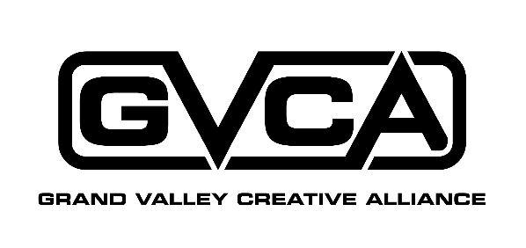

**Application for Board Membership**

Please fill in the following information and return to:

**Grand Valley Creative Alliance Or E-mail:**

**Attn: Board Development Committee info@gvcreates.org**

**PO Box 851 Attn: Board Development Committee**

**Grand Junction, CO 81502**

Date:

Contact Information

Name:

First Middle Initial Last

Home Address:

Mailing Address (if different):

Home Phone Work Phone (optional)

Cell Phone Email

Easiest/Best way to contact me ________

**About Me:**

Have you served on boards or committees for other organizations? If yes, please list:

What are your goals for serving as Grand Valley Creative Alliance Board Member?

What role do you think the Grand Valley Creative Alliance should serve in the community?

What special strengths, talents, or skills can you bring to the Grand Valley Creative Alliance Board?

Which of the following areas interest you and why?

Finance

Grant Writing Marketing Fund Raising

Special Events

Long Range Planning & Development

I’d like to be involved in the following committees: Advocacy/Community Art Partners (organizations)

Outreach/Community Arts Network (individuals)

MakerSpace

Grand Valley Open Studios Tour

Please attach a brief biography and/or resume.

Thank you for your interest in the Grand Valley Creative Alliance.