**Author Guest**

**Mike Thompson**

***Northern Virginia Author & Illustrator***

**Order Autographed Copies:**

**Student Name: _____________________________________________________________________**

**Teacher Name: _____________________________________________________________________**

Cash or check accepted. Please make checks payable to “Thompson Original”



**Chicken Boy and the Wrath of Dr. Dimwad**When an ordinary chicken is fed radioactive birdseed, he is granted amazing powers! But is it enough to stop the dreaded Dr. Dimwad? Join Chicken Boy in his quest to save the world!

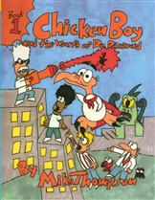

**Price: 9.95 each**

**Qnty: ________**



**Chicken Boy and the Destruction of the Doggy Doo Doo Demons**

Professor Big Nose has engineered his latest creation, a radioactive goblet. Any inanimate substance that is placed into it is brought to life. But, when the wrong substance falls into the goblet, things get messy! Join the Winged Defender in his second epic adventure!

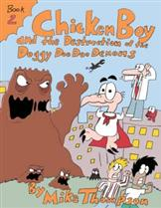

**Price: 9.95 each**

**Qnty: ________**



**Chicken Boy and the Fight of the Ferocious Flowers**When the Doggy Doo Doo Demons were defeated, they were turned into manure. Unfortunately, they were still radioactive. Now, anything planted in the manure becomes a hideous monster! Join Chicken Boy and all his friends, as they discover that the grass is meaner on the other side…

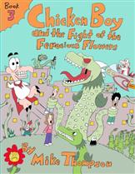

**Price: 9.95 each**

**Qnty: ________**



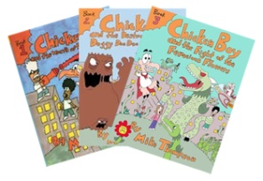

**Chicken Boy Series Bundle**

All three of Chicken Boy’s epic adventures for a reduced price.

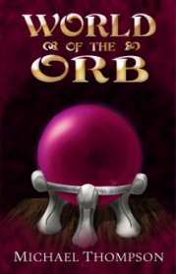

**World of the Orb**

(Reading Level: Middle Grade/Young Adult) Best friends Marvin and Andy have discovered the Museum of Natural History’s unnatural secret: The Orb, a mysterious relic that plunges these two modern teens into a medieval world of monsters, myths, and magic, and sets them on a treasure hunt to find Earth again.

***Also Available…***

**Price: 18.99 each**

**Qnty: ________**

**Price: 28.00 each**

**Qnty: ________**