Author Guest
Mike Thompson
Northern Virginia Author & Illustrator

Order Autographed Copies:

Student Name: _____________________________________________________________________

Teacher Name: _____________________________________________________________________

Cash or check accepted. Please make checks payable to “Thompson Original”

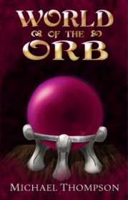

World of the Orb

Best friends Marvin and Andy have just discovered the Museum of Natural History’s unnatural secret: The Orb, a mysterious relic that plunges these two modern teens into a medieval world of monsters, myth, and magic. To return home, they must embark on a global treasure hunt to unite five elemental crystals, all while eluding the eye of a tyrannical warlock bent on conquering the Realms. This isn’t the field trip they expected…

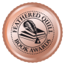
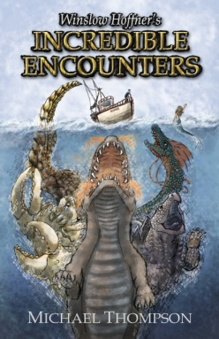
Price: 18.99 each
Qnty: ________
Price: 15.99 each
Qnty: ________
Winslow Hoffner’s Incredible Encounters

For most, Bayfield is a quaint, unassuming harbor town. For some, the decades-old headlines alleging unexplainable sightings of strange creatures in the water tell a different story. For a select few, the truth behind these legends, speculations, and folklore is more than a mere mystery: There’s magic in the bay. And for local fisherman Mr. Winslow Hoffner, it’s all just a matter of finding yourself in the wrong place at the right time...

