Author Guest
Mike Thompson
Northern Virginia Author & Illustrator

Order Autographed Copies:

Student Name: _____________________________________________________________________

Teacher Name: _____________________________________________________________________

Cash or check accepted. Please make checks payable to “Thompson Original”

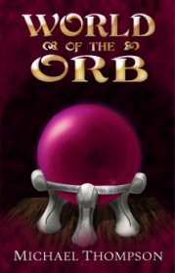
World of the Orb

Best friends Marvin and Andy have discovered the Museum of Natural History’s unnatural secret: The Orb, a mysterious relic that plunges these two modern teens into a medieval world of monsters, myths, and magic, and sets them on a treasure hunt to find Earth again.
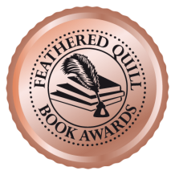

Price: 18.99 each
Qnty: ________
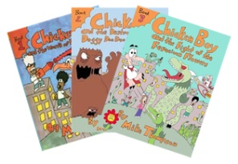
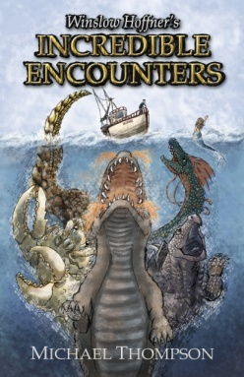
The Chicken Boy Series

When an ordinary chicken is fed radioactive birdseed, the small town of Oakwood takes a turn for the extraordinary, and a brand new superhero is hatched! With the help of his friends, Chicken Boy the Winged Defender takes on mad scientists, monsters, and more in this action-packed, funny, and charming trilogy of illustrated children’s chapter books.
Bundle (Complete Trilogy): 28.00 each
Qnty: ________
Book 3: 9.95 each
Qnty: ________
Book 2: 9.95 each
Qnty: ________
Also Available…
Book 1: 9.95 each
Qnty: ________
Price: 15.99 each
Qnty: ________
Winslow Hoffner’s Incredible Encounters

For most, Bayfield is a quaint, unassuming harbor town. For some, the decades-old headlines alleging unexplainable sightings of strange creatures in the water tell a different story. For a select few, the truth behind these legends, speculations, and folklore is more than a mere mystery: There’s magic in the bay. And for local fisherman Mr. Winslow Hoffner, it’s all just a matter of finding yourself in the wrong place at the right time...

