**M A Y 2 0 2 5**

***Inner*** *Voice*

**Newsletter of New Freedom Intergroup of OA**

**Step 5:** Admitted to God, to ourselves and to another human being the exact nature of our wrongs.

**Tradition 5:** Each group has but one primary purpose — to carry its message to the compulsive overeater who still suffers.

Around the World: The 65th Birthday of the OA Fellowship Celebrated in Poland

***The 65th birthday of the Overeaters Anonymous fellowship was celebrated in Poland, commemorated with a unique online meeting entitled “What was born to me?”***

The meeting gathered community members who wished to celebrate this special moment and share their experience. The meeting started with speeches by two speakers who spoke in an inspiring way about their recovery process, challenges and changes that took place in their lives thanks to their membership in the OA fellowship. Their testimonies aroused reflection and hope in the participants for further development within the spirit of the OA Twelve Steps programme.

The meeting was attended by 44 persons who actively shared their stories and thoughts. In an atmosphere of mutual support and acceptance, participants had the opportunity to celebrate not only the anniversary of the fellowship, but also their own progress in the recovery process.

The participants most often identified abstinence, emotional sobriety, serenity, self-forgiveness, friendship, weight loss, and improved personal relationships as the significant gifts they gained through their involvement in the OA and their dedicated work on the programme.

The event turned out to be a deep and moving experience, enabling OA fellows in Poland to share hope and the strength that comes from solidarity, while reaffirming their commitment to recovery and the transformative power of the Twelve Steps.

— Agnieszka, Representative of OA Poland

**NFI Meeting Highlights:**

(Note: These are NOT the official minutes; they are only a recap of what was discussed. Official minutes are released after changes and approval in the next month’s business meeting.)

New Freedom Intergroup business meeting was held April 12. Each meeting is welcome to send two voting members, and as many observers as desire to attend. The meeting is always the second Saturday of the month (unless otherwise decided) and runs for one and a half hours. Thus, the next business meeting is Saturday, May 10 from 10:00 am to 11:30 am by Zoom. (Meeting ID: 872 7218 1719, Password: 883350).

Highlights of what was covered at the April business meeting:

**Service Opportunities:**

* VACANCIES:

Elected positions:

* + Vice Chair – Serves in the absence of the Chair, assists with coordinating special events, maintains the meeting list, and serves on the bylaws committee.
  + Delegate – Attends the World Service Business Conference annually, attends the Regional business assemblies (2 per year), and provides reports to the Intergroup about the actions of the conference/assembly.

Appointed positions:

* + Parliamentarian – Ensures that we are operating the meetings fairly and following the Bylaws and Policies and Procedures manual.
  + Newsletter Chair – Creates the monthly newsletter by collecting articles from membership and OA resources.
  + Twelfth Step Within Chair – Focuses on membership retention and outreach to existing members and assists with special events and workshops.
  + Ways and Means Chair – Researches, reviews, and develops ideas for fundraising on behalf of the intergroup. These funds are used for carrying our message.
  + Young Adults subcommittee Chair – As part of the Professional Information/Public Outreach committee, the Young People’s subcommittee works to increase awareness of OA among the young people in our area, and welcomes young people who come to OA.
  + Sponsorship Coordinator – Maintain a list of available sponsors and help people seeking sponsorship to be connected to a potential sponsor.
* Want to give service, but you’re not sure where to start? Consider volunteering for one of our committees! We can always use help, and it’s a fabulous way to start giving service beyond the meeting level.
* In August of 2025, the World Service Convention will be held in Orlando, FL. While NFI is not officially sponsoring or hosting this event, ANYONE is welcome to give service for it! If you are interested in helping with planning or otherwise volunteering, please contact Susan B. by email at chair@oaregion8.org

**Other Items of Note:**

* All meetings are to let Chair know about changes in format. Thank you to those who sent us updates this month! They should be reflected on the website and meeting list.
* We were able to correct the issue with the website and PayPal donations!!! You may once again donate by selecting the “Donate” button on the website or by sending donations to @oanfig@gmail.com using PayPal.
* Per the updated Seventh Tradition recommendations from the World Service Office (https://oa.org/news/contribution-change-highlighted-in-updated-pamphlet/?news-category=0), a motion was made and passed that NFI will update our Bylaws and Policy and Procedures manuals to show that we will now be forwarding 40% of the contributions received to World Service.

|  |  |
| --- | --- |
| ***Step 5: Perfect Peace*** | **Step 5:** Admitted to God, to ourselves and to another human being the exact nature of our wrongs. |

The Fifth Step: what a daunting Step it was for me as a newcomer (and still is today)! However, as the *Big Book* says, “If we skip this vital step, we may not overcome . . .” (*Alcoholics Anonymous*, 4th ed., p. 72).

After having written my Fourth Step, I was hesitant to conduct the Fifth Step. However, since I reported to my sponsor that I had finished writing it, she put me on the spot to make our Fifth Step appointment. I can’t remember everything that was on my Fourth Step inventory, but I can remember the feeling when I was done with my Fifth Step. I was relieved. I had shared my deepest, darkest secrets with someone else, and two miracles happened: she still liked me and the sky didn’t fall on me. (And a mighty hole didn’t suck me into the core of the earth, either.) My Fifth Step helped me accept myself and the wrongdoings I had committed in the past. As the *OA Twelve and Twelve*, Second Edition says, “Nothing in us can be changed until we first accept it” (p. 41). Because both God and my sponsor accepted my defects, it was hard for me not to do the same.

I have also been the recipient of a Fifth Step or two since joining Overeaters Anonymous. What an honor that someone trusted me with their secret scandals, thoughts, and deeds. When I receive someone’s Fifth Step, I am mindful that I need to listen to that person and give him or her my full attention. I do not need to formulate my comments to them in my head while they share with me. I need to be fully present for them.

I have given away several Fifth Steps since joining Overeaters Anonymous. Whether you’re on the giving or receiving end of the Fifth Step, I suggest starting the process by reading together pages 72 to 75 in the *Big Book*, including the Fifth Step Promises, beginning with: “Once we have taken this step, withholding nothing, we are delighted . . .” (p. 75).

—Anonymous (reprinted from *Lifeline*)

***More on Step 4 from our Region***

What has kept me abstinent from mainstream sugar, which I am addicted to, and from bingeing, forty-two years? What removes the obsession with food, and the compulsions to eat this type of sugar and to binge – so I am free from the slavery of these “merciless creditors”? So, I can deal with my life, because I’m neither obsessed with food, wasting my finite time on this earth by bingeing, nor wrecking my health by cramming junk into my body? It’s the steps and tools of the program, and I’d like to share some things that have had particular impact for me.

I truly grabbed onto this program “like a drowning person seizes a life preserver.” I was seventeen when I came in and already had hit a horrible bottom. So, I found a sponsor who truly had what I wanted as far as recovery was concerned. Her recovery was solid – in her abstinence and “in all of her affairs.” She led me through the steps to “clean up the wreckage of my past,” and taught me how to work the steps on whatever was challenging me in the present.

I heard what the *Big Book* said about being “fearless and thorough from the start,” so I think my answer to the first question in the First Step, where we write about our history with food, was about sixty pages. My first Fourth Step was about two hundred pages – and I was eighteen when I did it, so, there weren’t too many years to cover. But I was so afraid of relapsing that I uncovered every nook and cranny of my shame, rage, fears, resentments, and secrets. I felt terrified to share these things, but I did anyway, having really taken to heart the admonition, “We are as sick as our secrets.”

At a meeting, I listened to the speaker talk about the various truly horrible things that had happened to her, and then she added, “The day I lost my abstinence was worse than all of those days.” This has stuck with me.

I have an untraditional Higher Power who I don’t call “God” and who I most definitely don’t understand. Spiritual growth and abstinence have been what I’ve spent most of my time and energy on for the past forty-two years of my life, yet despite all my hard work I know I’ve just scratched the surface.

Every day during my Eleventh Step practice, I apply the first three steps to other people, places, things, food, my other major spirit-blockers/character defenses, my life and my will. When I re-take Step 1, I spend a few moments and remember what it was like before I started turning each of these things over. That reminds me that I never want to go back there again. When I re-take Step 2, I consciously remember when each of these things was lifted. And with Step 3, I turn each one over to my Higher Power to handle for the day; away from unhealthy thought, word, and action patterns, and over to the part of me that is my deepest wisdom, compassion, courage, creativity, healing force, and love -- my core, and that which connects us all. Sometimes I call it IT’S (the contraction for It Is) – which stands for my Infinite True Self. This has components I can also talk with – like I AM – my Inner Amazing Mother or Inner Amazing Me.

Another thing that has helped me is a passage I read in the *Twenty-four Hours a Day* book, which says that if a food thought enters our brain, we should treat it as if it’s a thief entering our home, seeking to steal everything we have. I’d add, “and murder us slowly and sadistically.” That’s the food thought and what it will do, if I choose to act on it. “Choose,” because, through working OA, today I am able to choose to say, “No.” I don’t even need to decide, “Will I or won’t I?” I don’t eat cardboard, so if I see cardboard, it doesn’t occur to me to eat it, because I don’t eat cardboard. If I see a dog, I don’t eat dogs, so there’s no decision to make. It’s the same with mainstream sugar. I don’t eat it, so I don’t even need to decide. The answer is no.

By holding all this close to my heart and practicing it, one day at a time (and how quickly, in retrospect, those days add up to years), I have been able to have a life infinitely better than I would have had without Program. (I think I’d be dead by now without OA.) Program has enabled me to have a good life.

— Anonymous

|  |  |
| --- | --- |
| ***Tradition 5: Staying on Point*** | **Tradition 5:** Each group has but one primary purpose — to carry its message to the compulsive overeater who still suffers. |

Have you ever started a conversation with someone and from the beginning of the talk to the ending the purpose or focus or topic changed five or six times, whereby the end of the conversation was miles away from the subject that was initially discussed?

Personally, this diversion frustrates me; however, it’s human nature. It happens to us all, and it happens all the time, to the point that the spiritual fruit of patience teaches us to endure such an occurrence—to be patient, silently listen, and remain open in the mind and heart to understand and show empathy toward the other person’s point of view.

Now take this principle from a micro level of a conversation to a macro level of an organization, professional system, or social establishment. How do we as humans remain focused on the point at heart? Thus, we see the Fifth Tradition. It acts as a compass pointing our organization of Overeaters Anonymous toward the correct objective. It helps us stay on track so when others enter the group as a whole, the message of the program is not waived or lost in confusion.

Let’s keep our vision clear; then we can reach our goal of abstinence. Let’s respect the values of the Fifth Tradition.

—Tony (reprinted from *Lifeline*)

Trusted Servants and Committee Chairs (New emails)

GENERAL INFORMATION Secretary will forward as needed oanfig@gmail.com

Chair Echo G. 561.704.2917 chairnfi@gmail.com

Vice Chair **VACANT—Consider doing service** vicechairnfi@gmail.com

Treasurer Augusta L. 912.508.4777 nfitreasury@gmail.com

Secretary Lucy B. 786-351-0472 oanfig@gmail.com

Delegate **VACANT—Consider doing service** delegatenfi@gmail.com

Newsletter/Meeting List **VACANT—Consider doing service** innervoicenfi@gmail.com

Public Info/Prof. Outreach Nancy K. 516.286.1888 piponfig@gmail.com

Young Adults **VACANT—Consider doing service** youngpeoplenfi@gmail.com

12th Step Within **VACANT—Consider doing service** TSWnfi@gmail.com

Sponsor Coordinator **VACANT—Consider doing service** sponsor.nfig@gmail.com

Website Brian B. 904.616.0608 websitenfi@gmail.com

Ways and Means **VACANT—Consider doing service** wandmnfi@gmail.com

Bylaws Barbara C. 352.474.1366 [bcarter337@att.net](mailto:bcarter337@att.net)

The recordings from the **2024 Big Book Retreat** held at Marywood are now available for purchase through NFI. Please note: The recording for the weekend speaker, Larry K, was done by a professional recording company and is of excellent quality. It consists of over 9 hours of recovery, divided up into 10 different audio files, with labeling to indicate which steps are discussed.

To purchase a copy of the recordings from the weekend, please send a check for $40 to our treasurer at NFI PO Box 31072 Savannah, GA 31410, made payable to NFI and please include an email address in the memo line. Once payment is processed, you will be sent a link to the google drive where you can listen to and download the files.

We are looking into offering an option to pay for the recordings via our website, but right now the only way to receive a copy is to send a check.

If you have any questions, please reach out to Echo at [chairnfi@gmail.com](mailto:chairnfi@gmail.com)

Try A New Meeting On Zoom

Does your home meeting seem stale, or do you want to add a meeting to enhance your recovery? Try a new meeting from the comfort of your home. The Thursday 7:00 pm Gainesville “Acceptance” group of OA meets on zoom. Meeting session number is 843 857 645. Passcode is 964285.

The format varies based on the week of the month:

1. Step of the month from *OA 12 & 12*

2. *Big Book* of AA Reading

3. The principle underlying the step for that month (*Voices of Recovery* and *For Today*)

4. Tradition of the month from *OA 12 & 12*

5. Literature (any OA approved literature)

The meeting is small and intimate. There is a lot of sharing. Please join them.

|  |
| --- |
| Articles printed in this newsletter reflect the opinion of each individual OA member and do not represent OA as a whole. Intergroup meets on the 2nd Saturday of each month. The deadline to submit articles is the 20th of the month before the Intergroup meeting. Articles may be edited. When submitting articles, please include your name and phone number and whether or not you would like your name printed. This newsletter may be reproduced and enjoyed by other 12-steppers without written permission. If you would like to submit articles and/or comments, or if you would like to receive the Inner Voice in color as a pdf, send your email address to the Newsletter Chair at [innervoicenfi@gmail.com](mailto:innervoicenfi@gmail.com). |

Events from All Over

*ACT FAST!*

<https://form.jotform.com/250624154337251>

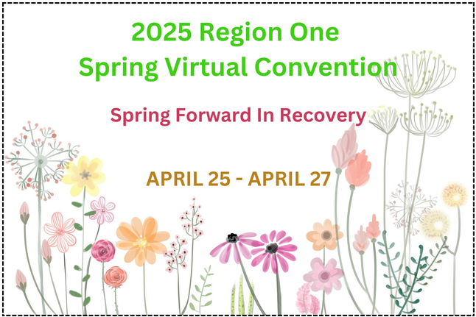

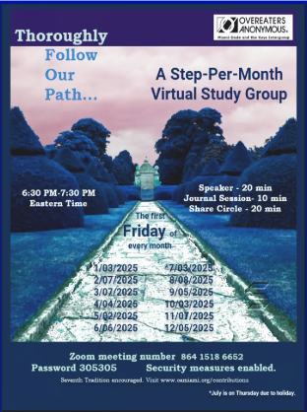

Registration Now Open!  
https://oa.org/world-service-convention/  
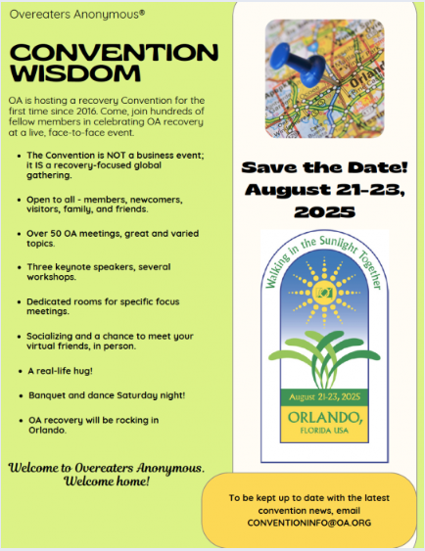

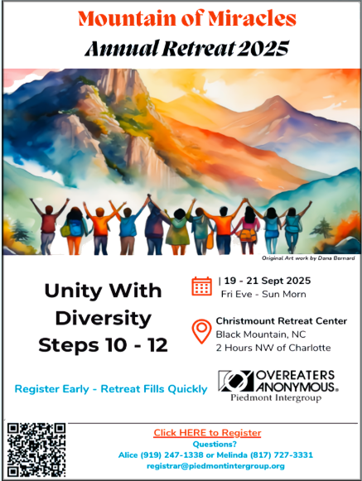

|  |
| --- |
| Rot |

**Where are your donations going?**

According to our Seventh Tradition, we are self-supporting through our own contributions. To donate directly to Intergroup, write a check made payable to ‘NFI’ and mail to: OA NFI, PO Box 550842, Jacksonville, FL 32255; or log onto oanfig.org and scroll down to the ‘donate’ button. You may pay by PayPal or credit card.

When you contribute your 7th Tradition donations, if you indicate your group number, the donation will be recorded for that specific group. When we do not have a group number to work with, we may include the donations as unspecified.

Each month, NFI tallies the group donations and sends 10% of the total to Region 8, with an additional 30% to the World Service Office. Donations sent directly to World Service Office do not reflect in our group donations total.