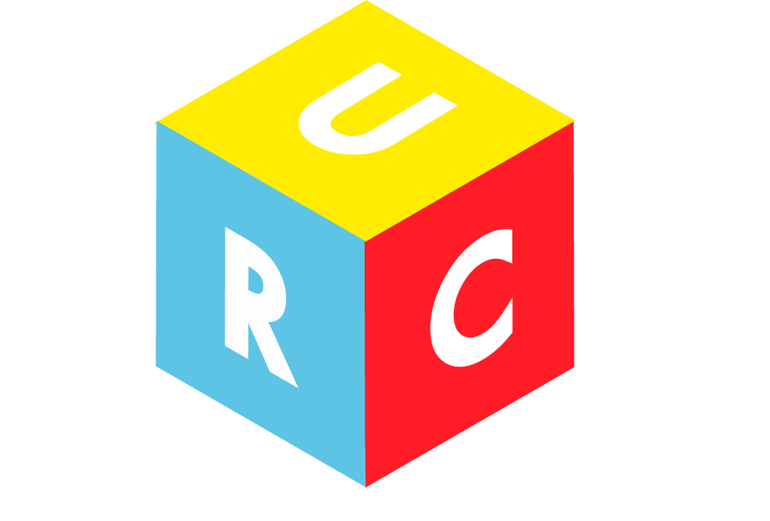

Preschool & Nursery Class
Prospectus 2019

‘We aim to provide a happy and secure environment in which children can learn and develop through play’

United Reformed Church Hall
Vaughan Road
Harpenden
AL5 4ED

URC Preschool & Nursery Class
Vaughan Road, Harpenden

Meet the Team
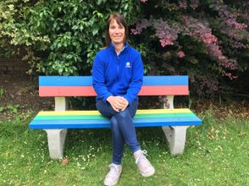
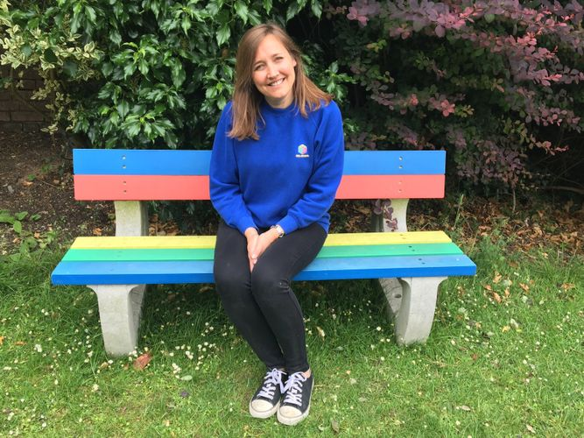

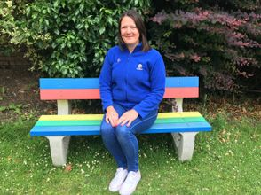
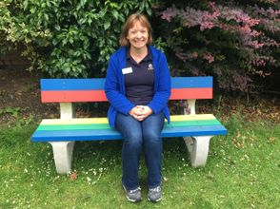
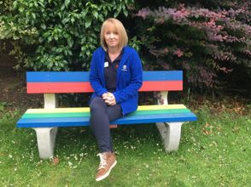
Mrs. Robinson – Manager
Mrs. Valle – Deputy
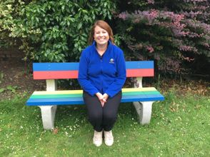
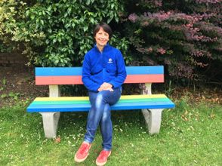
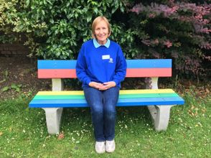
Mrs. Grainger
Mrs. Smith
Mrs. Powell
Mrs. Bates
Mrs. Burroughs
Mrs. Arnott
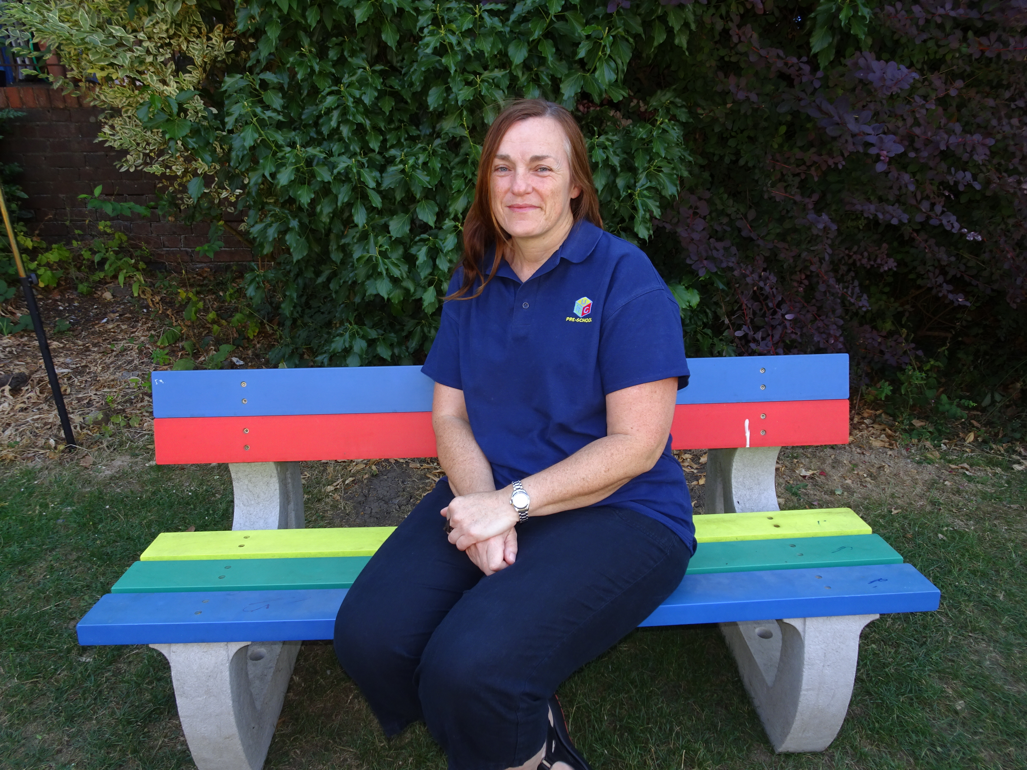

Mrs. Sergeant

Information about the Setting

- We provide care and education for young children between the ages of 2 and 5 years.
- We are open 48 weeks each year and are closed 14.
- We are open 4 days a week:
- Monday & Tuesday (9am – 12pm)
- Wednesday & Thursday (9am – 3pm), this is split into a morning session from 9am – 12pm and an afternoon session from 12pm – 3pm that includes lunch club.
- We provide a lunch club every day from 12pm – 1pm for children in the main room and red group if they attend the morning session. The children need to bring their own packed lunch containing no nuts including pesto.

Fees

- We charge £25 per session for each child, a full 6-hour day is charged at £45
- Our lunch club is charged at £6 per session for each child.
- We ask for a £50 deposit to secure your child’s place at the preschool which will come off the first half term bill.
- We accept childcare vouchers as a method of payment.

Working Together for your Children

At the United Reformed Church Preschool we maintain a high ratio of adults to children, for most of our provision we have a higher ratio than what is set by the national standards for day care. We also ask for volunteer parents on outings and special occasions to increase our ratios further. Our high ratios enable us to:
- Give time and attention to each child
- Talk with the children about their interests and activities
- Help children to experience and benefit from the activities we provide
- Allow the children to explore and be adventurous safely.

Communication

Key Person
Your key person is available to speak to you every morning for a short time, if you would like to see them on a more formal basis please arrange an appointment with the manager.

Preschool Leader
Please speak to the manager if you would like a meeting with her regarding your child/ren, appointments can be made for before, during or after the preschool meeting.
Mobile Telephone Number: 07786175705
Email: manager@urcpreschool.com

Written Correspondence & Fees for the Pre-School
The manager will issue a half termly newsletter in addition to the invoice for payment for that half term (at time of printing £25 per session). Please ensure that any money is in a sealed envelope with the name of your child and the reason for payment clearly marked on the front.
Please inform the preschool in writing should any of your details change including a minimum of a half term notice if/when your child is moving away from our setting (or fees will be charged).

Key Person
Your child’s key person will work closely with you and your child to build a positive relationship that makes him/ her feel safe and secure as they settle in, giving them the confidence to participate and enjoy their time with us.
They will observe your child to ensure that the care we provide meets his/ her individual needs and therefore your involvement is essential. We will keep you regularly informed of their progress and use the information you provide regarding your child’s interests and experiences you witness at home to help us build on your child’s development. Your key person is here to listen and help, so please feel free to share any comments or concerns you may have.

Staff
The staff that will be working with your child and the qualifications and training they have achieved are listed in the table below.

Name | Job Title | Qualifications and Experience
Mrs. Robinson | Manager | NVQ3  Designated Safe Guarding Officer  Level 5  First Aid Trained
Mrs. Valle | Deputy  Room Leader for Rainbow Room | NVQ3  First Aid Trained  Art Coordinator
Mrs. Bates | Room Leader for Red Room | SNNEB  First Aid Trained
Mrs. Burroughs | Key Person for Red Group  SENCO | NNEB (Level 3)  First Aid Trained  SENCO Accreditation
Mrs. Grainger | Key person for Red Group | Studying for NVQ3  First Aid Trained
Mrs. Smith | Key Person for Green Group | Studying for NVQ3  First Aid Trained
Mrs. Sergeant | Key Person for Orange Group | First Aid Trained
Mrs. Arnott | Key Person for Purple Group | NNEB  Designated Safeguarding Officer  First Aid Trained
Mrs. Powell | Room Helper for Rainbow Room | First Aid Trained

The Setting – URC Church Hall

The four main areas that the children will have access to over their time with us are pictured below.

The Main Room
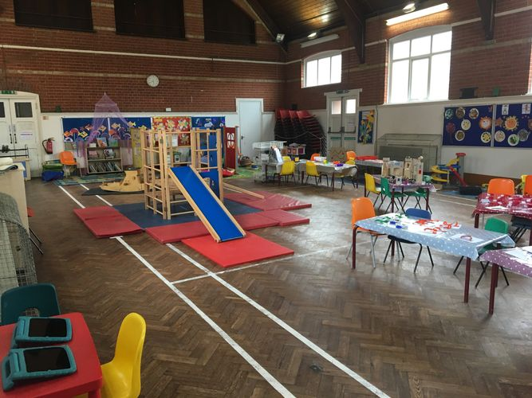
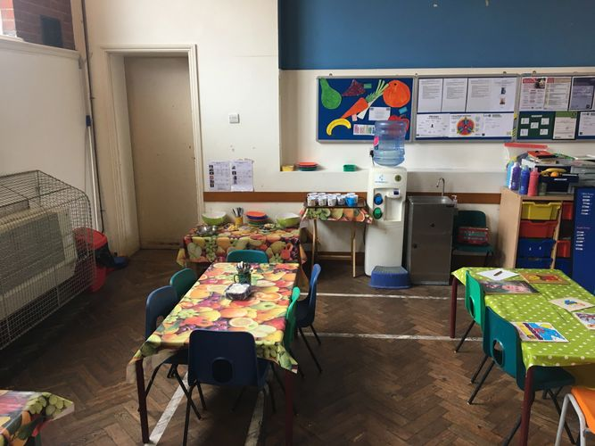

2-Year-Old Room
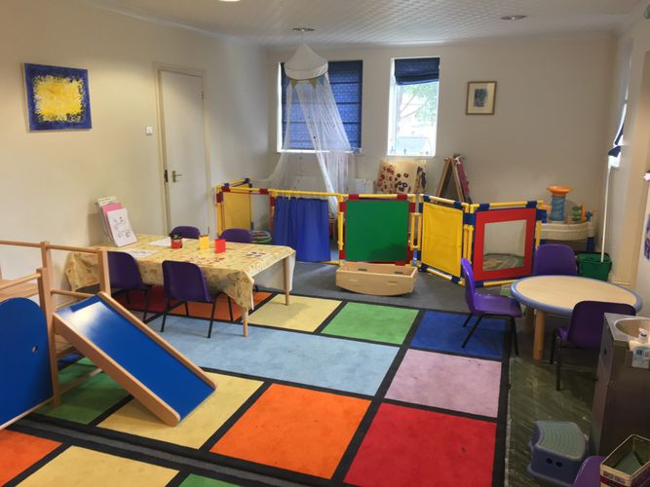
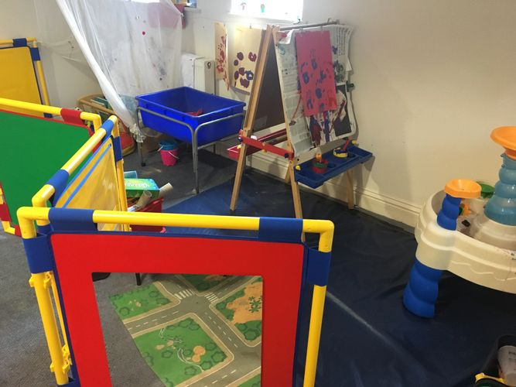

The Garden
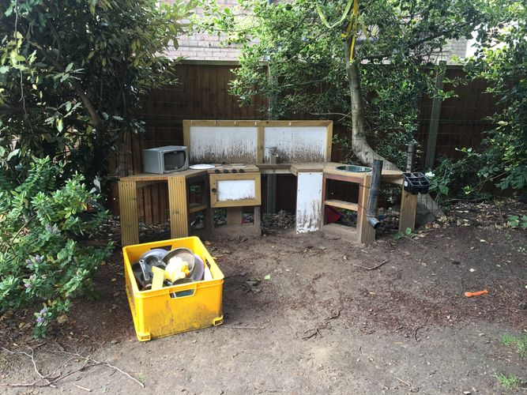
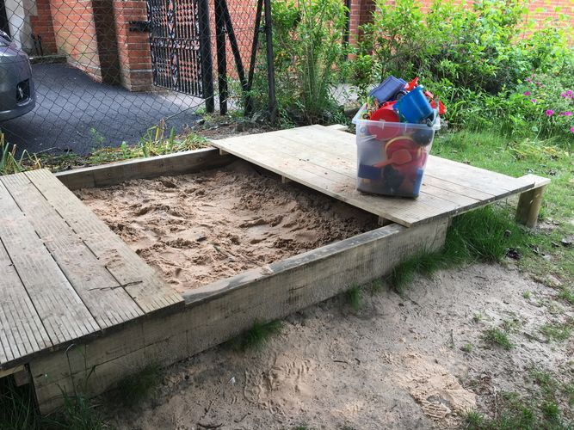

The Nursery
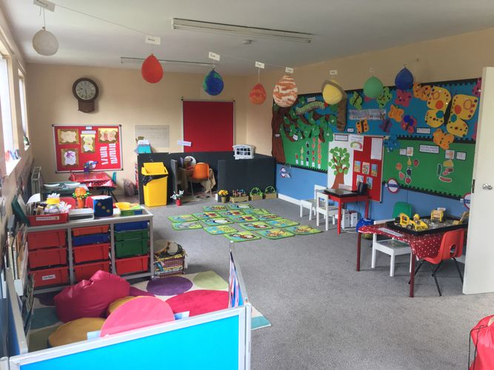
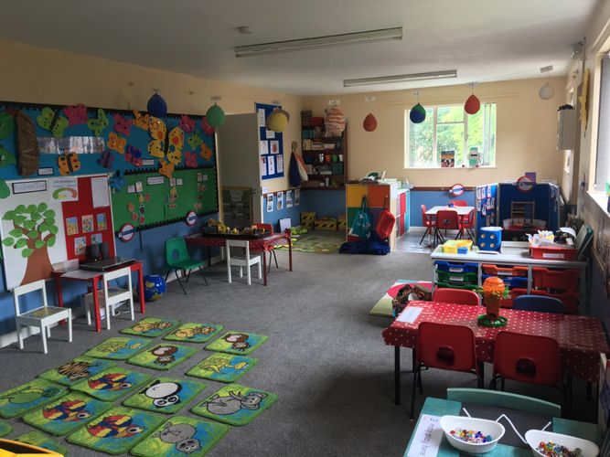

Information about the Day to Day Running of the Setting

Rolling Snack
Your child/ren will receive fruit, a healthy snack and a choice of milk or water during the morning sessions Monday to Thursday. At this time the free fruit that the government provides for schools doesn’t extend to preschool settings and therefore could you please be so kind as to replace the fruit in the fruit bowl as it empties.
If your child/ren has any dietary needs please inform their key person or manager as soon as possible.

Absence
If your child/ren is unable to attend preschool due to illness, please inform us immediately, the preschool is staffed from 8.45am or you can ring the manager on 07786175705.
If a child should become unwell during the morning, a first aider will assess the severity of the illness and parents will be telephoned if necessary. It is important to remember that children should not be re-admitted to preschool within 48 hours of the last episode of vomiting or diarrhoea.

Parking
Due to the rigorous parking attendants near our premises we ask parents/ guardians not to park your cars on the pavement near the preschool, it makes it hard for parents who have walked to get their buggies through the restrictive gaps in addition to you being at risk of a parking ticket. If you need to drive to the hall please park in the Bowers Way car park.

Lost Property
If your child/ren should leave an item at the preschool it will be left in the lost property box which can be found on the parents table, if you’re unable to find a lost item please speak to your child’s keyperson when you arrive and they will be able to assist you.

Parent Helpers
Parent helpers are actively encouraged to help at the preschool, before your first morning as a parent helper we ask you to read and sign a confidentiality agreement which is designed to give security to the children and the families represented within the preschool. We ask that you please wait until your child/ren have settled in before offering to help however we would be grateful if you could see the manager if you are interested.

Gates
Our gates lead on to the road from the garden and therefore we ask if you could please make sure that they are closed and place a chain on the gate every time you come in or out.

Preschool Bag
Please ensure that your child brings a bag to preschool with them each morning, the bag should contain the following:
- A change of clothes
- Pull ups (if necessary)
- Wellington boots in winter or rain
- A hat when sunny.

Sun cream
During the summer months could you please apply sun cream to your child/ren before they come in to preschool.

Medicines
It is the responsibility of the parents to issue medicines and tablets to their children, a key person cannot be responsible for administering medicine to your child/ren. If your child/ren needs an inhaler please speak to the manager or your child’s key person.

Website
Our website is regularly updated and you can find any relevant information you might need about the preschool including newsletters, PTA letters, notices and policies.

Nursery Class
If you have shown interest in your child/ren staying on to our nursery class, you will be informed whether you have been allocated a place during their first term at preschool. We encourage you to visit other appropriate nursery classes in addition to our red group, please ask if you need any further advice.

Policies
You can find all our policies and procedures on our website or in the policy folder on the parents table, if you have any queries please do not hesitate to ask.

The Early Years Foundation Stage
At the United Reformed Church preschool we are here to give your child a happy and healthy start in life by providing high quality childcare that meets your child’s needs and interests. We hope that the guide provided below regarding the Early Years Foundation State (EYFS) framework gives you an introduction in to how we will go about this.

Photos and Video footage
We cannot allow any photos or video footage to be taken at our events, The Child Protection Act doesn’t allow us to sanction photography as we have no control of their future use.
Occasionally our photographer Mr Lenman and his son take pictures and videos for us, both of whom are DBS checked.

General Timetable

This is a general timetable of the things that your child will be doing during the morning whilst they are with us (please note that times and activities are open to change).

Rolling snack is available upon your child’s arrival and throughout the morning session.

9.00am | Children arrive and self -register with their name labels.  Free play for children, a key worker will be available in the different play areas.
9.30am | Registration time – Children all come and sit together in the book corner whilst a register is taken.
9.40am | Free play is where the children can choose from the day’s activities, which might include:  - Project table e.g. collage/ painting/ models etc. related to theme of the day.  - Sand (with choices from the trolley as to what they would like to play with)  - Role play corner  - Water (with choices from the trolley as to what they would like to play with)  - Painting  - Drawing e.g. collage/ sticking, pencils, crayons, felt pens.  - Small world play  - Construction area  - Book corner  - Playdough  - Outdoor play  - Music
11.00am | Story time.
11.10am | Free play as above.
11.40am | Tidying up time.
11.45am | Singing time – the whole preschool join together.
11.55am | Physical e.g. parachute, racing, circle games, music and movement, climbing and balancing.
12.00pm | Home Time.

Children will have the choice to go outside each morning.

The Early Years Foundation Stage (EYFS)

The Early Years Foundation Stage (EYFS) is a legal framework which provides a set of requirements that we adhere to, to ensure that all children from birth to five years old who attend our provision are safe and healthy, and that they are supported to learn and develop to their full potential. The EYFS requirements cover the following.

- The learning and development requirements shape the activities and experiences we provide for your child.
- The early learning goals provide a general level of progress, covering knowledge, skills and understanding, that we will support your child to work towards having by the end of the academic year in which they turn five.
- The assessment requirements detail how we will monitor and plan for your child’s progress.
- The safeguarding and welfare requirements are steps we follow to ensure your child is kept safe and has their welfare promoted.
Our policies and procedures explain in detail the steps we take to satisfy the requirements of the EYFS in our everyday practice. We are inspected and regulated by Ofsted on the quality of our childcare provision against the requirements of the EYFS. Please ask a member of staff to view a copy of the EYFS or alternatively, you can download it at www.pre-school.org.uk/whats-new/new-eyfs. Our most recent Ofsted report can be found at www.ofsted.gov.uk/inspection-reports/find-inspection-report or on our website www.urcpreschool.com

How we support your child’s learning and development
There are seven areas of learning and development within the EYFS through which your child will be gaining knowledge, learning skills and showing understanding. These areas form the basis of the activities we provide for your child, alongside their unique interests and needs they enable us to plan for their progress.

Prime areas of learning and specific areas of learning and development
- Communication and language.  - Physical development.  - Personal, social and emotional development. | - Literacy.  - Mathematics.  - Understanding the world.  - Expressive arts and design.
These areas are connected, with learning and development in each area contributing towards that of the others. Building confidence in the prime areas of learning and development is particularly important for children, as it enables them to progress well in the specific areas. As we support your child towards achieving the early learning goals for each of these areas of learning, we aim to tailor the opportunities we provide to meet their personal learning and development needs.

Communication & Language
- being able to use conversation with one other person, in small groups and in large groups to talk with and listen to others
- adding to their vocabulary by learning the meaning of and being able to use- new words
- being able to use words to describe their experiences

Physical development
This area of children’s development covers:
- gaining control over the large movements that they can make with their arms, legs and bodies, so that they can run, jump, hop, skip, roll, climb, and lift
- gaining control over the small movements they can make with their arms, wrists and hands, so that they pick up and use objects, tools and materials
- learning about the importance of and how to look after their bodies.

Personal, social and emotional
This area of children’s development covers:
- having a positive approach to learning and finding out about the world around them
- having confidence in themselves and their ability to do things, and valuing their own achievements
- being able to get on, work and make friendships with other people, both children and adults
- becoming aware of and being able to keep to the rules which we all need to help us to look after ourselves, other people and our environment
- being able to dress and undress themselves, and look after their personal hygiene needs
- being able to expect to have their ways of doing things respected and to respect other people’s ways of doing things.

Literacy
This area of children’s development covers:
- Looking at books and listening to stories
- having favourite stories, rhymes and songs
- distinguishing between different marks when writing

Mathematics.
This area of children’s development covers:
- building up ideas about how many, how much, how far and how big;
- building up ideas about patterns, the shape of objects and parts of objects, and the amount of space taken up by objects;
- starting to understand the numbers help us to answer questions about how many how much, how far and how big;
- building up ideas about how to use counting to find out how many

Understanding the world.
This area of children’s development covers:
- finding out about the natural world and how it works
- finding out about the man made world and how it works
- learning how to choose and use the right tools for a task
- learning about technology, how to use it and what it can help us to do
- starting to put together ideas about past and present and the link between them
- begin to learn about their locality and it special features
- learning about their own and other cultures.
Expressive arts and design.
This area of children’s development covers:
- using paint, materials, music, dance, words, stories, and role-play to express their ideas and feelings
- Becoming interested in the way that paint, materials, music, dance, words, stories and role-play can be used to express ideas and feelings.
At the United Reformed Church, we believe play helps young children to learn and develop through doing and talking as research has shown this to be how young children think. Our setting uses the stepping stones lined to the goal to plan and provide a range of play activities which help children to make progress in each of the areas of learning and development. In some of these activities children decide how they will use the activity and in others, an adult takes the lead. In all activities guidance from the statutory early learning goals helps to decide what equipment to provide and how to provide it.

How we assess your child’s progress
We observe your child throughout the day to identify their interests, how they learn and their progress in each area of learning and development. As you know your child best, we also want to hear your observations of your child; what he/she likes to do at home, as well as any significant events, achievements or concerns. This assessment of your child helps us to identify and plan their next steps. In addition to our ongoing observations, two reviews of your child’s progress will be shared with you.
- A progress check at age two years
- When your child is aged between two and three years, your key person will work with you to prepare a summary of his/her development. The review may show that your child is progressing at a faster or slower rate in a area; this will generally be a normal part of your child’s unique developmental journey. Where we have concerns, we will carry out further observations and may seek your consent to share the review with other professionals where we feel their support would benefit your child.
- Early Years Foundation Stage Profile
- As your child prepares to start school at age five, an Early Years Foundation Stage Profile (EYFSP) is completed. The EYFSP aims to present a well-rounded picture of your child's knowledge, understanding and abilities; providing a review of your child’s progress as they come to the end of the EYFS, against the expected levels of development in the early learning goals. Due to the timing, it is likely that your child's reception class teacher will carry this out; however, the records and knowledge we have of your child will help to inform this process. On completion of your child’s EYFSP, the results will be shared with you, giving you the opportunity to ask questions.

Incorporating the Statutory Framework of the Early Years Foundation State

Policies and procedures are essential to help United Reformed Pre-school provide good quality provision that is compliant with the Statutory Framework for the Early Years Foundation Stage (EYFS). They do this by making clear to staff and parents what sort of setting we are and what actions we take to make sure that this happens. The EYFS requires providers to have written policies and procedures and to ensure that staff are given training at induction about them and that they are accessible and explained to parents.

1. Safeguarding and promoting children’s welfare
The United Reformed Church Pre-School takes the necessary steps to safeguard and promote the welfare of children. We promote the good health of the children, take necessary steps to prevent the spread of infection and take appropriate action when they are ill. Children’s behaviour is managed effectively and in a manner appropriate for their stage of development and individual needs.
2. Suitable people
The United Reformed Church Pre-school ensures that the adults looking after the children are suitable to do so whilst having the appropriate qualifications, training, skills and knowledge. Staffing arrangements are organised to ensure safety and the needs of the children are met.
3. Suitable premises, environment and equipment
The Outdoor and indoor spaces, furniture, equipment and toys are safe and suitable for their purpose.
4. Organisation
The United Reformed Church Pre-school & Nursery Class plans and organises their systems to ensure that every child receives an enjoyable and challenging learning and development experience that is tailored to meet their individual needs.
5. Documentation
The United Reformed Church Pre-School & Nursery Class maintains records, policies and procedures required for the safe and efficient management of the setting and to meet the needs of children.
There are ten Safeguarding and Welfare Requirements within the EYFS, some of which are broken down into further headings, as follows:

Child protection
The United Reformed Church must be alert to any issues for concern in the child’s life at home and elsewhere.

Suitable People
The United Reformed Church Pre-school ensure that people looking after children are suitable to fulfil the requirements of their roles.

Disqualification
Staff taking medication/other substances.

Staff qualifications, training, support and skills
The daily experience of children in early year’s settings and the overall quality of the provision depends on all practitioners having appropriate qualifications, training, skills and knowledge and a clear understanding of their roles and responsibilities
Key person
Each child is assigned a key person. Their role is to help ensure that every child’s care is tailored to meet their individual needs, to help the child become familiar with the setting, offer a settled relationship for the child and build a relationship with their parents.

Staff: child ratios
The Staffing arrangements must meet the needs of children and ensure their safety.

Health
The United Reformed Church Pre-school promotes good health of the children attending the setting. We discuss with parents and/or carers and respond appropriately to children who are ill or infectious, taking the necessary steps to prevent the spread of infection.
You can find out more about this by looking at the following polices:
- Food and drink
- Accident or injury

Managing behaviour
The United Reformed Church Pre-school implement a behaviour management policy and procedure.

Safety and suitability of premises, environment and equipment
You can find out more about this by looking at the following polices:
- Safety
- Smoking
- Premises
- Risk assessment
- Outings

Equal opportunities
The United Reformed Church Pre-school implement a policy and procedure to promote equality of opportunity for the children in our care, including support for children with special educational needs or disabilities.

Information and records
At the United Reformed Church Preschool, we maintain records and obtain and share information (with parents, carers and other professionals working with the child, the police, social services and Ofsted if appropriate) to ensure the safe and efficient management of the setting, and to help ensure the needs of all the children are met. Examples include:
- Information about the child
- Information for parents and carers
- Complaints
- Information about the provider
- Changes that must be notified to Ofsted
At the United Reformed Church Preschool, we are required to assess risks to children’s safety and review risk assessments regularly. The preschool also determines when it is helpful to make some written risk assessments in relation to specific issues.
In this book, the policy statement is set out at the start of each section followed by the relevant procedure describing how the policy will be fulfilled in a consistent and standardised way.

Policies
Copies of the policies and procedures are made available to all parents on the parents table should you require you own copy please ask the Manager who will be happy to provide you with this or alternatively they can be found on our website- www.urcpreschool.com.
At the United Reformed Church Pre-School & Nursery Class policies are reviewed annually by all staff. Reviews have taken place on the following dates: April 14, April 15 April 16, April 17

URC Preschool PTA

URC Pre-school PTA is a network of parents, carers, school staff and others who work together to raise money to support our pre-school.
Everyone can get involved, even if you only have a small amount of time to give. It is a great way to meet others, bring greater benefits and opportunities for the school and its children and for parents/carers to be more involved in school life.
What does the PTA do?
- Builds networks between parents/carers and teachers to help communicate information etc.

- Runs events for parent/carers and children.
- Raises funds to provide play equipment, educational materials and items which support the children's experience within the preschool
We are very keen to welcome new members to the PTA committee, particularly from September.
What does "being on the committee" mean?
- We run about three fundraising events, eight coffee mornings and three events for the children and families throughout the year.
- We hold three committee meetings a year - in the evening with a large glass of wine and some cake!
The funds raised by the PTA are crucial to the running of URC pre-school as we know and love it.
If you are interested in joining the PTA please speak to the manager or Nina Whitehead
If you are on Facebook please join our page ‘URC Preschool PTA - Harpenden' to keep up to date with PTA events and news.
We hope you and your child/ren enjoy your time at the URC Pre-School.

Yours Sincerely
Chair of PTA
Email – manager@urcpreschool.com

