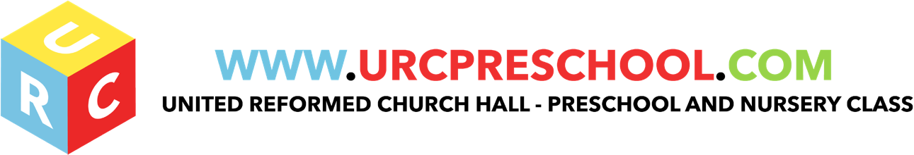

Admissions Policy

It is our intention to make the URC Pre-School accessible to all children and families from all sections of the local community regardless of their gender, special educational needs, disability, culture, language or religion.

There is a waiting list for admission to the URC Pre-School. Any child residing in the local community may be added to the waiting list without charge. Parents and carers enquiring about places are invited to visit by appointment in order to help make their decision about a place.

Children generally start the URC Pre-School around the time they reach 2yrs. We operate in line with Hertfordshire County Education guidelines, which at present have a two term per year entry policy. These entry times are September and January.

Parents/carers are usually contacted about a place for their child at the URC Pre-School in the term before they are due to start. Parent/carers of children unlikely to be offered a place within the pre-school will also be informed and advised to look for an alternative. Those wishing to remain on the waiting list are offered places as they become available, strictly by order of their position on the list.

In summary, our admissions/waiting list is managed according to the following criteria :-

- Children’s names and details are added to the URC waiting list strictly in the order in which the information is provided to us by their parents/carers. The date when they registered is recorded alongside their details.
- No fee is charged for being added to the waiting list
- The waiting list applies to places for the pre-school
- Admissions are normally twice yearly in September and January, but we can sometimes admit children during a term if a place becomes available. Admissions criteria as stated still apply.
- Children are only offered a place at pre-school once they reach the age of 2 years.

Our criteria for the order in which we admit children to the pre-school are as follows :-

- Children whom a health visitor, doctor, social services or the URC church have recommended or requested a place for are considered before others on the waiting list. (NB. This is a rare occurrence and applies to very few)
- Siblings of children already at or having attended the URC Pre-School are given priority
- Further admissions are made strictly according to a child’s place on the waiting list, offering those who are the appropriate age and have been on the list for the longest time, a place first.

Accepting A Place

Once you have accepted a place you will receive the following:

- Registration Forms
- My World Forms
- A Welcome Pack
- A Home Visit
- An Induction Morning (If Appropriate)

Once all the information has been returned to us, you then become a member of the URC preschool. Should your circumstances change at any time whilst you are with us and you need to leave the pre-school, you MUST give us at least half a terms notice in writing otherwise we will charge you for that period of time. This is due to you accepting a place when it could have been offered to another child.

EYFS key themes and commitments

A Unique Child | Positive Relationships | Enabling Environments | Learning and Development
1.1 Child Development  1.2 Inclusive Practice  1.3 Keeping safe  1.4 Health and Well-being. | 2.1 Respecting each other  2.2 Parents as partners  2.3 Supporting learning  2.4 Key person | 3.2 Supporting every child.  3.3 the Learning Environment  3.4 The wider context | 4.1 Play & Exploration  4.2 Active Learning  4.3 Creativity and Critical Thinking  4.4 Areas of Learning and Development
Nursery Admissions

Admissions to the nursery class (Red Group) are as follows
Our criteria for the order in which we admit children to the nursery class are as follows:

- Children whom a health visitor, doctor, social service or the URC church have recommended or requested a place for are considered before others on the waiting list.(NB this is a rare occurrence and applies to very few)
- Sibling of children already at or having attended the URC Pre-school are given priority
- Further admissions are made adorning to the information we receive in the Welcome Pack stating that you would like to be considered for a place in our Nursery (Red Group). If this is filled in, we then refer back to our waiting list and offer those who are the appropriate age and have been on the list for the longest time, the first 16 places.

However we are sorry to say that not all the children being offered a place in the Pre-School will automatically gain a place in the nursery class. This is due to the fact that we are limited by the size of our premises. At present our maximum class size is 16 children with three members of staff.
Those wishing to remain on the waiting list are offered places as they become available, strictly by order of their position on the original URC Pre-school waiting list.

Last Reviewed: September 2020

