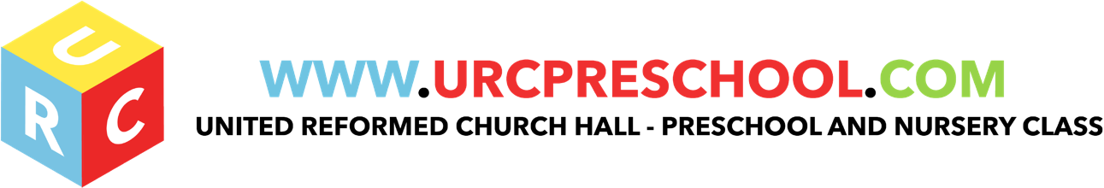

Equal Opportunities Policy

Statement on Promoting Equality of Opportunity
‘We are all special and all different’

The URC will ensure that our service is fully inclusive in meeting the needs of all children. We recognise that children and their families come from diverse backgrounds. All families have needs and values that arise from their social and economic, ethnic and cultural or religious backgrounds. Children grow up in diverse family structures that include two parent and one parent families; some children have two parents of the same sex. Some children have close links with extended families of grandparents, aunts, uncles and cousins while others may be more removed from close kin or may live with other relatives or foster carers. Some children have needs that arise from disabilities or impairment or may have parents that are affected by disability or impairment.
Our setting is committed to an anti-discriminatory practice to promote equality of opportunity and valuing diversity for all children and families.

We aim to:

- Provide a happy and secure environment, which promotes and reflects cultural differences and social diversity.
- All children will be valued equally regardless of gender, culture, race, religion, or ability.
- Value diversity and adopt our curriculum accordingly to meet the needs of the children in our care.
- Encourage everyone to gain a positive self-image and high self- esteem.
- Challenge offensive language or behaviour with regards to race, religion, culture, disability or gender.
- Promote mutual respect and value each other’s similarities and differences and face equality issues openly.
- Monitor, evaluate and review all our practices regularly to secure continuous improvements in all that we do.
- Provide a secure and accessible environment in which all our children can flourish and in which all contributions are considered and valued
- Include and value the contribution of all families to our understanding of equality and diversity
- Provide positive non-stereotyping information about gender roles and diverse family structures, diverse ethnic and cultural groups and disabled people
- Improve our knowledge and understanding of issues of anti-discriminatory practice, promoting equality and valuing diversity
- Challenge and eliminate discriminatory actions
- Make inclusion a thread that runs through all of the activities of the setting and
- Foster good relations between all communities.

The United Reformed Church Pre-School believes that no child, individual or family should be excluded from the Pre-School’s activities on the grounds of age, gender, religion, sexuality, class, family status, means, ethnic origin, culture religion or belief. We aim to ensure that all who wish to participate in our Pre-School have an equal chance to do so.

Admissions

The URC Pre-School is open to every family in the community. Families joining the pre-school are made fully aware of its equal opportunities policy.

- We provide information in clear, concise language, whether in spoken or written form.
- We base our admissions policy on a fair system.
- We ensure that all parents are made aware of our Equal opportunities policy.
- We do not discriminate against a child or their family, or prevent entry to our setting, on the basis of a protected characteristic as defined by the Equalities Act 2010. These are:
- Disability
- Race
- Gender reassignment
- Religion or belief
- Sex
- Sexual orientation
- Age
- Pregnancy or maternity and marriage and civil partnership.
- We do not discriminate against a child with a disability or refuse a child entry to our setting for reasons relating to a disability.
- We ensure whenever possible that we have a balanced intake of boys and girls in to the setting.
- We develop an action plan to ensure that people with impairments can participate successfully in the services offered by the setting and in the curriculum offered

EYFS Key Themes and Commitments

A Unique Child | Positive Relationships | Enabling Environments | Learning and Development
1.2 Inclusive practice  1.3 Keeping safe | 2.1 Respecting each other  2.2 Parents as partners  2.3 Supporting learning  2.4 Key person | 3.2 Supporting every child  3.4 The wider context | 4.4 Areas of learning and development (KUW/ PSE)

Last Reviewed: May 2019

