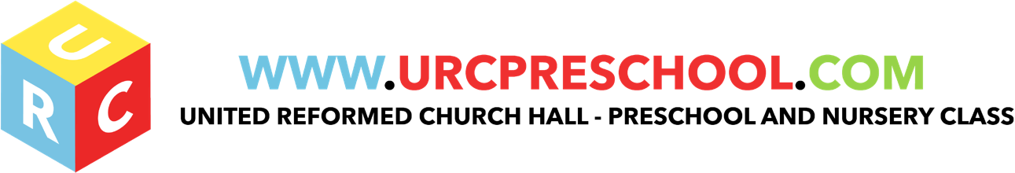

Equipment & Toys Policy and Practice

The toys and equipment in the pre-school provide opportunities for children, with adult help, to develop new skills and concepts in the course of their play and exploration. The equipment we provide:

- Is appropriate for the stage/development of the children present
- Offers challenges to developing physical,social, personal and intellectual skills.
- Features positive images of people, both male and female, a range of ethnic and cultural groups with and without disabilities.
- Includes a range of raw materials, which can be used in a variety of ways and encourages an open-ended approach to creativity and problem solving.
- Will enable children, with adult support, to develop individual potential and move towards required leaning outcomes
- Conforms to all relevant safety regulations and is sound and well-made.
- The Pre-school Manager will check the equipment every day as it is put out for use.
- Staff will also check the equipment when putting it away.
- A thorough check on all equipment is made every Sunday during term time.

Activities and resources

- The layout of play equipment allows adults and children to move safely and freely between activities.
- All equipment is regularly checked for cleanliness and safety and any dangerous items are repaired or discarded.
- All materials, including paint and glue, are non-toxic.
- Sand is clean and suitable for children's play.
- Physical play is constantly supervised.
- Children are taught to handle and store tools safely.
- Children learn about health, safety and personal hygiene through the activities we provide and the routines we follow.
- Any faulty equipment is removed from use and is repaired. If it cannot be repaired, it is discarded.
- Large pieces of equipment are discarded only with the consent of the Manager.

EYFS key themes and commitments
A Unique Child | Positive Relationships | Enabling Environments | Learning and Development
1.3 Keeping safe.  1.4 Health and well-being |  | 3.3 The learning environment.

Last Reviewed: May 2019

