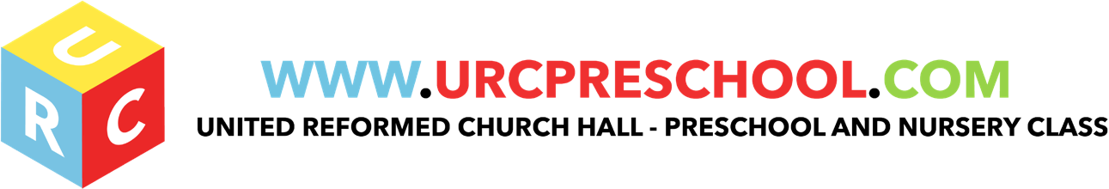

Food and Drink Policy

The United Reformed Pre-school regards snack time as an important part of our session. Eating represents a social time for children and adults and helps children learn about healthy eating. At the URC Pre-School we normally operate a ‘café’ system where the children can choose when they wish to have their snack during the pre-school session.
The children make their way to the snack area and select their name. This shows staff who has had their snack during any session.
Children wash their hands, help themselves to a drink and food of their choice and then sit down at the snack table. The food choice consists of fruit & vegetables (provided if possible, by parent’s contributions) and other healthy snacks such as bread, crackers bread sticks, rice cakes and cheese.

We provide a variety of snacks to meet our children’s individual dietary needs. Before a child starts at the URC Pre-School we find out from the parents/carers their child’s dietary needs, including any allergies. This information is recorded in the child’s records. Sensitivity is shown in both our provision of snacks and in our cookery activities. We try to provide foods from children‘s individual cultural backgrounds promoting an inclusive practice for everyone.

- We follow these procedures to promote healthy eating in our setting.
- We record information about each child's dietary needs in her/his registration record and parents sign the record to signify that it is correct.
- We display current information about individual children's dietary needs so that all staff and volunteers are fully informed about them.
- We implement systems to ensure that children receive only food and drink that is consistent with their dietary needs and preferences as well as their parents' wishes.
- We provide nutritious snacks, avoiding large quantities of saturated fat, sugar and salt and artificial additives, preservatives and colourings.

We include a variety of foods from the four main food groups:

- Dairy and soy products.
- Grains and cereals.
- Fruit and vegetables.

- We include foods from the diet of each of the children's cultural backgrounds, providing children with familiar foods and introducing them to new ones.
- We take care not to provide food containing nuts or nut products and are especially vigilant where we have a child who has a known allergy to nuts.
- We use snack times to help children to develop independence through making choices, serving food and drink and feeding themselves.
- We provide children with utensils that are appropriate for their ages and stages of development whilst taking into account the eating practices of other cultures.
- We have fresh drinking water constantly available for the children. We inform the children about how to obtain the water and that they can ask for water at any time during the day.

In order to protect children with food allergies, we discourage children from sharing and swapping their food with one another.

Food Poisoning

We notify Ofsted of any food poisoning affecting two or more children looked after on the premises as soon as is reasonably practicable, but in any event within 14 days of the incident.
In order to comply with Hertfordshire County Council guidelines we use the Safer Food Better Business Pack to keep records on the following :

- Fridge Temperature
- Food dates
- Kitchen hygiene at start and close of session
- Food hygiene

Procedures

The person in charge and the person responsible for food preparation understands the principles of Hazard Analysis and Critical Control Point (HACCP) as it applies to their business. This is set out in Safer Food Better Business. The basis for this is risk assessment as is applies to the purchase, storage, preparation and serving of food to prevent growth of bacteria and food contamination.

- All staff follow the guidelines of Safer Food Better Business.

The person responsible for food preparation and serving carries out daily opening and closing checks on the kitchen to ensure standards are met consistently. (See Safer Food Better Business.)

- We use reliable suppliers for the food we purchase.
- Food is stored at correct temperatures and is checked to ensure it is in-date and not subject to contamination by pests, rodents or mould.
- Food preparation areas are cleaned before use as well as after use.
- There are separate facilities for hand-washing and for washing up.
- All surfaces are clean and non-porous.
- All utensils, crockery etc are clean and stored appropriately.
- Waste food is disposed of daily.
- Cleaning materials and other dangerous materials are stored out of children's reach.
- Children do not have unsupervised access to the kitchen.

When children take part in cooking activities, they:

- are supervised at all times
- understand the importance of hand washing and simple hygiene rules.
- They are kept away from hot surfaces and hot water
- Do not have unsupervised access to electrical equipment such as blenders etc.

Reporting of food poisoning

Food poisoning can occur for a number of reasons; not all cases of sickness or diarrhoea are as a result of food poisoning and not all cases of sickness or diarrhoea are reportable.
Where children and/or adults have been diagnosed by a GP or hospital doctor to be suffering from food poisoning and where it seems possible that the source of the outbreak is within the setting, the manager will contact the Environmental Health Department and the Health Protection Agency, to report the outbreak and will comply with any investigation.
Any confirmed cases of food poisoning affecting two or more children looked after on the premises will be notified to Ofsted as soon as is reasonably practicable, and always within 14 days of the incident.

EYFS key themes and commitments

A Unique Child | Positive Relationships | Enabling Environments | Learning and Development
1.4 Health and well-being | 2.1 Respecting each other.  2.2 Parents as Partners  2.4 Key person | 3.2 supporting every child  3.4 The Wider context. | 4.4 Personal , social and emotional development.

Legal Framework

Regulation (EC) 852/2004 of the European Parliament and of the Council on the hygiene of foodstuffs.

Last Reviewed: September 2020

