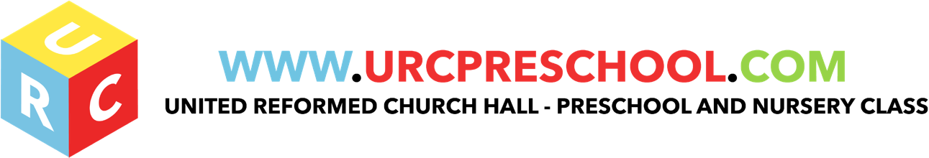

Fundamental British Values in the Early Years

At the United Reformed Pre School, we uphold fundamental British values of democracy, rule of law, individual liberty, mutual respect and tolerance for those with different faiths and beliefs which are already implicitly embedded in the 2014 Early Years Foundation Stage.

The Counter Terrorism and Security Act also places a duty on us as Early Years providers “to have due regard to the need to prevent people from being drawn into terrorism” (the Prevent duty). Statutory guidance on the duty is available at https://www.gov.uk/government/publications/prevent-duty-guidance.
.
Democracy: Making decisions together

As part of the focus on self-confidence and self-awareness as cited in Personal, Social and Emotional Development:
At the United Reformed Church, the managers and staff
- encourage children to see their role in the bigger picture,
- encourage children to know their views count, value each other’s views and value and talk about their feelings.
For example, when they do or do not need help. When they appropriately demonstrate democracy in action, for example, children sharing views on what the theme of their role play area could be with a show of hands.
All staff and managers support the decisions that children make and provide activities that involve turn-taking, sharing and collaboration. Children should be given opportunities to develop enquiring minds in an atmosphere where questions are valued.
Staff ensure that children understand their own and others’ behaviour and its consequences and learn to distinguish right from wrong.
Staff collaborate with children to create the rules and the codes of behaviour for example the children agree the rules about tidying up and we ensure that all children understand that the rules apply to everyone.
The Rule of Law: Understanding rules matter
As part of the focus on managing feelings and behaviour as cited in Personal, Social and Emotional development;
All the staff ensure that the children understand their own and others behaviour and its consequences and learn to distinguish right from wrong.
Staff collaborate with the children to create rules and codes of behaviour for example, to agree the rules for tidying up and ensure that all the children understand that rules apply to everyone.

Individual liberty: Freedom for all

As part of the focus on self-confidence & self-awareness and people & communities as cited in Personal Social and Emotional development and Understanding the World:
All the staff ensure all children develop a positive sense of themselves. We provide opportunities for children to develop their self-knowledge, self-esteem and increase their confidence in their own abilities, e.g. through allowing children to take risks on an obstacle course, mixing colours, talking about their experiences and learning.
All Staff encourage a range of experiences that allow children to explore the language of feelings and responsibility, reflect on their differences and understand we are free to have different opinions.

Mutual respect and tolerance: treat others as you want to be treated

The United Reformed Church focuses on people & communities, managing feelings & behaviour and making relationships as cited in Personal, Social and Emotional development and Understanding the World:
Managers and staff create an ethos of inclusivity and tolerance where views, faiths, cultures and races are valued, and children are engaged with the wider community.
- Children are taught to acquire a tolerance and appreciation of and respect for their own and other cultures;
- Know about similarities and differences between themselves and others and among families, faiths, communities, cultures and traditions and share and discuss practices, celebrations and experiences.
All staff encourage and explain the importance of tolerant behaviours such as sharing and respecting other’s opinions.
All staff should promote diverse attitudes and challenge stereotypes, like, sharing stories that reflect and value the diversity of children’s experiences and providing resources and activities that challenge gender, cultural and racial stereotyping.

At the URC we are aware that it is not acceptable to:
- Actively promote intolerance of other faiths, cultures and races.
- Fail to challenge gender stereotypes and routinely segregate girls and boys.
- Isolate children from their wider community
- Fail to challenge behaviours (whether of staff, children or parents) that are not in line with the fundamental British values of democracy, rule of law, individual liberty, mutual respect and tolerance for those with different faiths.

Last Reviewed: May 2019

