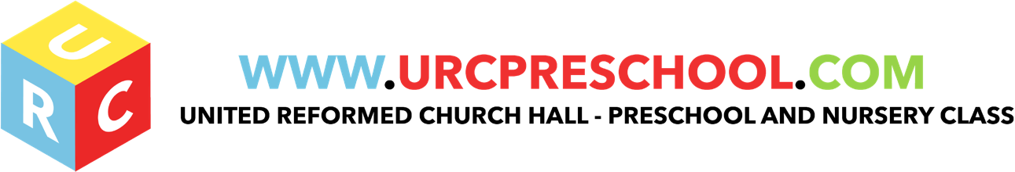

Nappy changing and Intimate Care

Policy statement

No child is excluded from participating in our setting who may, for any reason, not yet be toilet trained and who may still be wearing nappies or equivalent. We work with parents/carers towards toilet training, unless there are medical or other developmental reasons why this may not be appropriate at the time. The URC staff are committed to ensuring that they undertake their duties in a professional manner at all times.

- We make necessary adjustments to our bathroom provision and hygiene practice in order to accommodate children who are not yet toilet trained.
- We see toilet training as a self-care skill that children have the opportunity to learn with the full support of an adult. Intimate care will sometimes demand direct or indirect contact with or exposure to the the child’s genitals. Examples include wiping a child’s bottom.

Procedures

- All the staff are made aware when a Key person needs to change any of the young children in their care who are in nappies or ‘pull-ups’.
- Young children from two years should wear ‘pull ups’ or other types of trainer pants as soon as they are comfortable with this and their parents/carers agree.
- Changing areas are warm and there is a safe area to lay a young child on if they need to have their bottoms cleaned
- Each young child will have their own changing products: nappies, pull ups and wet wipes in their bags.
- Gloves and aprons are put on before changing starts and the areas are prepared. The changing mat is cleaned after each child and is therefore clean and fresh for the next one.
- All the staff are familiar with the hygiene procedures and carry these out when changing nappies.
- In addition, staff ensure that nappy changing is relaxed and a time to promote independence in young children.
- The young children are encouraged to take an interest in using the toilet; they may just want to sit on it and talk to a friend who is also using the toilet.
- All the children are encouraged to wash their hands with soap after they have been to the toilet or had their nappy changed. They should be allowed some time for play as they explore the water and the soap.
- The older children in the setting can access the toilet when they have the need to and are encouraged to be independent.
- Nappies and ’pull ups’ are disposed of hygienically. Any soiled (faeces) in nappies or pull ups is generally flushed down the toilet and the nappy or pull up is bagged and put in the bin. Cloth nappies, trainer pants and ordinary pants that have been wet or soiled are bagged for the parent/carer to take home.

EYFS key themes and commitments

A Unique Child | Positive Relationships | Enabling Environments | Learning and Development
1.2 Inclusive practice.  1.4 Health and well-being | 2.2 Parents as partners  2.4 Key person | 3.2 Supporting every child.

Last Reviewed: September 2020

