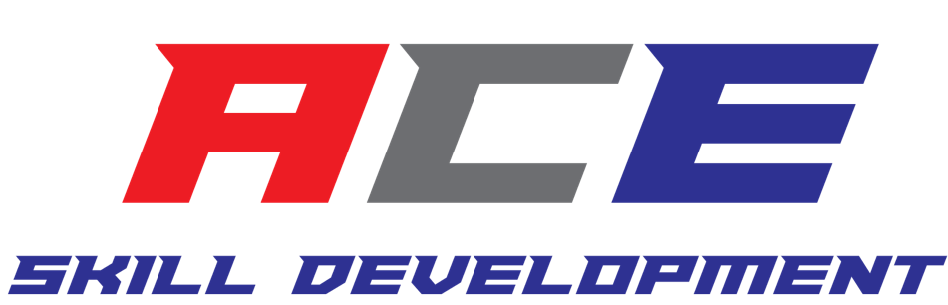
Sponsorship Packages

A.C.E. Skill Development is a local, multisport company designed to focus on skill development to create elite athletes. Working with youth from the surrounding area schools, as well as other local organizations, we assess skills and design training programs allowing them to excel at their sport. Our commitment to youth athletics is also shown by supporting several community events throughout the year. Our philosophy at A.C.E. Skill Development is to provide an energetic and positive training facility which focuses on skill development and high-level talent. Over the past 2 years, our company has shown substantial growth. We are currently working out of a facility that we rent but our vision is to build a larger facility which will offer larger scale training, camps, clinics and host tournaments. Increasing enrollment to capitalize on the growing athletic industry.
The youth sports industry generates over $15 billion with annual growth of 2.1%. There is a low level of market share concentration in our area. Because of this, facilities are continuing to open. ACE Skill Development will corner the market as we are promoting services to youth athletes. Our facility, unlike other fitness clubs, will focus on developmental training all the way through elite athlete training. We will take advantage of the increasing population and growth in the area.

After thinking of businesses in the community that we want to be affiliated with, we naturally thought of your commitment to youth athletics. Sponsoring our company/teams is not only a great way to get involved with the community; it’s also an amazing form of marketing for your business. We understand that you have several choices when considering different marketing and community outreach opportunities, but we truly believe that this is a great fit. We encourage you to check out our website at www.acesdcharlotte.com to see everything we have to offer along with links to our Social Media accounts within the site. Below is the breakdown of our packages, if you would like something a little more customized in return for your sponsorship, we are very open to your ideas.

Sponsorship Packages

 | Platinum  $2000 | Silver  $1500 | Bronze  $1000 | Team Sponsorship Only $500
Signage*
20% Employee Discount
Website Promo
Email Promo*
Social Media Partnership Posts
Sponsorship Rights to Events
Verbal Acknowledgements
Social Media Partnership Promoted Ad
Promotional Bags*
A.C.E. Nights
Team Sponsorship
*Items provided by Sponsor

Description of Package Categories

Signage*-
Any logos/signage can be displayed at trainings, events or camps. But must be provided by sponsor.
20% Employee Discount-
Current employee/family receives 20% off any trainings or events.
Website Promo-
Will be listed on website sponsor page. All business information can be listed when provided by sponsor.
Email Promo*-
Sponsor’s logo with hyperlink will be listed at the bottom of ACE email blasts.
Social Media Partnership Posts-
ACE will be responsible for posting 1 partnership post from trainings/events/camps per week within current quarter. Tagging sponsor upon approval from sponsor. (This is not a paid sponsorship post on social media. It’s a business partnership tag)
Sponsorship Rights to Events-
The event will be known as the “ACE Christmas Camp; Proudly Sponsored by (Your Company Name)” One sponsored event per quarter.
Verbal Acknowledgements-
Verbal acknowledgements throughout the event and on all advertising/printed material for the event.

Social Media Partnership Promoted Ad-
ACE will be responsible for posting 1 partnership post from trainings/events/camps every 2 weeks within the current quarter. Tagging sponsor upon approval from sponsor. (This is a paid, promoted sponsorship post; used to boost the number of exposures to business). $30 value for a 15-day Ad.

Promotional Bags*-
Any promotional items provided by sponsor can be distributed at trainings/events/camps.
A.C.E. Nights-
ACE to hold special family night, once per quarter at sponsors location. % of kickback to ACE can be discussed.
Team Sponsorship-
Sponsor’s logo on ACE team uniforms.

