Kunia Orchid Society Newsletter
March 2021

Visit us at: http://www.kuniaorchidsociety.org/ or www.facebook.com/KuniaOrchidSociety

Edited by Denise Stewart

NOTE: Input for April Newsletter is due by
March 20, 2021
to Denise Stewart

A Message from Our President

Dear Kunia Orchid Society Members & Friends,
Around this time last year, we were scurrying around preparing for the 66th Annual Kunai Orchid Show. Shortly before the Show, we joined other organizations and schools in cancelling various planned events due to the COVID-19 pandemic. The past year has manifested many disappointments and challenges.
One possibility for us could have been to go into hibernation until the health issues improved and the various sanctions would be lifted. With the ingenuity of our Education Committee, we started having our monthly meetings via Zoom. We were able to continue learning about orchids and share informational meetings with others, but the most important factor was we got to see and hear our members and friends via Zoom. For some of our members our monthly newsletter, which a lot of times included the sharing of pictures of your blooming orchids, was the only orchid news that some of our members received.
Sadly, the inability to meet with each other personally and not being able to participate in our annual show and events, seems to have had an effect on our membership. We now have less members than last year. I would like to take this opportunity to thank those of you that have renewed your membership. We value all contributions to the Kunia Orchid Society and memberships make up the lifeblood of our organization. Your continued involvement is extremely important to us and is very much appreciated.
I commend all of you who continue to maintain your orchid collection with care and devotion. I am one of the few who has neglected my orchids for quite a while, but I pledge to again turn over a new orchid leaf. I will strive to water, fertilize and more properly care for my orchids systematically. The hopeful result is that I will be better able to share my orchid blooms with you at future meetings and shows. Whether it is a life challenge or an orchid challenge, don’t give up!
Aloha,
Ken Ching

Tom’s African Adventure

Thomas Mirenda will be presenting at Kunia’s General Membership meeting on March 2, 2021.
Tom is the Chair of the AOS Conservation Committee, which is the main reason why he traveled to Africa. He is also the President of the Hilo Orchid Society and for the past 18 years, Tom has written two monthly columns (Tom’s Monthly Checklist and Genus of the Month) for the American Orchid Society’s ORCHIDS magazine. He recently (2017), along with two scientists from Kew, published The Book of Orchids, which contains very intriguing and unusual information about 600 orchid species. Be sure to join us for the ultimate orchid safari adventure!

Upcoming
General Membership Meeting
via Zoom Video Conference
7:00 pm March 2, 2021

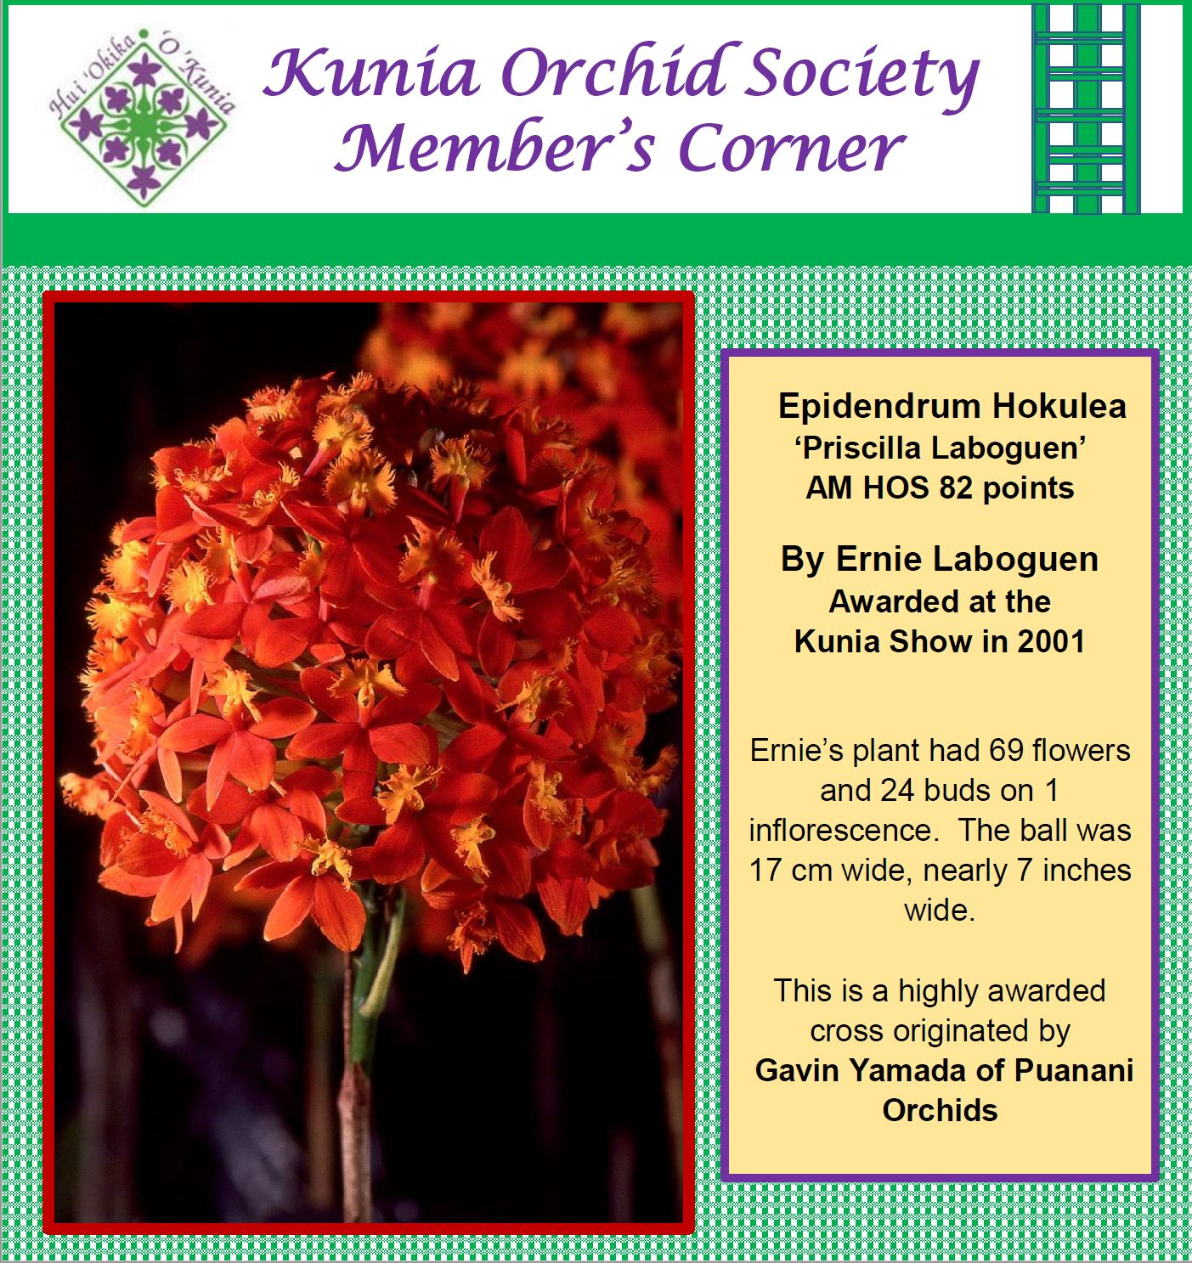

MAHALO!
KOS remains most grateful for donations received from members and supporters to help our Society survive this pandemic. Of particular note, is the generous donation received from Senator Robert Bunda in memory of dedicated member Callman Au. Mahalo Nui to Senator Bunda and other donors for their contributions to the legacy of the Kunia Orchid Society.

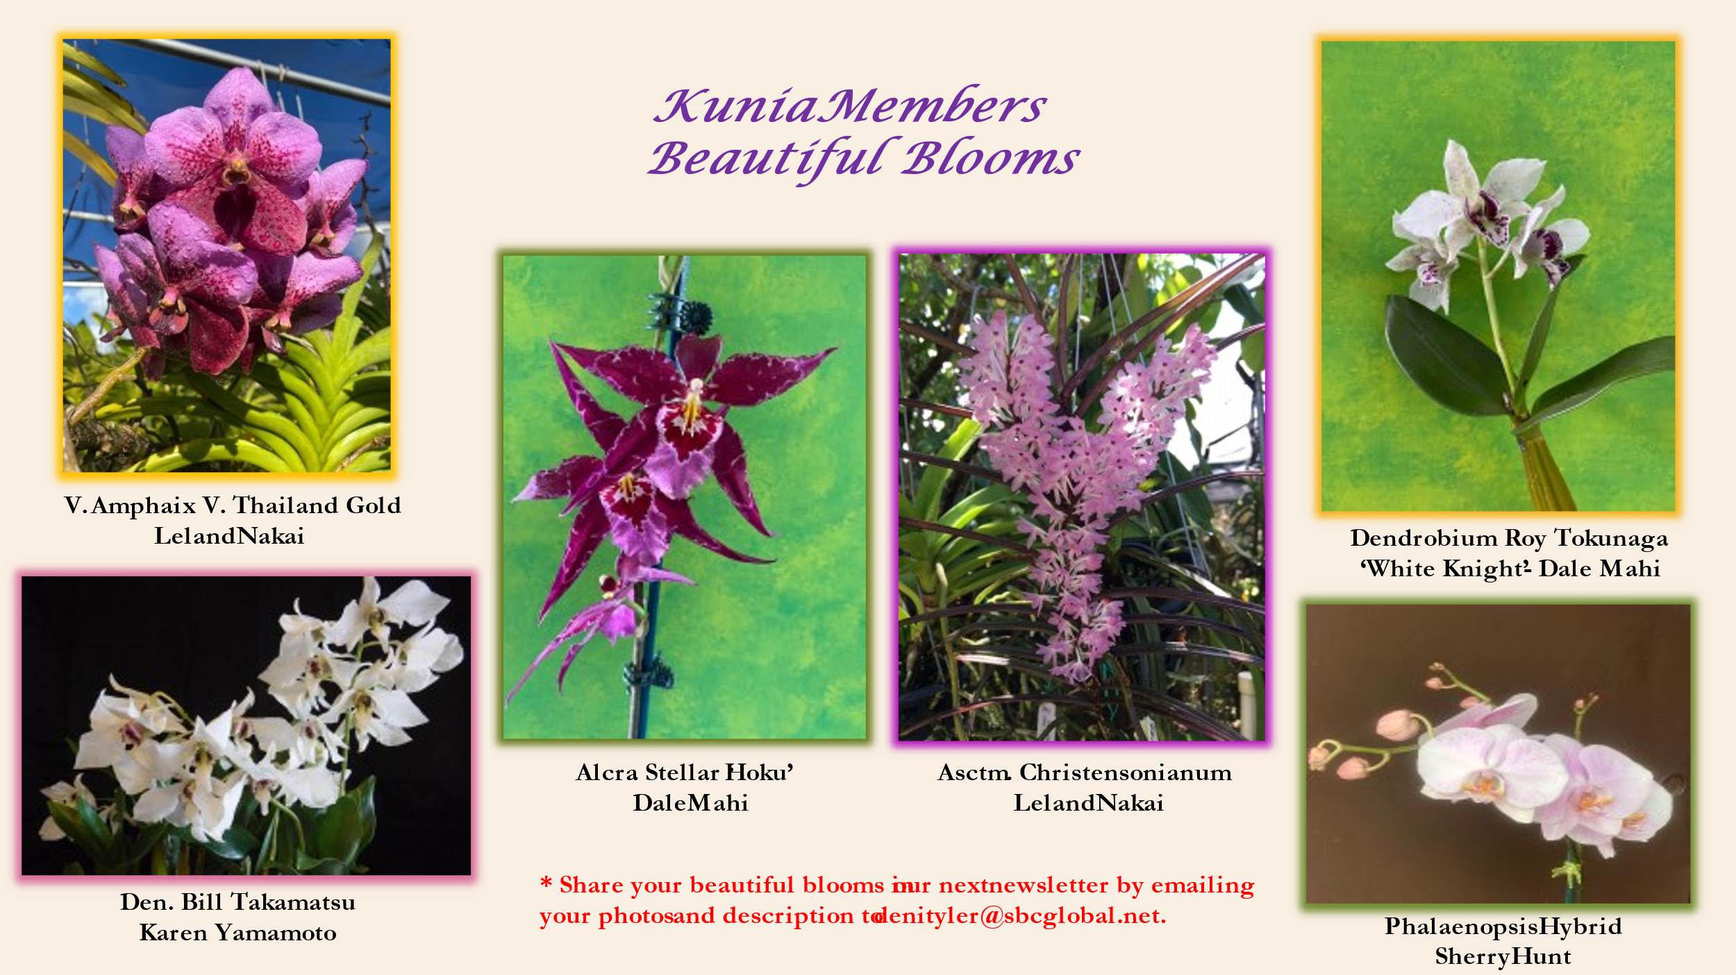

Let There Be Light
by Brad Lau

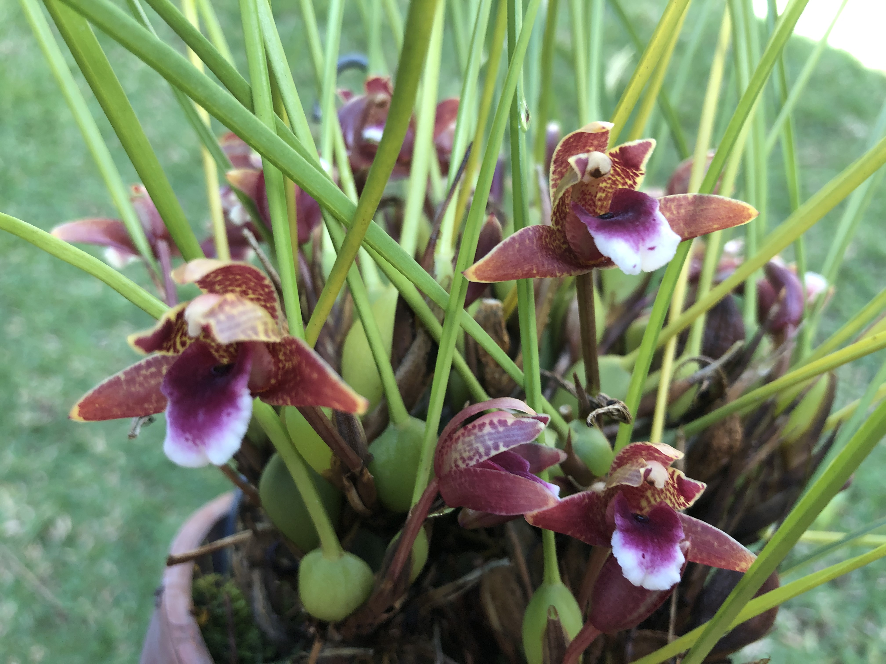

Beyond watering, fertilizing, fresh media and air movement, all orchids require light. What makes light is so important? Orchids are naturally adapted to their environment no matter the weather and light conditions.

For orchids to grow well and bloom we need to mimic those light levels that benefit our plants. If light is too weak the plant will grow with dark green leaves, fail to bloom or have slower growth. If light is too strong we risk sunburn or stress on the plant which may show yellow to light green leaves.

There are three main factors to consider about light for our plants: number of hours of light; light intensity; and quality of light.

Orchids can be sensitive to seasonal changes with less light duration triggering rest periods. In the summer the days grow longer which helps growing. Orchids benefit from about 11 hours per day of light. We live in areas with trees or houses nearby that may shade plants from getting the full amount of light possible. In addition the direction of the sun plays a major role in how much light a plant may get.

East facing plants usually get favorable less intense morning light which increases until midday. South facing plants get high intensity light and risk sunburn on clear days. West facing plants will get strong midday light then sometimes harsh afternoon light of high intensity.

Seasonally, in late Fall to early Spring, our days are shorter and sunlight weaker by about 20% vs summer months. This may be a time to move plants to brighter areas to give them more light. If allowed to adjust to a change in location some plants may eventually tolerate full sun especially if the weather is partly cloudy or it is winter.

Rainy or cloudy weather can cut light levels by 50-75% but storms can pass quickly so monitoring changes is best. Some shade houses have multi-layers of shade cloth to adjust for seasonal changes in light. In sunny months a layer of 50% shade can be added or even a solid roof to reduce light and keep water off plants during storms.

What does light do for plants? Sunlight is a spectrum of radiation from infrared light (creates heat and sunburn on leaves) to visible light and invisible ultraviolet light. Plants use light energy to synthesize carbohydrates using photosynthesis. Visible light can be broken down into different colors: red helps reproduction, flowering and fruiting; while blue allows for photosynthesis, plant germination and growth. Grow lights can be full spectrum white light to add hours of light for plants to grow more.

Each type of orchid may have different light requirements. Low light orchids include Phalaenopsis and Paphiopedilum and thrive with between 1000-2000 foot candles. One foot candle is the light from one candle at one foot distance. 1000 foot candle light is very shady, I get that level under eve which is shaded between two story homes separated by 25 feet and under small tree cover. These orchids should never get full sun. Broad flat leaves of Phalaenopsis are adapted to collect as much shady light as possible and easily sunburn.

Moderate light orchids include Dendrobium and Cattleyas which require between 2000 to 3000 foot candles of light. Bright shade or moderate filtered light with many hours of light are the best conditions for these plants. Watch leaf color and use it as a gauge to how the plant is accepting light conditions.

High light orchids are Vandas, Cymbidiums and Oncidiums which tolerate up to 6000 foot candles of light. Just a warning, in my west facing yard I have measured afternoon light as high at 12,000 to 17,000 foot candles in summer months. If I had more cloud cover light intensity would be less and more usable.

If you have a shade house or grow orchids vertically hanging, you can put light tolerant plants highest and shade loving plants lower down each hanging from one another at levels to allow for air flow. Or have a plant bench with a layer of hanging plants above to catch more light and shade those below.

When in your growing area you can check your own light levels easily. Do the “Hand test”- On a clear day place your hand between the leaves and the light source about one foot from the plant. Look at the shadow your hand casts.

If you see no shadow, you have very low light which is too little for most orchids. If you see barely noticeable shade then it is low light. If there is noticeable shade and a faint outline of your hand this is medium light. And if there is a sharp dark shadow this is high light.

If you grow plants indoors or want to supplement light for your plants in a patio or at night you can add artificial lights. Use a light that gives off about half the recommended number of foot candles for your plant. You can also adjust the distance between light and plant to vary the light intensity. You can put the grow light on timer to control the hours of light. While incandescent lights are not energy efficient, florescent and LED lights are efficient and come in a variety of bulbs from full spectrum to very narrow ranges.

If you group your plants based on light requirements it may make them easier to manage. If your growing area favors a certain light level then focusing more on plants that thrive with that light can be more practical. I have small trees and like to hang plants in locations that are partly shady. I will prune the trees to allow for more air flow and light as needed. Be creative but always aware of your orchids’ light requirements for healthy growth and flowering.

For more on light:
https://www.aos.org/orchids/additional-resources/light-the-key-to-successful-blooming.aspx

KOS March General Meeting
Tuesday, March 2, 2021
7:00pm

Click link to join meeting: March General Meeting

Meeting ID: 830 8361 7178
Passcode: 499413

If you are still having issues with Zoom and would like personal attention, please leave Adam a message at 808-295-4842 or email him at adam.almeida@gmail.com.

.

Members are encouraged to submit their orchid questions to Brad at email minihune2000@yahoo.com.
Brad will usually reply by email and maybe stimulate further discussion for our newsletter.
It can also be discussed at any of the Zoom meetings.

