**Kunia Orchid Society Newsletter**

**December 2022**

Visit us at: [http://www.kuniaorchidsociety.org/](http://www.kuniaorchidsociety.org/%20)  or [www.facebook.com/KuniaOrchidSociety](http://www.facebook.com/KuniaOrchidSociety)

Edited by Denise Stewart

**PRESIDENT’S MESSAGE**

Dear Kunia Orchid Society Members & Friends,

It has been another challenging year for the Kunia Orchid Society.  With your membership dues, donations and some fundraising efforts, we were able to continue our orchid education program via Zoom arrangements and sending out our monthly newsletters, while maintaining a steady treasury balance.  Thank you for your assistance in helping KOS meet its financial obligations.

By the time you receive this newsletter, you will have approximately 30 days left in the old year to renew your Kunia Orchid Society 2023 membership dues.  We plan to provide in-person meetings beginning in January and every month thereafter for the new year.  In order for us to accomplish that, we will need sufficient funds to meet the expenses for the school cafeteria rental/utility fees, speaker fees, cost of insurance and any needed educational supplies.  In order to fund our planned meetings for 2023, we need your continued support by renewing your annual membership dues.  Additional donations are always welcome whenever possible.  You, our members, are the lifeblood of our society.

During these Covid pandemic years, our Education Committee continued to provide valuable orchid education offerings via Zoom.  A special thank you to Jan Takamiya, Brad Lau and the rest of the Education Committee for providing quality education offerings these past years.  Now that Jan and Brad are stepping down, we need to form a new Education Committee.  Please contact any of our Board of Directors if you would like to help in our Education Committee.  For the time being, I will assist until we can find committee members and a chairman.

The Officers and Board of Directors of the Kunia Orchid Society thank you for your membership and look forward to meeting with you again at our KOS monthly meetings.  We wish you and your family a prosperous, healthy and safe new year!

Ken Ching

**2023 KOS OFFICERS & BOARD OF DIRECTORS**

At the KOS November 1, 2022 general meeting, via Zoom, the attending membership

approved the proposed slate of KOS Officers & Board of Directors for 2023.

**KOS Officers & Board of Directors Slate for 2023**

President: Kenneth Ching

Vice-President: Karen Yamamoto

Secretary: Denise Stewart

Treasurer: Virginia Puzon

Ex Officio: Robert Speer (Immediate Past President)

Sergeant at Arms: Guy Mikasa

Director (3 years): Dale Mahi

Director (3 years): Amy Teves

Director (2 years): Paul Mahi

Director (2 years):  Laura Figueira

Director (2 years): Julianne Puzon

Director (1 year): Joy Ann Long

**Exciting Times at the Honolulu Orchid Society Show**

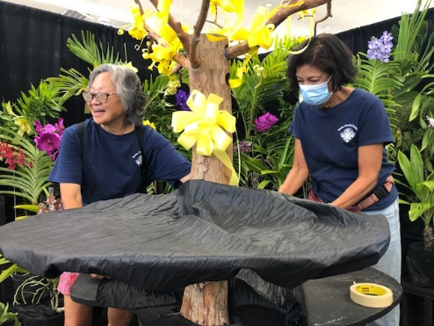It took a little effort at first getting into the groove, after not having participated in an orchid show for “3 Long Years.”  Once we got started working with each other, past knowledge and preparation basics began to kick in.  First, we selected our display theme, “It’s Been 3 Long Years,” since it has been 3 long years since the last Oahu orchid show.  As a focal point we decorated yellow ribbons on our “Old Oak Tree” as symbols of successfully coming back again.  After a while, our “Old Oak Tree” with the many yellow ribbons got lost due to the many blooming orchids and greenery.  It was a fun thought anyway.

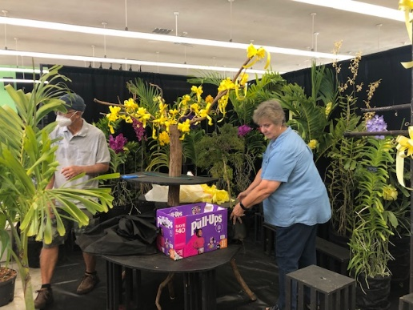

We had a massive turnout to help with our preparation, blooming orchid contributions, supporting greenery, yellow ribbons, transportation, setup and take down:  Karen Yamamoto, Milton Yamamoto, Bob Speer, Dale 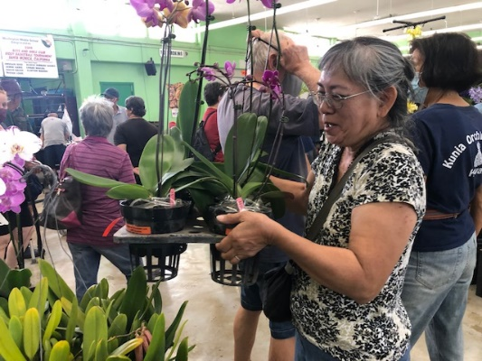Mahi, Wendel Takase, Laura Figueira, Gary McCurdy, Gerald Miyasato, Inez Brunson, Ann Geschwandtner, Amy Teves, Julianne Puzon, Virginia Puzon, Henry Hattal, Lolita Talbo, Francis Au, Penny Wakamura, Stan Watanabe, Carmela Watanabe, Calvin Kumano, Jan Takamiya, Norman Takeya, Denise Takeya, Guy Ransom, Larry Yamamoto, Denise Stewart, Cindy Fuentes, Stan Fuentes, Carol Kawamoto, Aileen Ching, Ken 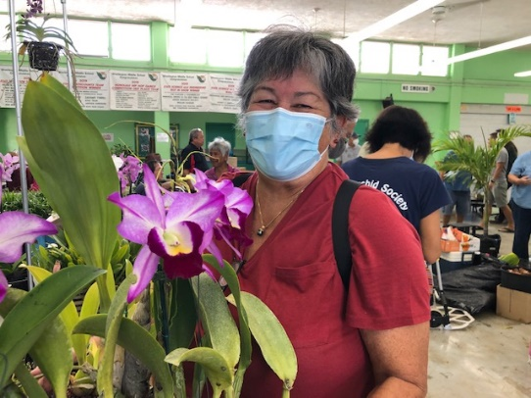Fabulous volunteers!
Ching.

Special recognition to ***Jan Takamiya, Calvin Kumano & Carol Kawamoto*** for their prize-winning orchids.  Thank you so much everybody for your help.  We hope you learned something about setting up an orchid show display so you can be of even greater help for future shows.

***MAHALO!***

Something new for the end of the Year - Catasetinae Orchids

It’s the end of the year and I ask myself what did I learn that was new and fun? To add variety and something fresh I decided to give Catasetinae a try with a few orders from Sunset Valley Orchids of California in midyear.

Catasetinae orchids are a diverse collection which include Cycnoches (elegant swan shaped flowers) , Catasetums, Mormodes (Goblin orchid) , and Clowesia. They are characterized by sexual dimorphism and have distinctive growing and dormancy periods. Dormancy is signaled in the late fall or early winter with yellowing of the broad leaves which will drop leaving a plump bare pseudobulb. Cutting back of watering and fertilizing helps the plant into a rest period that lasts for many months until the spring.

With minimal watering or even none at all for months, the plants will come alive in the early spring and new shoots will appear. These are followed by new roots which eventually reach 2 to 3 inches long and signal the time to start watering as the plants are now ready to grow. In this rapid growth phase you can add up to full strength fertilizer regularly. Prior to this growth phase the large pseudobulb was providing the plant any needed nutrients.

In 3 to 4 months the new growth will develop large broad leaves and a thick pseudobulb. Flowering varies in timing from late summer to the fall sometimes more than once. After flowering the plant will move into dormancy and may need a little help for those in Hawaii due to our mild winter weather.

The plants that I bought were all seedlings so the exact flowers were each different from plant to plant and only appreciated once they bloomed. Light levels requirements are similar to Cattleyas, they prefer bright filtered light. Potting mix for mature plants can be bark and medium perlite. Seedlings in 3” pots prefer sphagnum moss with styrofoam at the bottom for drainage. Containers can be pots, baskets or slabs but avoid over potting.

Good air movement is essential and a hanging basket will grow well. When repotting or dividing the best time is when there is new growth just before new roots emerge. When dividing plants try to keep at least two bulbs together. One pest to watch for are spider mites so check the underside of leaves especially in the hot weather months.

Sexual dimorphism means that plants can make male and female flowers, usually in response to how much light the plant gets or with the strength of the overall plant. More light and stronger growing may favor production of female flowers which are quite waxy and thick. The male flowers tend to be very showy and colorful with a wide variety of patterns. The flowers last about 2 weeks and can be fragrant.

If you want to learn more keep your eye out for these orchids at meetings or orchid shows in the coming year. Our Hawaii climate is very friendly to growing Catasetinae but we do need to respect their rest period for optimal growing. Most of all, have fun growing them.

Reference

<https://www.sunsetvalleyorchids.com>

Photos

Ctsm. Dentigrianum ‘SVO Excellent’ x Portagee Star ‘Brian Lawson’s Sunrise’

Cyc. Swan Cascade ‘Dark Swan’ x Dark Swan ‘Black Swan’

Fdk. After Dark ‘SVO’

Ctsm. Melana Davison ‘Snow White’ x Diana’s Dots ‘SVO’

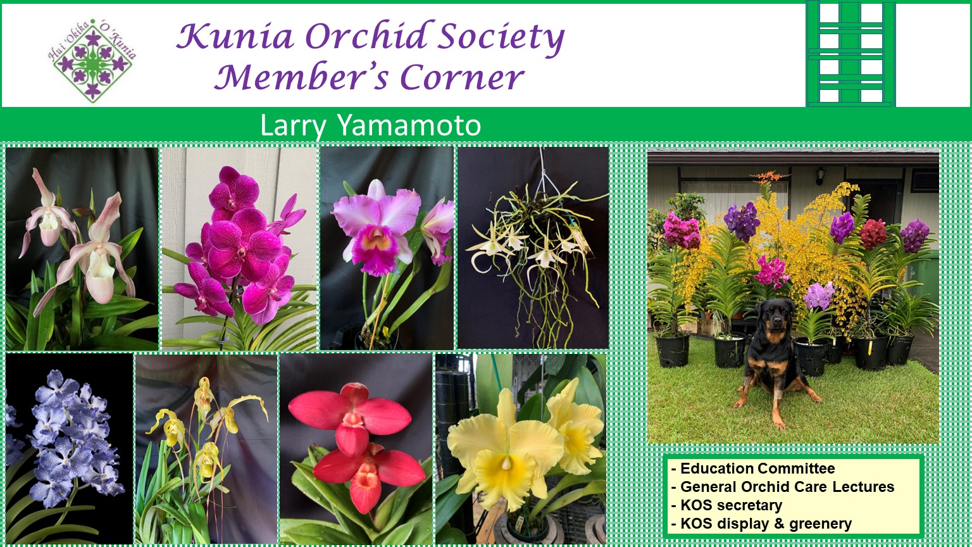

**KOS NOVEMBER GENERAL MEETING**

**Tuesday, November 1, 2022**

**7:00 PM**

**Meeting ID: 845 8320 1130**

**Click link to join meeting:** [KOS General Meeting](https://us02web.zoom.us/j/84583201130)

**If you are still having issues with Zoom and would like personal attention, please leave Denise a message at 818-679-2369.**

……………………………………………………………………………………………………………………………………………………………………

**Kunia Orchid Society – 2023 Membership Application**

**$15 Membership Renewal for all current 2022 paid up members.**

**$20 New Membership (Jan 1 to Dec 31)**

**Tax Deductible Donation, if any:**



**$10     $20     $50     $100     Other $___________**

**Complete and mail to:** $________________ **Amount Enclosed**

**Please make Check Payable to:  Kunia Orchid Society. Your Cancelled Check will be your receipt. Mail to P.O. Box 893956, Mililani, HI 96789**  

Name: _____________________________________________    Date: _________________________

Street Address: ________________________________ City: ______________  Zip Code: ____________

Home Phone: ___________________________ Cell Phone: ___________________________________

Email Address:  ____________________________________________________________________