Non-Profit Organization U.S. POSTAGE PAID
Permit No. 33
Office hours
Monday, Tuesday, Thursday, 9am – 3:30pm
Wednesday, 9am- 12pm, Fridays, closed
www.flcnorthwood.org
Office Phone: 641-324-2984
E-mail: flc@flcnorthwood.org

First Lutheran Church
309 Ninth Street North
Northwood, IA 50459

First Lutheran Focus October 2021
Address Service Requested

Week | Counter | Lay Reader | Sound | Ushers
October 3 | Team 5 | Lisa Wangsness | Eli Mix | Team 1
October 10 | Team 1 | Patti Irons | Hayden Moore | Team 2
October 17 | Team 2 | Carolyn Reeder | Logan Mayberry | Team 3
October 24 | Team 3 | Doug Krull | Andrew Breitsprecher | Team 4
October 31 | Team 4 | TBD | Hayden Moore | Team 5

PASTOR’S PAGE
Why is change so difficult? I’m pretty sure that you have wrestled with change. Some things change without our consideration. The weather and seasons happen regardless of how you feel about it. The calendar changes and we age whether graciously or reluctantly. Some people are good about going with the flow while others drag their feet and gripe about the changes happening around us.
Maybe that was why the writer of Ecclesiastes put the words we turn to often: For everything there is a season, a time for every matter under heaven… Eugene Peterson paraphrased this way… “There’s an opportune time to do things, a right time for everything on the earth: A right time to cry and another to laugh, A right time to lament and another to cheer… A right time to hold on and another to let go, A right time to rip out and another to mend, A right time to shut up and another to speak up…”
The Seasons of the year provide a rhythm for our lives. I love the colors of Fall. The brilliant reds, golds, greens. The cold and harsh winds of winter remind me of the need to rest and let the land rest. Spring puts a bounce in our step and new life in the air. And, summer, we all like summer. But for some reason we are still resistant to change.
One of the books that I have read and studied with other pastors is Embracing God’s Future without Forgetting the Past written by Michael K. Girlinghouse, the bishop of the Arkansas-Oklahoma Synod.
The book offers a way through the struggle many churches deal with as we realize that we can’t always do things the same way. The pandemic forced the issue but there are other pieces of our life together that are struggling and need to change. The altar guild feels this pain more than most of us at First Lutheran. The council and staff are working on ways to get more people engaged in the ministry but in the meantime, if you can help, please say so. (You don’t have to be a female over 60 to help set up for communion.)
First Lutheran is blessed by all of you sharing your gifts and talents. We celebrate and give thanks for those who have served up until this point and now embrace the future with hope and excitement!
Blessings!
For everything there is a season, a time for every matter under heaven…
Pastor Becky

PASTORAL ACTS - 2021
Wedding
Gordon/Madson 9/4/21
Haberman 9/11/21
Baptisms
Sofie Ann Quam 9/19/21
Aurora JoAnn Navratil 9/15/21
Solara June Navratil 9/15/21

YOUTH NEWS
We had a very busy September, as attendance for both groups has gone way up from our summer numbers.
Sr. High is averaging over 30 kids for the month which hasn't happened for quite a few years. We had some great lessons as well, with the highlight for me being the Freedom lesson (2nd Corinthians 3:17). Each year when we do this, the kids paint each other’s faces in neon colors with blacklights in the room. They also paint one hand, while the other remains unpainted, which represents how one hand can bring God such glory and the other brings Him shame. The real lesson comes in with how each of those hands are connected to the same person??? God sure does make us complicated people!

We also had lessons on what God has in store for us (The Plan - Jeremiah 29:11). Sin and how it grabs ahold of us (James 1: 13 - 18) and how we have strengths and weaknesses (Strong person competition - Matthew 26:41).

With things getting back to normal we will be doing 2 ValleyScare trips this year. The Jr. High students will go on October 2, and the Sr. High students will go on October 16. The spots for these trips were decided by attendance as we were not able to take everyone that wanted to go.

Since we've had more students attending Youth this past month, we've realized that our pool table room needed some updating. I've currently got a core group together who are figuring out paint colors and how to make the room more into what they need it to be.
On Halloween night, we'll be doing things a bit different. Since it falls on a Sunday, we'll be sending the Jr. High kids out as Mana Monsters to collect canned goods for Mana of Worth County. The Sr. High students will be allowed to hang out in the Youth Room that night and will be allowing children to come into trick or treat.

First Lutheran Missions
January 1 – August 31, 2021
Bremwood | $
Operation Christmas Child | $
Youth Fund (Bibles & Catechisms) | $ 565.00
Caring Tree | $
Meals on Wheels | $ 305.43
Manna | $ 1,238.94
Heifer International | $
Riverside Bible Camp | $ 25.00
Campers Fund | $ 50.00
Good Samaritan Fund | $ 1,483.94
Lutheran Services | $ 72.14
Dayspring Children’s Village | $ 575.00
Northern Lights Shelter | $ 459.92
LRH Auxiliary | $ 20.00
TOTAL | $ 4,208.31
First Lutheran Financial Update
August 2021
Income | $15,105.00
Electronic Income | $2,965.21
Expense | ($18,613.06)
End of Month | ($542.85)
YTD as of August 31
Income | $117,911.22
Electronic Income | $24,514.89
Expense | ($147,744.72)
End of Month | ($5,318.61)

August General Budget Expenses
PAYROLL: $ 12,755.38
E-GIVING EXPENSE $ 46.58
CHURCH MAINTENANCE $ 85.00
PARSONAGE MAINTENANCE $ 87.72
UTILITIES $ 1,431.19
TELEPHONE $ 430.86
OFFICE EXPENSE $ 551.16
TOTAL EXPENSES $ 15,387.89
INCOME $ 10,254.94
NET $ (5,132.95)

Donations
$50 - 3rd Grade Bibles and Catechisms
$200 - Kitchen Fund
$89.92 - Northern Lights
$47.14 - LWR Kits
Memorials
Irl Madson $500 - General Fund
Sharon Aase $50 - General Fund
Norma Adams $10 - General Fund
David Block $100 - Youth Fund

October Share Shoppe
JULIA Circle will be working October 2nd

Staff Phone Numbers
Pastor Sogge 612-718-9151
Mark Willand 641-390-1032
Troy Bachtle 641-430-8305
Jan Thompson 641-390-0883
Christa Larson-Trenhaile 641-390-0484
Mission Project for October
The Caring Tree / Operation Christmas Child

SPECIAL MEETING of the Congregation
October 17th, at 10am in the church sanctuary or by ZOOM.
The matter of business at this meeting:
To vote to approve the Rodger Organ proposal as recommended
by Dewey Kruger.
The project total is $148, 600 - could be split into 2 phases.

PROCESS FOR SPECIAL MEETING
The process requires a 2/3’s majority vote of voting members present either in person or by Zoom at 10am when the meeting is called to order. *Those wishing to take part in the meeting by Zoom are asked to sign up and indicate if they will be voting online or coming to the church for a paper ballot. The voting will be open until noon.
As stated in the Constitution of First Lutheran-Northwood,
only one matter of business may be conducted at a Special Meeting of the Congregation.
*Process for Zoom Attendance and Voting: If you are calling into the meeting on a landline, once again we would like to know that ahead of time and then be able to receive your paper ballot at the church by noon of that day. If you have questions, please ask Pastor Becky before the day of the meeting and she will help you sort out your options for taking part in this process.
1. Roll Call--During the meeting a roll call link will be posted in the chat box.
2. Online attendees will need to click the link and enter their name for roll call, so we know how many people are in attendance.
1. Voting--When it is time for the vote, a link containing the ballot will be posted in the chat box.
-(The voting/online monitor can see that you voted but not how you voted.)
2. The link should automatically open to the ballot.
3. If the link does not open automatically, then perhaps copying and pasting the link into a web browser will be necessary.
4. If more than one person in a household is voting, then the first person to vote must choose "submit another response" to reopen the ballot for the next person.
5. If the link does not work for any reason, voters have the option to go to the church and vote via paper ballot. Please let nkoenig@nkvikings.com and Pastor Becky know that you were unable to open the link.

Congratulations to Michael Gordon and Riley Madson who were married on September 4th.
Congratulations to Tanner and Liz Habberman on the renewal of their wedding vows on September 11th.
Congratulations to Jon and Donna Navratil on the baptism of their daughters, Aurora JoAnn and Solara June on September 15th. Their sponsors are Julie & Brian Schutz, Jeremy Navratil and Carol Lukes.
Congratulations to Gene and Sarah Quam on the baptism of their daughter, Sofie Ann on September 19th. Her sponsors are Lindsey Berwald and Aaron Liss.
Our Condolences to the family of Kimberly Anderson on the passing of her mother, LaVaughan Govig. Funeral service will be held at the end of October at Peace Lutheran Church in New London, MN.
Missing! Have you seen the glass bowl that is used in the baptismal font? If you know what happened to it, please contact the office.
(If it’s broken, that is okay, we would just like to know so we don’t keep looking for it.)
Bell Choir meets on Monday’s at 6:30pm and there is a spot for you! If interested, contact Russ Knudson at rdknudson1249@gmail.com.
Lydia Circle will meet at 2pm on October 6th at the home of Lois Hogan.
If you know anyone who is interested in becoming a member of FLC, please contact Pastor Becky at pastorbecky@flcnorthwood.org or 641-324-2984.
“The Gifts to the Church” committee has to pictures that they are giving away if anyone is interested in them please contact the office or Janelle Johnson.
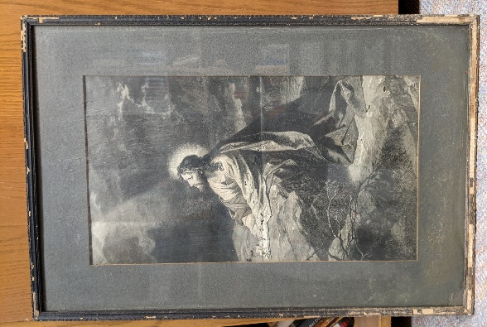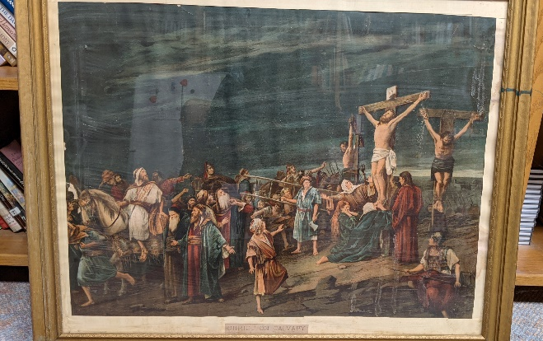
Congregation of First Lutheran……
You are invited to help with one month per year of altar duties. Currently the church circles are covering the duties, but church circle members are getting older and many are not physically able to continue. These women have served faithfully for many, many years! An additional new group of people (men or women) are needed to help with duties. Younger ages can join in too, with supervision.

Duties that urgently need volunteers:
- Fill (with oil) and light Eternal Lights (one in sanctuary, one in chapel) twice a week for a month.
- Fill (with oil) Candelabra Candles once every two Sundays unless there is a wedding/funeral, etc.
- Change alter/lectern/pulpit paraments if needed over the course of a month.
- Water flowers in the cooler once a week for a month.
Set flowers out for church services and put them back in the cooler after the service….for one month. Dispose of wilted flowers. If no fresh flowers are in the cooler, put artificial ferns out.
- Prepare communion cups twice a month. Record usage. Clean communion ware after the service.
Ask in the office what type of communion will take place. Take count of the number who communed by recording in a notebook in the Alter Guild Room.
- Prepare for a baptism: Put glass pitcher on the stand placed near the baptismal font. (Pastor will put the water in the pitcher. Troy will place baptismal font and the baptismal candle.)

Volunteers please sign-up to do one duty listed above during the month of choice, or several duties during a month, or all duties during a month.

Name: _______________________________________________________
Contact information: ___________________________________________
I would like to help with: _________________________________________
Month(s) preferred: ____________________________________________________
To volunteer call the Church Office: 324-2984 christa@flcnorthwood.org

1 Randy Buehrer, Ila Jensen, Lois Meyer
2 Daryl Hennigar, Lisa Irons, Tyler Mills
3 Lane Ballandby, Phyllis Mortenson, Larry Perkins, Rachel Ritzert, Dale Sime
4 Janet Reeder, Ryan Wahl
5 Dustin Hodson, Russell Olson, Jill Willand
6 Harley Severson, Sandra Thoen
7 James Medlang
8 Katie Baker, Trey Gonzales, Maggie Rye
9 Keith Braun, Linda Loken, Paige McClure, Daniel Reeder, Dennis Reeder
10 Lisa Christianson, Kary Paulson, Sharron Petznick, Judy Wangen
11 Gloria Fallgatter, Douglas Krull, Tayah Lande, Danneka Love
12 Mitchell Athey, Kimberly Helgeson, Vivian Peterson, Mark Severson
13 Gavin Hankins, Kelvin Hendrikson, Tony Katcher
14 Anthony Hauge, Ben Johnson, Reese Nielsen, Jessica Paulsen
15 Deanna Gentz, Michael Kuhlmann, Bryan Odegaard
16 Becky Logemann, Ronnie Stricker
17 Kenneth Schmidt
18 Harold Van Sabben
19 Lynn Schaub
20 Chris Thofson
21 Sydney Harris, Suzanne Senne
22 Arly Hillman
23 Axel Flattum, Sandra Madden
24 Mark Midtgaard, Lawson Perkins,
25 Becky Haberman
26 Marcia Kraft, Kaelix Iverson, Journey Thompson, Emmalee Van Sabben, Lisa Wangsness
27 Allix Braun, Jacob Katcher
28 Dwayne Wright
29 Sue Anderson, Kali Butler
30 Candace Low
31 Baylor Abrams, Patricia Brekken, Damon Reyerson, Raegen Reyerson, Dennis Schutz,
Alex Shoger, Ella Stevens, Daniel Turner, Weston Willand

OCTOBER 2021
Sunday | Monday | Tuesday | Wednesday | Thursday | Friday | Saturday
26 | 27 | 28 | 29 | 30 | 1  7:00pm: Property | 2  Valley Scare  S
3 Pentecost 19  9:00am- Service with H.C.  10:10am- Sunday School  6:30pm- JH. Youth | 4  6:30pm Bell Choir | 5  9:30am: Bible Study  11am: Staff Mtng.  6:00pm: Worship Mtg.  7:30pm: AA – Al-Anon | 6  5:45pm: 7th & 8th Confirmation  7:00pm: Choir  7:00pm: SH. Youth | 7  8:30am: Quilting  9:00am: Prayer Gr.  6:30pm: Taekwondo | 8 | 9
10 Pentecost 20  9:00am- Service with N.O.  10:00am: Council Meeting  10:10am- Sunday School  6:30pm- JH. Youth | 11  6:30pm Bell Choir | 12  9:30am: Bible Study  11am: Staff Mtng.  7:30pm: AA – Al-Anon | 13  5:45pm: 7th & 8th Confirmation  7:00pm: Choir  7:00pm: SH. Youth | 14 Pastors Conf.  8:30am: Quilting  9:00am: Prayer Gr.  6:30pm: Taekwondo  7:00pm: Pub Theology | 15 | 16
 |  |  |  |  |  | Valley Scare
17 Pentecost 21  9:00am- Service with H.C.  10:00am- Special Meeting  10:10am- Sunday School  6:30pm- JH. Youth | 18  6:30pm Bell Choir | 19  9:30am: Bible Study  11am: Staff Mtng.  7:30pm: AA – Al-Anon | 20  5:45pm: 7th & 8th Confirmation  7:00pm: Choir  7:00pm: SH. Youth | 21  8:30am: Quilting  9:00am: Prayer Gr.  6:30pm: Taekwondo | 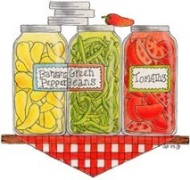  22 | 23
24 Pentecost 22  9:00am- Service with N.O.  10:10am- Sunday School  6:30pm- JH. Youth | 25  6:30pm Bell Choir | 26  9:30am: Bible Study  11am: Staff Mtng.  7:30pm: AA – Al-Anon | 27  2:00pm: Sr. Comm.  5:45pm: 7th & 8th Confirmation  7:00pm: Choir  7:00pm: SH. Youth | 28  8:30am: Quilting  9:00am: Prayer Gr.  6:30pm: Taekwondo  7:00pm: Pub Theology | 29 | 30
31 Reformation Day  9:00am- Service with N.O. w/ affirmation of Baptism  10:10am- Sunday School  5:00pm- JH. Youth | 1 | 2 | 3 | 4 | 5 | 6

