FIRST LUTHERAN CHURCH
Northwood, Iowa
641-324-2984
www.flcnorthwood.org
THAT ALL MAY KNOW THE LOVE OF GOD IN JESUS CHRIST
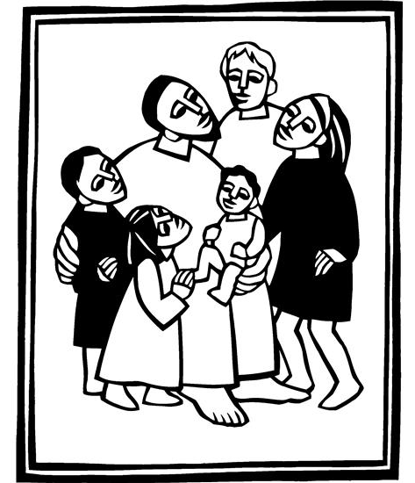
19th Sunday after Pentecost

October 3rd, 2021
9:00am

Pastor Becky Sogge

Acolyte: Taylor Foss and Olivia Gentz

Organist/Pianist: Loraine Mix

Lay reader: Lisa Wangsness

Special Music: Senior Choir and Laure Buehrer
Sound/Video: Eli Mix, Mark Willand
Counters: David and Sharron Petznick, Steph Perkins
Altar Guild: JULIA Circle

Prelude - Loraine Mix

Welcome – Announcements

Confession and Forgiveness
Blessed be the holy Trinity, one God, whose teaching is life, whose presence is sure, and whose love is endless. Amen.
Let us confess our sins to the one who welcomes us with an open heart.
Silence is kept for reflection.
God our comforter: like lost sheep, we have gone astray. We gaze upon abundance and see scarcity. We turn our faces away from injustice and oppression. We exploit the earth with our apathy and greed. Free us from our sin, gracious God. Listen when we call out to you for help. Lead us by your love to love our neighbors as ourselves. Amen.
All have sinned and fall short of the glory of God. By the gift of grace in Christ Jesus, God makes you righteous. Receive with glad hearts the forgiveness of all your sins. Amen
Opening Hymn “God is Here!” ELW 526

Greeting p. 138

Kyrie p. 138

Hymn of Praise….This is the Feast p. 140

Prayer of the Day
Sovereign God, you have created us to live in loving community with one another. Form us for life that is faithful and steadfast, and teach us to trust like little children, that we may reflect the image of your Son, Jesus Christ, our Savior and Lord. Amen.
Special Music : “Day by Day” by Bradley Ellingboe -Senior Choir and Laure Buehrer

First Reading: Genesis 2:18-24
Word of God, word of life. Thanks be to God.

Psalm 8

O Lord our Lord, how majestic is your name in all the earth!

you whose glory is chanted above the heavens out of the mouths of infants and children; you have set up a fortress against your enemies, to silence the foe and avenger.

When I consider your heavens, the work of your fingers, the moon and the stars you have set in their courses,

what are mere mortals that you should be mindful of them, human beings that you should care for them?

Yet you have made them little less than divine; with glory and honor you crown them.

You have made them rule over the works of your hands; you have put all things under their feet:

all flocks and cattle, even the wild beasts of the field,

the birds of the air, the fish of the sea, and whatever passes along the paths of the sea.

O Lord our Lord, how majestic is your name in all the earth!

Second Reading: Hebrews 1:1-4, 2:5-12
Word of God, word of life. Thanks be to God.

Gospel: Mark 10:2-16
(Before) The holy gospel according to Mark.
Glory to you, O Lord.
(After) The gospel of the Lord.
Praise to you, O Christ.

Children’s Sermon

Sermon Pastor Becky Sogge

Hymn of the Day “Let Justice Flow like Streams” ELW 715

Prayers of Intercession
Lord, in your mercy, hear our prayer.
Peace

Offering is received in the plates at the entrance of the sanctuary or electronically through Vanco
Offering Prayer
Great Thanksgiving p. 144

Lord’s Prayer p. 145
Invitation to Communion
All who hunger and thirst, come. The table is ready.

Lamb of God p. 146
Prayer after Communion
Benediction
Closing Hymn “Go, My Children, with My Blessing” ELW 543

Dismissal
Go in peace. The living Word dwells in you.

That all may know the love of God in Jesus Christ.
Thanks be to God.
Postlude -Loraine Mix
Copyright © 2020 Augsburg Fortress. All rights reserved. Reprinted by permission under Augsburg Fortress Liturgies Annual License #SAS020622. Used by permission.

Mission Project for October
The Caring Tree / Operation Christmas Child

Weekly Attendance and Giving
Date | Attendance | Giving
September 26 | 95 | $2,325.00
September 19 | 85 | $731.00
September 12 | 62 | $718.00
September 5 | 31 | $1,558.00

Announcements
Our Condolences to the family of Kimberly Anderson on the passing of her mother, LaVaughan Govig. Funeral service will be held at the end of October at Peace Lutheran Church in New London, MN.
Lydia Circle will be meeting at the home of Lois Hogan on October 6th at 2:00pm.
Missing! Have you seen the glass bowl that is used in the baptismal font? If you know what happened to it, please contact the office.
(If it’s broken, that is okay, we would just like to know so we don’t keep looking for it.)
Bell Choir meets on Monday’s at 6:30pm and there is a spot for you! If interested, contact Russ Knudson at rdknudson1249@gmail.com.
The new piano in the Fireside Room was originally owned by Eldora Stoddard and passed down to her daughter, Sharlene Stoddard. Sharlene’s daughter, donated it to the FLC upon the passing of her mother and will be getting a memorial plaque made.
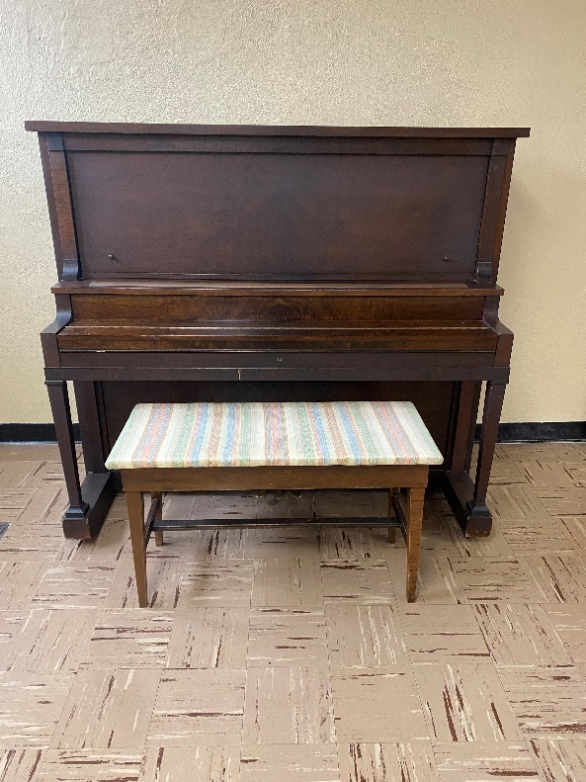

Weekly Calendar
Sunday, October 3 |  | 9:00 am | Worship Service with H.C.*
 | 10:10 am |  | Sunday School
 |  | 6:30 pm | JH. Youth
Monday, October 4 |  | 6:30 pm | Bell Choir
Tuesday, October 5 |  | 9:30 am | Bible Study
 | 11:00 am |  | Staff Meeting
 |  | 6:00 pm | Worship Meeting
 |  | 7:30 pm | AA –Al-Anon
Wednesday, October 6 |  | 5:45 pm | Confirmation
 |  | 7:00 pm | Choir Practice
 |  | 7:00 pm | SH. Youth
Thursday, October 7 |  | 8:30 am | Quilting
 |  | 9:00 am | Prayer Group
 |  | 6:30 pm | Taekwondo
Sunday, October 10 |  | 9:00 am | Worship Service with N.O.*
 | 10:00 am |  | Council Meeting
 | 10:10 am |  | Sunday School
 |  | 6:30 pm | JH. Youth

