Non-Profit Organization U.S. POSTAGE PAID
Permit No. 33
Office hours
Monday, Tuesday, Thursday, 9am – 3:30pm
Wednesday, 9am- 12pm, Fridays, closed
www.flcnorthwood.org
Office Phone: 641-324-2984
E-mail: flc@flcnorthwood.org

First Lutheran Church
309 Ninth Street North
Northwood, IA 50459

First Lutheran Focus November 2021
Address Service Requested

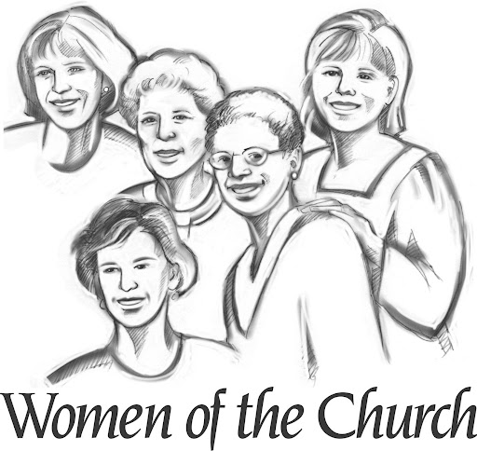

Attention all women of First Lutheran, we ask your participation!
November is our Thank offering yearly gift and this year it will be divided between Manna of Worth County and Good Samaritan Fund. Please write checks to First Lutheran Woman and bring it to your circle meeting or put in FLW Treasurer’s box outside the office or you may send it to Myra Harris at 1325 460th St. Northwood, IA. This is our mission project for the year.

PASTOR’S PAGE
Somewhere online I saw a fun craft as an alternative to carving a pumpkin. The family took turns each during the month of November and wrote what they were thankful for which became the centerpiece for their thanksgiving celebration. I believe that gratitude and thankfulness are an important part of our daily life. Some people journal, some include it at their meal or bedtime routines and some people seem to have the ability to live simply and thankfully.
The next two months are full of activities including thanksgiving. In the church we also celebrate All Saints Day, turn the page on the church year as we enter Advent and celebrate Christmas. We also use consider our stewardship and budget for the new year. For a lot of us these days simply go by and we do our part but for many people it feels like being on a rollercoaster without the safety bar holding us in. It could be that you are grieving the loss of a loved one or feeling the heaviness of life with the changes that Covid-19 has forced on you. Did you miss out on big events? Are you tired of people arguing about vaccines and masks? Are you worried that the prices around us are going up but your income is not?
On Sunday, November 7 we will be celebrating All Saints Day and taking time in worship to pray, grieve, cry, and name the sadness in our own lives (in a meaningful yet personal way). The reality for most of us is that we are on the journey of grief and gratefulness and challenged to embrace both much of the time.
What are you thankful for? What ways you down? Here’s a challenge: take a few minutes and write your own psalm. Many Psalms express the very journey of grief and gratefulness that I just talked about. You can look at Psalm 136 which tells of God’s work of creation, redemption and steadfast love.
As I create my psalm, I will include my love of music and that I often have a song running through my mind. I give thanks to the Lord for my mother’s beautiful voice and the memory of her singing in our home. I give thanks to the Lord for the gift of music which calms my heart and quiets my mind. I am also very aware that I wish I could have shared a lot more of my life with my mom.
Psalm 136
O give thanks to the Lord, for he is good, for his steadfast love endures forever.
O give thanks to the God of gods, for his steadfast love endures forever.
O give thanks to the Lord of lords, for his steadfast love endures forever.
Always thankful for the privilege to be your pastor.
Pastor Becky
PASTORAL ACTS - 2021
Baptisms
Danielle Alanna Gentz 10/21/21
Funerals
Kary Paulson 10/23/21

YOUTH NEWS

October was a very busy month for Youth and the Youth room itself. We decided our pool table room needed a freshening up, so we spent some long hours getting things done. We put new felt on the pool table, bought new rugs, tables and pool sticks. We painted the entire room, as well as hung new lighting. Troy was a huge help (meaning he did all the work) in putting in new plugins and all the lighting. We're also going to purchase a new TV for the room as well as get some security cameras in the near future.
We took 2 trips to ValleyScare, one for Junior High on the 2nd and one for Senior High on the 16th. Both trips were lots of fun with 14 students attending each trip. It's always so fun to take the kids on these trips as they actually put their phones away and enjoy being in company with one another.
Youth attendance for Senior High has gone up the past couple of months. In October we're averaging over 33 students each Wednesday night, which hasn't happened for quite a while. Junior High numbers continue to be near 20 most weeks. We continue to draw a large number of teens from other churches or no church at all, and I cannot stress enough what a huge outreach our youth program continues to be for the young people of our community.
Preparations are underway for Lifest 2022, July 6 – 10. This year we have decided that each student that is going, needs to attend Youth at least 30% of the time. The cost for this trip is going to be $130 with $65 due at the end of November 24th, and the other half due in March. Students will still be allowed to sign up after November, but the price will increase depending upon when they purchase their tickets.
Looking forward on the calendar, we will have all normal Youth meetings in November, except for Senior High meeting on the week of Thanksgiving on Tuesday November 23rd instead of their normal Wednesday. For the end of the year Senior High will have their lock-in on Wednesday, December 22nd and Junior High on Friday, December 31st, and we're tentatively planning on a 20 somethings lock-in on Sunday, December 26th.

First Lutheran Missions
January 1 – September 30, 2021
Bremwood | $
Operation Christmas Child | $ 75.00
Youth Fund (Bibles & Catechisms) | $ 565.00
Caring Tree | $ 75.00
Meals on Wheels | $ 305.43
Manna | $ 1,238.94
Heifer International | $
Riverside Bible Camp | $ 25.00
Campers Fund | $ 50.00
Good Samaritan Fund | $ 1,483.94
Lutheran Services | $ 72.14
Dayspring Children’s Village | $ 575.00
Northern Lights Shelter | $ 459.92
LRH Auxiliary | $ 20.00
TOTAL | $ 4,945.37
First Lutheran Financial Update
September 2021
Income | $7,932.00
Electronic Income | $2,999.80
Expense | $17,038.58)
End of Month | ($6,106.58)
YTD as of September 30
Income | $126,858.42
Electronic Income | $27,514.69
Expense | ($154,373.11)
End of Month | ($10,194.76)

September General Budget Expenses
PAYROLL: $ 13,691.55
E-GIVING EXPENSE $ 45.11
CHURCH MAINTENANCE $ 295.19
FALL CONFERENCE $ 65.00
PASTORS EDUC. EXPENSE $ 114.11
UTILITIES $ 986.57
TELEPHONE $ 214.92
OFFICE EXPENSE $ 411.13
WORSHIP $ 90.00
MISC. EXPENSE $ 1,125.00
TOTAL EXPENSES $ 17,038.58
INCOME $ 10,932.00
NET $ (6,106.58)

Donations
$75 - Caring Tree
$75 - Operation Christmas Child
Memorials
Kary Paulson $500 - General Fund

November Share Shoppe
SARAH Circle will be working November 6th

Mission Project for November
Meals on Wheels and Manna of Worth Co.

Staff Phone Numbers
Pastor Sogge 612-718-9151
Mark Willand 641-390-1032
Troy Bachtle 641-430-8305
Jan Thompson 641-390-0883
Christa Larson-Trenhaile 641-390-0484

Thank you, for your donation of $501.58 to Northern Lights Homeless shelter. Your commitment to helping the homeless is appreciated.
Thank you, for you recent gift of $88.80 to Lutheran World Relief. When you love your neighbors, you change lives in amazing ways.
We at First Lutheran were excited to present Bibles to our third-grade students. They are from Spark House and designed to draw students in. Thank you to FLW for providing them. Students receiving Bibles today are: Charlotte Berry, Graham Holstad, Emelia Nelson, Max Rugland, Aydan Schutz, Olivia Urbatsch, Silas Waller and Ayden Woodside.
We extend our sympathy and prayer to the Paulson family. Kary Paulson passed away October 15th in Jackson Hole, WY. His service was held on Saturday, October 23rd.
Thank you for your gift of 6 quilts to LSI Refugee and Immigrant Services. We are grateful for your friendship.
Dear Quilters, thank you so very much for the quilt you donated to Riverside Bible Camp. The Queen size “Scrappy 9 Patch” tie quilt brought in $900 at the auction!
The new piano in the Fireside Room was originally owned by Eldora Stoddard and passed down to her daughter, Sharlene Stoddard. Sharlene’s daughter, donated it to the FLC upon the passing of her mother and will be getting a memorial plaque made.
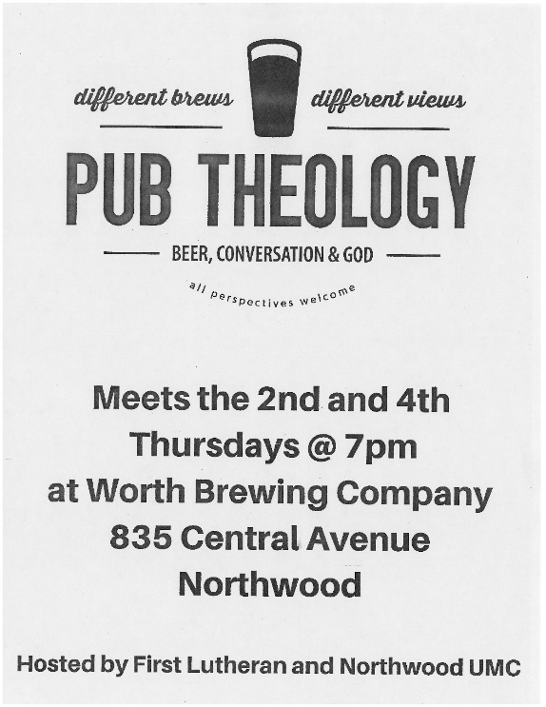

Week | Counter | Lay Reader | Sound | Ushers
November 7 | Team 5 | Stu Anderson | Eli Mix | Team 6
November 14 | Team 1 | Richard Selvig | Logan Mayberry | Team 7
November 21 | Team 2 | Madelyn Midtgaard | Andrew Breitsprecher | Team 8
November 28 | Team 3 | Tim Knutson | Hayden Moore | Team 1
Annual Meeting Date and Deadline for Reports
The Annual Meeting will be held on Sunday, January 23rd at 10:00 am.
The deadline for all committee reports is Thursday, January 6th. The best way to send your reports is by emailing a word, publisher or excel file. We can also use a PDF document or hard copy printed out but it is not ideal and takes more office time to make it work in the report. If you have any questions please call or email Christa at christa@flcnorthwood.org or 641-324-2984.
2021 Trust Fund Updates
The Trust Fund Committee would like to remind congregation members that grant application forms are available in the Church Office. Grants are recommended for new ministries, separate and apart from the day to day operation of the Church. Please submit your application to the appropriate committee of the church for review and approval. The deadline for committees to submit approved applications to the Church Office is noon on December 9, 2021. Please contact any Trust Fund member with questions.
Community Thanksgiving Service
Join us on November 21st at 7:00 pm, at United Methodist Church for a Community Thanksgiving Service! If you have any questions call the office at 324-2984.
Consecration/Pledge Sunday – November 14th
Pastor Steve Brackett from the Northeastern Iowa Synod office will be preaching as we continue our journey of “You Are Not Alone” and consider our financial commitment to the ministry of First Lutheran. You are asked to return your Pledge card during service on Sunday or mail it in using the return address envelope you will be receiving in the mail.

2021 Poinsettias Order

The Worship Committee invites you to help us fill the sanctuary with poinsettias again this Christmas at First Lutheran. You may fill out an order form which you will find in the sanctuary before worship service on Sunday as well as the office.
Orders will be taken in the church office from November 3rd - 28th. Payment must be made with your order. You may take your plant home after Christmas.
We will print a list of those contributing poinsettias and whom they wish to memorialize or honor so please fill out your order completely.
If you have questions, please call the Church Office at 324-2984.

1. Stephanie Perkins, Harrisyn Severson
2. Erbin Anderson, Gerald Bakken, Nicole Kroneman
3. Daniel Schutz
4. Michael Brunsvold, Betty Johnson, Morgan Johnson, Tiarra Walk
5. Jennie Christianson, Valerie Foss, Michael Gordon, Skyler Petry
6. Gail Read, Jack Wheeler
7.
8. Carolyn Reeder, Gordon Wilde
9. John Anderson, Tony Gentz, Donald Johnson, Kenly Solberg
10. Cody Hanson
11. Robert Bloomingdale, Eileen Dahlby, Brian Kenison, Lindsey Severson, Ivy Toresdahl
12. Erin Kaufmann, Ryder Duvall, Zane Bauers, Harry Kuhlmann, Kyler Varner
13. Colby Eskildsen, Matthew Midtgaard, Katie Reding, Tyler Thofson, Baylee Walk
14. Sara Jacobs, Danny Tenold
15. Trudy Capitani, Mary Ann Christianson, Mary Irons, Logan Mix, Zander Severson, Jeannie Tenold
16. Andrew Ballantyne, Kenedie Berry, Clay Bauers
17. Kail Christianson, Alan Fredericks, Randy Hengesteg, Kay Reyerson
18. Kathleen Eilertson, Jim Hanson
19. John Adams, Chloe Costello, Hayden Halbach, David Quisley
20. Amber Julseth, Chris Quisley, Blane Maher
21. Luane Odden, Amaya Rugland, Ashton Trenhaile
22. Jacklyn Einertson, Zane Bauers, Paisley Olson
23. Kayla VanderKolk
24. Cameron Campbell, Lisa Hagen, Brenda Moretz, Randy Sime
25. Holly Adams
26. Rebecca Hickman, Carson Tufte
27. Conner Harris, Jacob Schroader
28. Madison Avelar, Brandon Brockman, Quincey Reyerson, Haisley Severson
29. Wayde Willand
30. Jennifer Costello, Andrea Foley

NOVEMBER 2021
Sunday | Monday | Tuesday | Wednesday | Thursday | Friday | Saturday
31 | 1  6:00pm: Bell Choir  6:00pm: Worship Mtg. | 2  11am: Staff Mtng.  7:30pm: AA – Al-Anon | 3  5:45pm: 7th & 8th Confirmation  7:00pm: Choir  7:00pm: SH. Youth | 4  8:30am: Quilting  9:00am: Prayer Gr.  6:30pm: Taekwondo | 5 | 6
7 All Saints Day  9:00am- Service with H.C.  10:10am- Sunday School  6:30pm- JH. Youth | 8  6:00pm: Bell Choir  7:00pm: Property  Pastor Gone | 9  7:30pm: AA – Al-Anon | 10  5:45pm: 7th & 8th Confirmation  7:00pm: Choir  7:00pm: SH. Youth | 11  8:30am: Quilting  9:00am: Prayer Gr.  6:30pm: Taekwondo  7:00pm: Pub Theology | 12 | 13
14 Pentecost 24  9:00am- Service with N.O.  10:10am- Sunday School  6:30pm- JH. Youth | 15  6:00pm: Bell Choir  Pastor Gone | 16  7:30pm: AA – Al-Anon | 17  5:45pm: 7th & 8th Confirmation  7:00pm: Choir  7:00pm: SH. Youth | 18  8:30am: Quilting  9:00am: Prayer Gr.  6:30pm: Taekwondo | 19 | 20
21 Christ the King  9:00am- Service with H.C.  10:00am- Council Meeting  10:10am- Sunday School  3:00pm- LRH Comm.  6:30pm- JH. Youth  7:00pm- Community worship at UMC | 22  6:00pm: Bell Choir | 23  11am: Staff Mtng.  7:30pm: AA – Al-Anon  7:00pm: SH. Youth | 24  2:00pm: Sr. Comm.  7:00pm: Choir | 25  Building Closed | 26 | 27
28 Advent 1  9:00am- Service with N.O.  10:10am- Sunday School  6:30pm- JH. Youth | 29  6:00pm: Bell Choir | 30  11am: Staff Mtng.  7:30pm: AA – Al-Anon | 1 | 2 | 3 | 4

