Non-Profit Organization U.S. POSTAGE PAID

Permit No. 33

**Office hours**

Monday, Tuesday, Thursday, 9am – 3:30pm

Wednesday, 9am- 12pm, Fridays, closed

**www.flcnorthwood.org**

**Office Phone:** 641-324-2984

**E-mail:** flc@flcnorthwood.org

**First Lutheran Church**

**309 Ninth Street North**

**Northwood, IA 50459**

**First Lutheran Focus December 2021**

Address Service Requested

|  |  |  |  |  |
| --- | --- | --- | --- | --- |
| **Week** | **Counter** | **Lay Reader** | **Sound** | **Ushers** |
| December 5 | Team 4 | Leila Gangstad | Eli Mix | Team 2 |
| December 12 | Team 5 | Heather Rheingans | Hayden Moore | Team 3 |
| December 19 | Team 1 | Children’s Program | Logan Mayberry | Team 4 |
| December 24 | - | Myra Harris | TBD | Team 5 |
| December 25 | - | Sharyl Nestor | TBD | Team 6 |
| December 26 | Team 2 | Larry Klitzke | Andrew Breitsprecher | Team 7 |

**PASTOR’S PAGE**

Advent is a time of anticipation.

Advent is a time of preparing.

Advent is a time of waiting.

Decorating our homes.

Connecting our stories.

Listening, laughing, loving.

Singing, praying.

May you each know the

Hope

Peace

Joy

Love

We have in the birth of Jesus at Bethlehem.

Emmanuel, God with us.

**PASTORAL ACTS - 2021**

**Baptisms**

Walker Ray Ogea 11/21/21

Valerie Marie Johnson 11/28/21

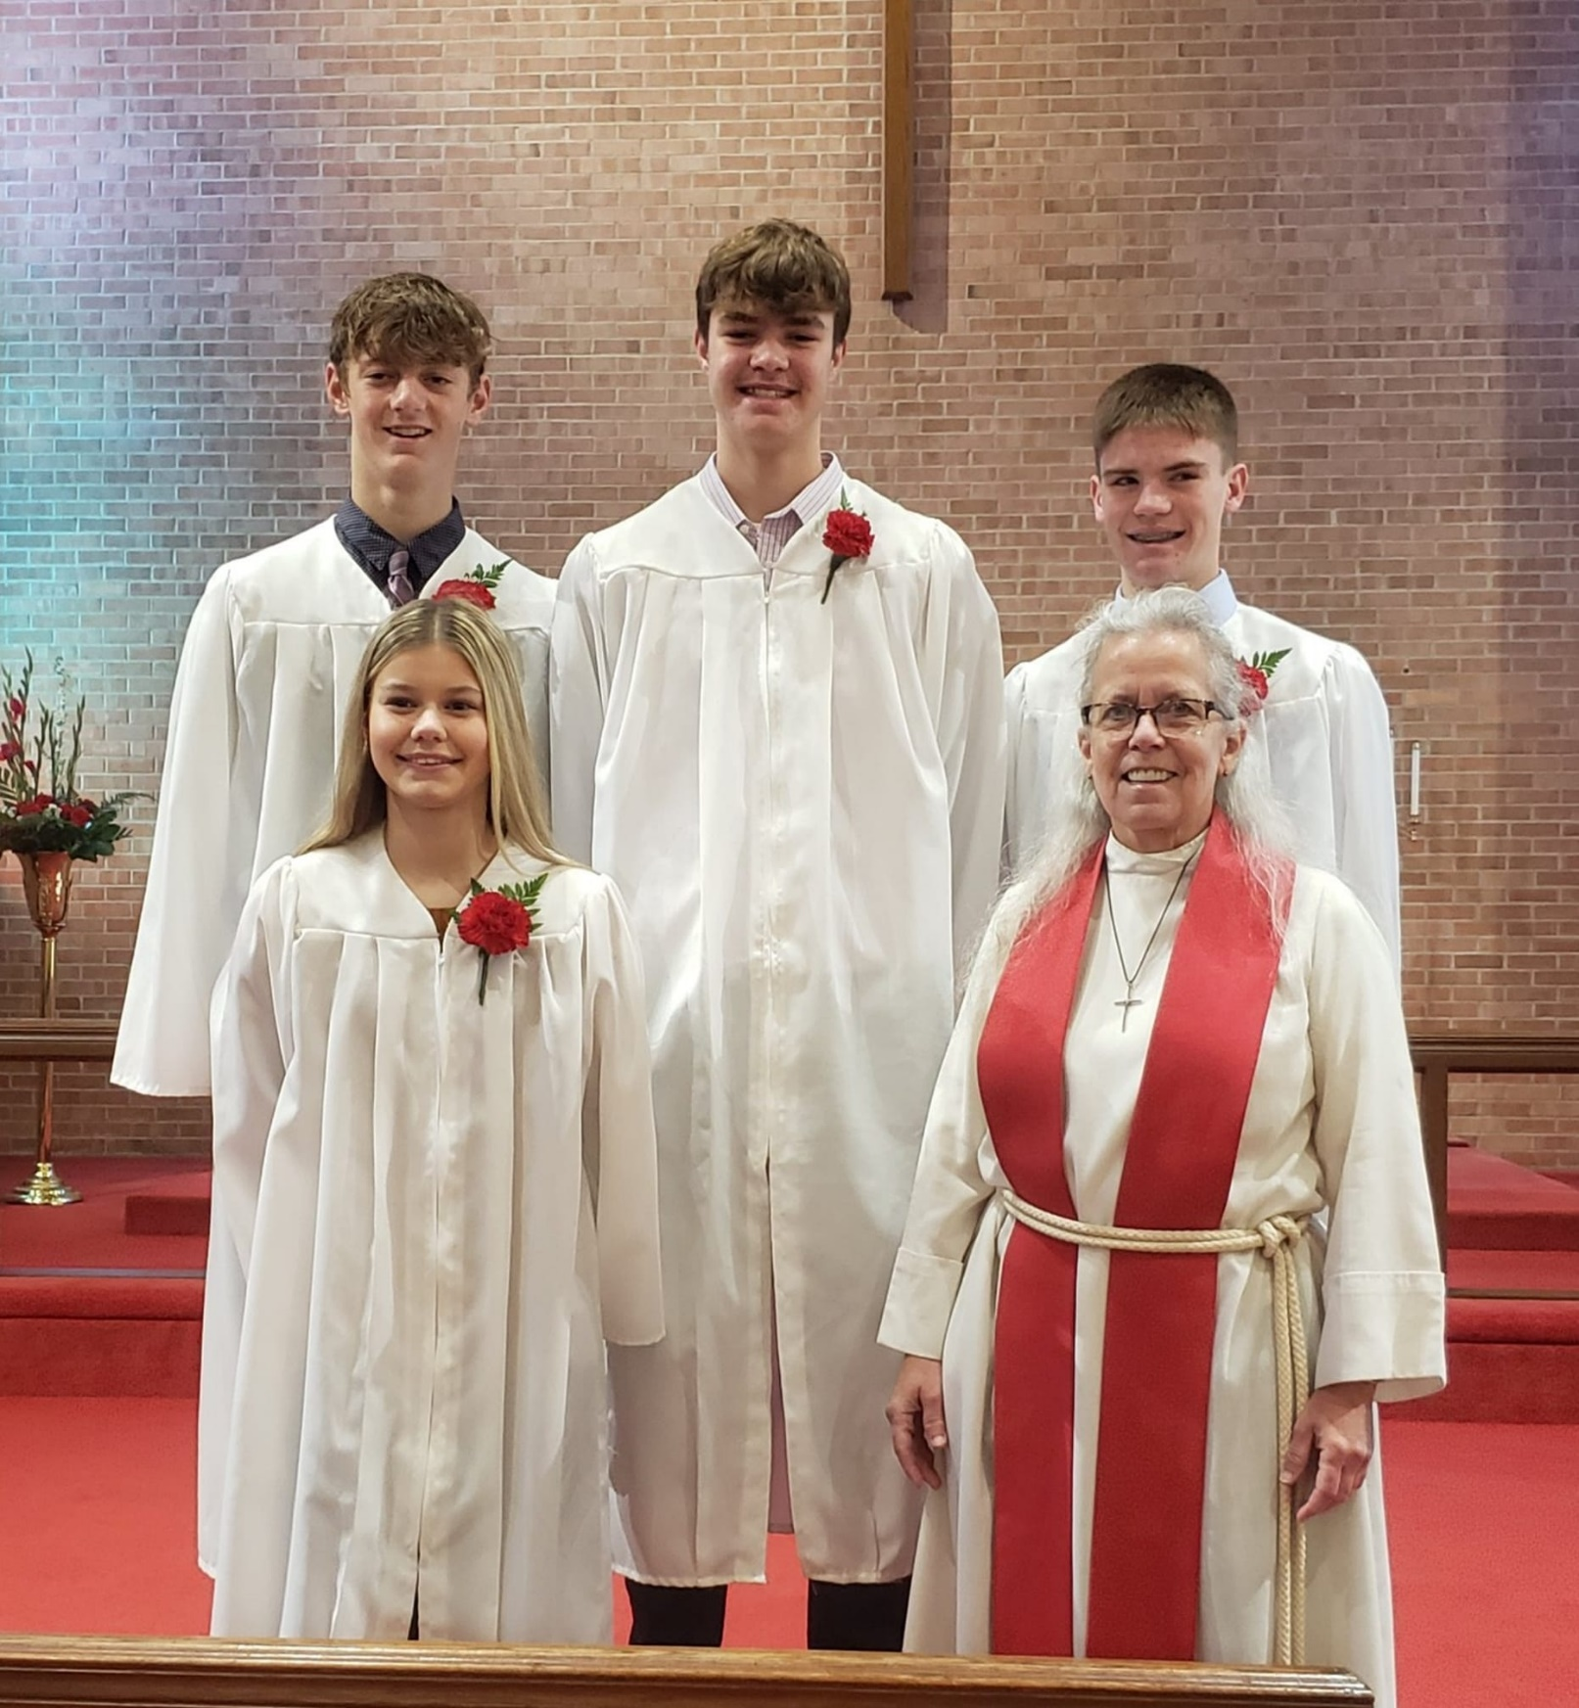

**Back Row, left: Kooper Julseth, Colby Eskildsen and Loghan Nelson**

**Front Row, left: Kyle Buehrer and Pastor Becky Sogge**

***Kyle Marie Buehrer***

***“You must understand this, my beloved: let everyone be quick to listen, slow to speak, slow to anger.”***

**James 1:19**

Daughter of Beth and Nathan Buehrer. She was baptized on November 26, 2006, at St. Theodore’s in Albert Lea, MN. Her sponsors are Brianna Baumann and Bryant Dagestad.

***Colby James Eskildsen***

***“I can do all things through Christ who strengthens me.”***

**Philippians 4:13**

Son of James and Steph Eskildsen. He was baptized on May 6, 2007, at Mercy Hospital. His sponsors are Katie Reding and Jenny & Ryan Wahl.

***Kooper Alvin Julseth***

***“I have fought the good fight, I have finished the race,   
I have kept the faith.”*****2 Timothy 4:7**

Son of Andy and Amber Julseth. He was baptized on October 15, 2006, at First Lutheran. His sponsors are Kevin & Susan McNutt and Andy & Kelly Eskildsen.

***Loghan Michael Nelson***

***“Because the LORD your God is a merciful God, he will neither abandon you nor destroy you;   
he will not forget the covenant with your ancestors that he swore to them.”***

**Deuteronomy 4:31**

Son of Chad and Jamie Nelson. He was baptized on April 1, 2007, at First Lutheran. His sponsors are Gabe Smutz and Kevin & Michelle Petznick.

**YOUTH NEWS**

We've made it to December, and what a busy month we have ahead of us!

We'll have Youth on all our normal days all month long, except Jr. High Youth on the 19th will move to 5:00pm and on the 26th will be moved to Tuesday, December 28th at 6:30pm. Both groups will have Christmas parties – Sr. High on the 15th and Jr. High on the 19th.

During Christmas break there will be 3 lock-ins. The 6th graders will be invited to the Jr. High New Year’s Eve   
lock-in. There will also be a special night for the former students to gather here for a night of fun and fellowship.

Sr. High – Wednesday, December 22nd

Jr. High + 6th Grade – Friday, December 31st

20 Somethings – Sunday, December 26th

We are making big plans for this upcoming summer and the music festival. We've already purchased camping and tickets for 52 of us for the Oshkosh Lifest, as well as 10 tickets for Music City, Tennessee Lifest which we'll be taking 8 of the current seniors.

The Youthroom will be getting new carpeting after the new year. The current carpet is around 13 years old and has definitely seen A LOT of hard use over the years. We just purchased a portable carpet cleaner in preparation to take care of any spills that may occur.

The Youthroom was also recently updated with some security cameras to record what's happening and allows me more supervision as I can now see what's happening in the backroom or youth kitchen without having to physically be in those rooms. The kids seem to have already forgot that they are installed, and life goes on as normal for them, but it gives me some added security to be able to see everything that's happening.

|  |  |
| --- | --- |
| **First Lutheran Missions** |  |
| **January 1 – October 31, 2021** | |
| Bremwood | $ |
| Operation Christmas Child | $ 100.35 |
| Youth Fund (Bibles & Catechisms) | $ 715.00 |
| Caring Tree | $ 100.37 |
| Meals on Wheels | $ 375.43 |
| Manna | $ 1,288.94 |
| Heifer International | $ |
| Riverside Bible Camp | $ 25.00 |
| Campers Fund | $ 50.00 |
| Good Samaritan Fund | $ 1,483.94 |
| Lutheran Services | $ 72.14 |
| Dayspring Children’s Village | $ 575.00 |
| Northern Lights Shelter | $ 459.92 |
| LRH Auxiliary | $ 20.00 |
| **TOTAL** | $ 5,266.09 |

|  |  |  |  |
| --- | --- | --- | --- |
| **First Lutheran Financial Update** | | | |
| **October 2021** |  | |  |
| Income | $11,004.00 | | |
| Electronic Income | $2,972.01 | | |
| Expense | ($15,923.47) | | |
| End of Month | ($1,947.46) | | |
| **YTD as of October 31** | |  |  |
| Income | $137,862.42 | | |
| Electronic Income | $30,486.70 | | |
| Expense | ($180,491.34) | | |
| End of Month | ($12,142.22) | | |

**October General Budget Expenses**

PAYROLL: $ 12,638.28

E-GIVING EXPENSE $ 45.69

CHURCH MAINTENANCE $ 101.00

PASTORS EDUC. EXPENSE $ 56.32

UTILITIES $ 825.99

TELEPHONE $ 214.92

OFFICE EXPENSE $ 1,969.27

WORSHIP $ 72.00

TOTAL EXPENSES $ 15,923.47

INCOME $ 13,976.01

NET $ (1,947.46)

**Donations**

**$100 - Education**

**$100 - Youth Fund**

**$70 - Meals on Wheels**

**$50 - Manna of Worth County**

**$25.37 - Caring Tree**

**$25.35 - Operation Christmas Child**

**Memorials**

**Kary Paulson $15 - General Fund**

**$15 - Youth Fund**

**Mary Thompto $15 - General Fund**

**$15 - Youth Fund**

**Sandy Nitcher $20 - Youth Fund**

**Carol Overgaard $200 - General Fund**

**Mission Project for December**

**Heifer International**

**December Share Shoppe**

**LEAH Circle will be working December 4th**

**Staff Phone Numbers**

Pastor Sogge 612-718-9151

Mark Willand 641-390-1032

Troy Bachtle 641-430-8305

Jan Thompson 641-390-0883

Christa Larson-Trenhaile 641-390-0484



**Those remembered for All Saints Sunday:** *Mary Ihnen, Arthur Kalvig, Robert Reeder Jr., Arlene Van Sabben, Robert Wilder, CherAmi Barr, Betty Johnson, Arlynn McHenry, Sharon Aase, Sharlene Stoddard, Irl Madsen and Kary Paulson.*

**Congratulation to** Bryce and Joann Ogea on the baptism of their son, Walker Ray. His sponsors are Wade Feldmann and Elizabeth Feldmann.

**Congratulation to** Jason Johnson and Crystal Flattum on the baptism of their daughter, Valerie Marie Johnson. Her sponsors are Matt & Morgan Johnson, Dave & Jessica Reyerson, Wade & Callie Flattum and Rose DeBoer.

**Thank you** for the charger, speaker and for thinking of me on my Confirmation Day. Thank you to Pastor Becky, it was fun! *-Kooper Julseth*

**Thank you very much** for the bible I received. *-Ayden Woodside*

**Covid fatigue is real and so is our care for one another. Please do what you can to help FLC to be able to worship in person. First and foremost, if you are sick or have been in close contact with someone who has Covid please stay home and join the service on Facebook live. Vaccination has been proven effective and are easily accessible**

**Year End Offering**

You may leave your 2021-year end contribution in the mailbox attached to the office door if the offices are closed. Please have it in by December 31st if you would like it on your 2021 Contribution Statement.

**Sunday School Dates**

**December 15 -** K-6th grade Christmas Program Practice, 5:30-6:45pm

**December 19 -** Christmas Program with Jesus’s Birthday party following in the basement. The entire congregation is invited!

**December 26 -** No Sunday School

**January 2 -** No Sunday School

**First Lutheran Church**

In December First Lutheran will be featured on the KCMR radio program, “Churches of North Iowa” Inspiration 97.9 KCMR

**Soup Ministry**

If you or someone you know could use the comfort of homemade soup, please let us know as the Soup Ministry has been busy cooking for those in need.

**2021 Trust Fund Updates**

The Trust Fund Committee would like to remind congregation members that grant application forms are available in the Church Office. Grants are recommended for new ministries, separate and apart from the day to day operation of the Church. Please submit your application to the appropriate committee of the church for review and approval. The deadline for committees to submit approved applications to the Church Office is noon on December 9, 2021. Please contact any Trust Fund member with questions.

**Annual Meeting Date and Deadline for Reports**

**The Annual Meeting will be held on Sunday, January 23rd at 10:00 am.**

The deadline for all committee reports is Thursday, January 6th. The best way to send your reports is by emailing a word, publisher or excel file. We can also use a PDF document or hard copy printed out but it is not ideal and takes more office time to make it work in the report. If you have any questions please call or email Christa at [christa@flcnorthwood.org](mailto:christa@flcnorthwood.org) or 641-324-2984.

**ELCA Good Gifts**

**If your looking to give a different type of gift this year, ELCA Good Gifts can help grow the church, fight hunger and transform lives.**





**1.  Kase Bachtle, Andrew Houg, Marlee Nelson, Mark Senne**

**2.  Cole Eilertson, Jackson Foss, Jenna Bauers, Truman Hengesteg, Teresa Johnson, Bryce Ogea**

**3.  Jacob Loken**

**4.**

**5. Austin Morris, Emily Tufte, Jeff Vansteenburg**

**6.  Ashley Leegaard, Suzanne Olson, Rylee Watts**

**7.  Debra Brockman, Natalee Lohmann, Max Rugland**

**8.**

**9. Kory Olson, Kathleen Thrond**

**10.  Joseph Bedford, Jessica Berry, Justin Senne**

**11. Tiffany Berg, Sue Bestul, Jacob Krull**

**12.  Tony Fredericks, Addie Rugland,**

**13.  Gary Hanson, Bret Johnson, Carter Thofson, Patricia Trenhaile**

**14. Linda Christianson, Daryl Love, Madelyn Midtgaard**

**15.  Chelsea Boyden, Judith Jorgensen, Bryan Sime**

**16.  Tom Hakes, Jesse Harang, Tyler Hillman, Barbara Trenhaile**

**17.  Jason Adams, Holly Hankins, Bonnie Hengesteg, Frances Olson, Austin Schutz, Joclyn Shackleton**

**18.  Troy Einertson, Kristine Gordon**

**19. Callan Brunsvold, Nalda Zipse**

**20.  Elexis Carrison, Mary Dewitt, Candee Hunchis, Katelyn Thofson, Russell Knudson**

**21.**

**22.  Wade Flattum, Ronald Hengesteg, Janelle Johnson, Mason Thofson, Avery Nielsen**

**23. Rhonda Taylor, O’Brian Tyrrell**

**24.**

**25.  Mary Bachtle, Michael Lee, Carol Van Veldhuizen**

**26. Stephanie Hengesteg, Calli O’Neill**

**27.  David Borcherding, Larry Roerish, Samantha Zipse**

**28.  Jan Mielke, Grayson Pangburn, Megan Storvick**

**29.  Larry Foley, Sawyer Hulshizer, Lauren Welty, Gina Solberg**

**30.  Jonathan Berry, Jordan Helgeson, Arlys Reeder**

**31.  Darin Dahlby, Olivia Gentz, Brandon Knutson, Lauren Petznick, Blythe Vandell**

|  |  |  |  |  |  |  |
| --- | --- | --- | --- | --- | --- | --- |
| DECEMBER 2021 | | | | | | |
| **Sunday** | **Monday** | **Tuesday** | **Wednesday** | **Thursday** | **Friday** | **Saturday** |
| **28** | **29** | **30** | **1**  4:30pm: 7th & 8th Confirmation  6:00pm: Bell choir  7:00pm: Choir  7:00pm: SH. Youth | **2**  8:30am: Quilting  9:00am: Prayer Gr.  5:00pm: Worship Mtg.  6:30pm: Taekwondo | **3** | **4** |
| **5 Advent 2**  9:00am- Service with H.C.  10:10am- Sunday School  6:30pm- JH. Youth | **6** | **7**  11am: Staff Mtng.  7:00pm: AA–Al-Anon | **8**  4:30pm: 7th & 8th Confirmation  6:00pm: Bell choir  7:00pm: Choir  7:00pm: SH. Youth | **9**  8:30am: Quilting  9:00am: Prayer Gr.  6:30pm: Taekwondo  7:00pm: Pub Theology | **10** | **11** |
| **12 Advent 3**  9:00am- Service with N.O.  10:00am- Church Council  10:10am- Sunday School  6:30pm- JH. Youth | **13** | **14**  11am: Staff Mtng.  7:00pm: AA–Al-Anon | **15**  4:30pm: 7th & 8th Confirmation  6:00pm: Bell choir  7:00pm: Choir  7:00pm: SH. Youth | **16**  8:30am: Quilting  9:00am: Prayer Gr.  6:30pm: Taekwondo | **17** | **18** |
| **19 Advent 4**  9:00am- Service with Kid’s Christmas Program.  10:10am- Sunday School  3:00pm- LRH Service  5:00pm- JH. Youth  7:00pm-Candlelight Service | **20** | **21**  7:00pm: AA–Al-Anon | **22**  **S.H. Lock In** | **23** | **24**  **Christmas Eve Worship**  **4:30 pm**  **10:00 pm** | **25**  **Christmas Day Worship**  **10:30 am** |
| **26 Christmas 1**  9:00am- Service with N.O.  **20’s Lock In** | **27** | **28**  6:30pm- JH. Youth  7:00pm: AA–Al-Anon | **29** | **30**  8:30am: Quilting  9:00am: Prayer Gr.  6:30pm: Taekwondo | **31**  **J.H. Lock In** | **1** |