**FIRST LUTHERAN CHURCH  
Northwood, Iowa  
641-324-2984  
www.flcnorthwood.org**

*THAT ALL MAY KNOW THE LOVE OF GOD IN JESUS CHRIST*

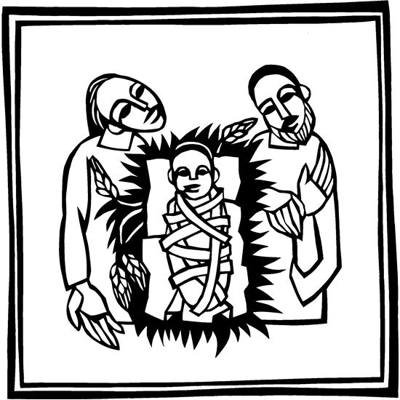

**Christmas Eve Worship**

**December 24th, 2021  
4:30 pm**

**Pastor Becky Sogge**

**Acolyte:** Kennedy Berry and Kinley Stambaugh

**Organist/Pianist:** Leila Gangstad

**Lay reader:** Heather Rheingans

**Special Music:** Senior Choir

**Sound/Video:** Hayden Moore, Mark Willand

**Counters:** David & Sharron Petznick, Steph Perkins

**Altar Guild:** LEAHCircle

### Prelude -Leila Gangstad

### Welcome – Announcements

**Confession and Forgiveness**

Blessed be the holy Trinity, one God, who alone does wonders, who lifts up the lowly, who fills the hungry with good things. **Amen.**

Let us confess our sin, trusting in the tender mercy of our God.

*Silence is kept for reflection.*

God for whom we wait, **in the presence of one another,** **we confess our sin before you.** **We fail in believing that your good news is for us.** **We falter in our call to tend your creation.** **We find our sense of self in material wealth.** **We fear those different from ourselves.** **We forget that we are your children** **and turn away from your love.** **Forgive us, Blessed One,** **and assure us again of your saving grace.** **Amen.** God, in Christ Jesus, has looked with favor upon you! Through the power of the Holy Spirit, your sins are forgiven. You are children of the Most High, inheritors of the eternal promise, and recipients of divine mercy. God strengthens you anew to follow the way of peace. **Amen.**

**Opening Hymn** *“Awake, Awake, and Greet the New Morn”* ELW 242

**Greeting p. 138**

**Lighting of the Advent Wreath**

**Reading**

**Prayer –** O ransomed people of the Lord, come,

**Let us travel on God’s holy way and enter into Zion with singing. Amen**

### Prayer of the Day

**Stir up the wills of your faithful people, Lord God, and open our ears to the preaching of John, that, rejoicing in your salvation, we may bring forth the fruits of repentance; through Jesus Christ, our Savior and Lord, who lives and reigns with you and the Holy Spirit, one God, now and forever. Amen.**

**Special Music *“Give your Fear to Faith” -Senior Choir***

**First Reading: Zephaniah 3:14-20**

Word of God, word of life. **Thanks be to God.**

### Psalm: Isaiah 12:2-6

Surely God is my salvation; I will trust, and will not be afraid, for the Lord God is my strength and my might, and has become my salvation.

**With joy you will draw water from the wells of salvation.**

And you will say in that day: Give thanks to the Lord, call on God’s name; make known the deeds of the Lord among the nations; proclaim that this name is exalted.

**Sing praises to the Lord, for he has done gloriously; let this be known in all the earth.**

Shout aloud and sing for joy, O royal Zion, for great in your midst is the Holy One of Israel.

**Second Reading: Philippians 4:4-7**

Word of God, word of life. **Thanks be to God.**

### Gospel Acclamation: Alleluia…. p. 142

### Gospel: Luke 3:7-18

(Before) The holy gospel according to Luke.  
**Glory to you, O Lord.**

(After) The gospel of the Lord.   
 **Praise to you, O Christ.**

### Children’s Sermon

### Sermon *Pastor Becky Sogge*

### Hymn of the Day “*People, Look East”* ELW 248

### Apostles’ Creed p. 105

### Prayers of Intercession

### Hear us, O God. Your mercy is great.

### *Offering is received in the plates at the entrance of the sanctuary or electronically through Vanco*

### Offering Prayer

**Lord’s Prayer p. 145**

**Blessing**

The God of hope fill us with all joy and peace in believing, so that we may abound in hope by the power of the Holy Spirit, through Christ Jesus for whom we wait. **Amen.**

**Closing Hymn “***Comfort, Comfort Now My People”* ELW 256

**Dismissal**

Go in peace. Christ is near.

**Thanks be to God.**

### Postlude -Leila Gangstad

|  |  |  |  |
| --- | --- | --- | --- |
| **Weekly Attendance and Giving** | | | |
| **Date** | **Attendance** | | **Giving** |
| December 5 | 67 | | $3,553.00 |
| November 28 | 68 | $1,557.00 | |
| November 21 | 86 | $1,861.00 | |
| November 14 | 106 | $353.00 | |

Copyright © 2020 Augsburg Fortress. All rights reserved. Reprinted by permission under Augsburg Fortress Liturgies Annual License #SAS020622. Used by permission.

**Mission Project for December**

**Heifer International**

Announcements

**Next Sunday,** is the Children’s Christmas Program during the worship service. After worship, the entire congregation is invited to a Christmas Party in the Fellowship Hall!

**Join us next Sunday** at 7:00pm for “The Seven Noels” a Candlelight Choir Service.

**Dear Pastor Becky and First Lutheran Church,** Thank you very much for baptizing Valerie and for the beautiful gifts. It was a great service that we will never forget. Hope to be back soon. *-The Johnson family*

**Place your bid** for the Handmade Christmas Quilt hanging outside the sanctuary. Made and donated by the First Lutheran Quilters.

**Sunday School Dates**

**December 15 -** K-6th grade Christmas Program Practice from 5:30-6:45pm

**December 19 -** Christmas Program with Jesus’s Birthday party following in the Fellowship Hall.   
The entire congregation is invited!

**December 26 -** No Sunday School

**January 2 -** No Sunday School

|  |  |  |  |
| --- | --- | --- | --- |
| **Weekly Calendar** | | | |
| Sunday, December 12 | | 9:00 am | Worship Service with N.O.* |
|  | 10:00 am | | Church Council |
|  | 10:10 am | | Sunday School |
|  | 6:30 pm | | JH. Youth |
| Tuesday, December 14 | 11:00 am | | Staff Meeting |
|  | | 7:00 pm | AA –Al-Anon |
| Wednesday, December 15 | | 4:30 pm | Confirmation |
|  | | 5:30 pm | Christmas Program Practice |
|  | | 7:00 pm | Choir Practice |
|  | | 7:00 pm | SH. Youth |
| Thursday, December 16 | | 8:30am | Quilting |
|  | | 9:00 am | Prayer Group |
|  | | 6:30 pm | Taekwondo |
| Sunday, December 19 | | 9:00 am | Worship Service with Sunday |
|  |  | | School Christmas Program |
|  | 10:10 am | | Sunday School |
|  | | 3:00 pm | LRH Worship |
|  | | 5:00 pm | JH. Youth |
|  | | 7:00 pm | Candlelight Service |

**Year End Offering**

You may leave your 2021-year end contribution in the mailbox attached to the office door if the offices are closed. Please have it in by December 31st if you would like it on your 2021 Contribution Statement.

**Soup Ministry**

If you or someone you know could use the comfort of homemade soup, please let us know as the Soup Ministry has been busy cooking for those in need.

**First Lutheran Church**

In December First Lutheran will be featured on the KCMR radio program, “Churches of North Iowa” Inspiration 97.9 KCMR