FIRST LUTHERAN CHURCH
Northwood, Iowa
641-324-2984
www.flcnorthwood.org
THAT ALL MAY KNOW THE LOVE OF GOD IN JESUS CHRIST
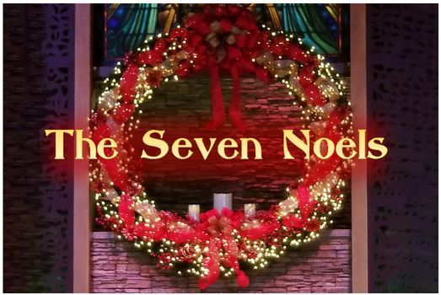
Choir Candlelight Service

December 19, 2021
7:00 pm

Welcome – Announcements Pastor Becky
Light Candle 1 Wanda Hoffman
“The First Noel We Long to Hear” Nikkole Koenig

Reading: The First Noel Ray Hoffman

“Prayers for Emmanuel” Choir

Light Candle 2 Roxanne Hughes

“The Second Noel – The Prophet Did Say”

Ron Christianson, Linda Griffith, Lisa Hagen, Roxanne Hughes, Delores Knudson, Russ Knudson, Rich Selvig, Tom Watts

Reading: The Second Noel Leila Gangstad

“Unto Us a Child is Born” Choir

Light Candle 3 Nikkole Koenig

“The Third Noel- Mary Would Hear” All Women

Reading: The Third Noel Patty Irons

“Give Your Fear to Faith” Choir

Light Candle 4 Haddie Hansen

“The Fourth Noel – A Baby is Born” Lauren Welty

Reading: The Fourth Noel Steve Clagett

“Night of the Manger” Choir

Reading Rich Selvig

Light Candle 5 Larry Klitzke

“The Fifth Noel- The Angel Did Say” Ron Christianson

Reading: The Fifth Noel Mary Jo Senne

“Never Been a Night” Choir

Light Candle 6 Linda Griffith

“The Sixth Noel- Was Proclaimed by a Star” Tim Knutson

Reading: The Sixth Noel Laure Buehrer

“A Star” Choir

Light Candle 7 Leila Gangstad

Reading: The Seventh Noel Wanda Hoffman

Candle Lighting Ceremony Laure Bueher and Loraine Mix

“A Beautiful Worship Noel” Choir

Prayers and Closing Pastor Becky

A huge thank you to all our choir members who participated in tonights worship service: Kimberly Anderson, Stuart Anderson, Laure Buehrer, Ron Christianson, Steve Claget, Sonya Dahly, Leila Gangstad, Lisa Hagen, Haddie Hansen, Ray Hoffman, Wanda Hoffman, Patty Irons, Delores Knudson, Russell Knudson, Tim Knutson, Nikkole Koenig, Dennis Lester, Loraine Mix, Megan Ott, Richard Selvig, Mary Jo Senne, Pastor Becky Sogge, Tom Watts and Lauren Welty.

