FIRST LUTHERAN CHURCH
Northwood, Iowa
641-324-2984
www.flcnorthwood.org
THAT ALL MAY KNOW THE LOVE OF GOD IN JESUS CHRIST
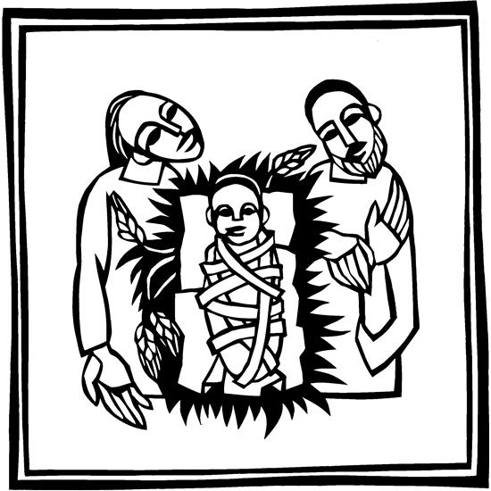
Christmas Eve Worship

December 24th, 2022
4:30 pm

Pastor Becky Sogge

Organist/Pianist: Loraine Mix

Acolyte: Landen Nelson

Ushers: Tony & Lauren Welty

Greeters: The Rheingans family

Lay Reader: Heather Rheingans

Special Music: Lauren Welty and Loraine Mix

Prelude -Loraine Mix

Welcome – Announcements

Confession and Forgiveness
Blessed be the holy Trinity, one God, who sends the word with angels, who is made flesh among all peoples, and who breathes peace on all the earth. Amen.
In Christ, we are bold to name our sin and cry out for peace.
Silence is kept for reflection.
Holy God, we confess our sin before you. We replace compassion with competition. We seek what is mighty while ignoring the meek. We are quick to anger but slow to forgive. We have not put on love in harmony with you. Wrap us in the grace of your powerful Word. Swaddle our hearts with your peace, that all we do, in word or deed, may reflect your love born among us. Amen.
I bring you good news of great joy for all people: God has come among us in the child born of Mary, Christ the Lord. In Christ your sins are forgiven and you are clothed in peace. Amen.
Opening Hymn Hark! The Herald Angels Sing ELW 270
Greeting p. 138

Prayer of the Day
Almighty God, you made this holy night shine with the brightness of the true Light. Grant that here on earth we may walk in the light of Jesus’ presence and in the last day wake to the brightness of his glory; through your Son, Jesus Christ our Lord, who lives and reigns with you and the Holy Spirit, one God, now and forever. Amen.
Special Music Noel Lauren Welty and Loraine Mix
First Reading: Isaiah 9:2-7
²The people who walked in darkness have seen a great light; those who lived in a land of deep darkness, on them light has shined. ³You have multiplied the nation, you have increased its joy; they rejoice before you as with joy at the harvest, as people exult when dividing plunder. ⁴For the yoke of their burden, and the bar across their shoulders, the rod of their oppressor, you have broken as on the day of Midian.
⁵For all the boots of the tramping warriors and all the garments rolled in blood shall be burned as fuel for the fire. ⁶For a child has been born for us, a son given to us; authority rests upon his shoulders; and he is named Wonderful Counselor, Mighty God, Everlasting Father, Prince of Peace. ⁷His authority shall grow continually, and there shall be endless peace for the throne of David and his kingdom. He will establish and uphold it with justice and with righteousness from this time onward and forevermore. The zeal of the Lord of hosts will do this. Word of God, word of life. Thanks be to God.

Psalm: 96
Sing to the Lord a new song; sing to the Lord, all the earth.
Sing to the Lord, bless the name of the Lord; proclaim God’s salvation from day to day.
Declare God’s glory among the nations and God’s wonders among all peoples.
For great is the Lord and greatly to be praised, more to be feared than all gods.
As for all the gods of the nations, they are but idols; but you, O Lord, have made the heavens.
Majesty and magnificence are in your presence; power and splendor are in your sanctuary.
Ascribe to the Lord, you families of the peoples, ascribe to the Lord honor and power.
Ascribe to the Lord the honor due the holy name; bring offerings and enter the courts of the Lord.
Worship the Lord in the beauty of holiness; tremble before the Lord, all the earth.
Tell it out among the nations: “The Lord is king! The one who made the world so firm that it cannot be moved will judge the peoples with equity.”
Let the heavens rejoice, and let the earth be glad; let the sea thunder and all that is in it; let the field be joyful and all that is therein.
Then shall all the trees of the wood shout for joy at your coming, O Lord, for you come to judge the earth.
You will judge the world with righteousness and the peoples with your truth.
Second Reading: Titus 2:11-14
¹¹The grace of God has appeared, bringing salvation to all, ¹²training us to renounce impiety and worldly passions, and in the present age to live lives that are self-controlled, upright, and godly, ¹³while we wait for the blessed hope and the manifestation of the glory of our great God and Savior, Jesus Christ. ¹⁴He it is who gave himself for us that he might redeem us from all iniquity and purify for himself a people of his own who are zealous for good deeds.
Word of God, word of life. Thanks be to God.

Hymn Away in a Manger ELW 277
The holy gospel according to Luke. Glory to you, O Lord.

Gospel: Luke 2:1-20
¹In those days a decree went out from Emperor Augustus that all the world should be registered. ²This was the first registration and was taken while Quirinius was governor of Syria. ³All went to their own towns to be registered. ⁴Joseph also went from the town of Nazareth in Galilee to Judea, to the city of David called Bethlehem, because he was descended from the house and family of David. ⁵He went to be registered with Mary, to whom he was engaged and who was expecting a child. ⁶While they were there, the time came for her to deliver her child. ⁷And she gave birth to her firstborn son and wrapped him in bands of cloth, and laid him in a manger, because there was no place for them in the inn.
⁸In that region there were shepherds living in the fields, keeping watch over their flock by night. ⁹Then an angel of the Lord stood before them, and the glory of the Lord shone around them, and they were terrified. ¹⁰But the angel said to them, “Do not be afraid; for see—I am bringing you good news of great joy for all the people: ¹¹to you is born this day in the city of David a Savior, who is the Messiah, the Lord. ¹²This will be a sign for you: you will find a child wrapped in bands of cloth and lying in a manger.” ¹³And suddenly there was with the angel a multitude of the heavenly host, praising God and saying,
¹⁴“Glory to God in the highest heaven,
and on earth peace among those whom he favors!”
¹⁵When the angels had left them and gone into heaven, the shepherds said to one another, “Let us go now to Bethlehem and see this thing that has taken place, which the Lord has made known to us.” ¹⁶So they went with haste and found Mary and Joseph, and the child lying in the manger. ¹⁷When they saw this, they made known what had been told them about this child; ¹⁸and all who heard it were amazed at what the shepherds told them. ¹⁹But Mary treasured all these words and pondered them in her heart. ²⁰The shepherds returned, glorifying and praising God for all they had heard and seen, as it had been told them.
The gospel of the Lord. Praise to you, O Christ.

Children’s Sermon

Sermon Pastor Becky Sogge

Hymn of the Day Angels We Have Heard on High ELW 289

Prayers of Intercession

Hear us, O God. Your mercy is great.

Offering

You are invited to place your offering in the plates as you come forward to receive Holy Communion or electronically through Vanco

Words of Institution

Lord’s Prayer p. 145
Invitation to Communion
In Christ’s manger, at Christ’s table, come, see what God makes known for you.
Lamb of God p. 154
Distribution
Communion Blessing and Prayer
Candle Lighting
Tip the unlit candle to receive the flame from the lit candle
Hymn “Silent Night” ELW 281
Blessing
Extinguish Candles
Closing Hymn “Joy to the World” ELW 267

Dismissal
Go in peace. Rejoice in Christ our Savior.

Thanks be to God.

Postlude -Loraine Mix
Copyright © 2020 Augsburg Fortress. All rights reserved. Reprinted by permission under Augsburg Fortress Liturgies Annual License #SAS020622. Used by permission.
Year End Offering
You may leave your 2022-year end contribution in the mailbox attached to the office door if the offices are closed. Please have it in by December 31st if you would like it on your 2022 Contribution Statement.

Sunday School Dates
December 25 - No Sunday School
January 1 - No Sunday School

Mission Project for December
Heifer International

Weekly Calendar
Saturday, December 24 |  | 4:30 pm | Christmas Eve Worship
 | 10:00 pm |  | Christmas Eve Worship
Sunday, December 25 | 10:30 am |  | Christmas Day Worship with Dinner to follow
Monday, December 26 |  |  | Office Closed
Tuesday, December 27 |  | 11:00 am | Staff Meeting
 |  | 7:00 pm | AA-Al-Anon
Thursday, December 30 |  | 8:30 am | Quilting
 |  | 9:00 am | Prayer Group
 |  | 6:30 pm | Taekwondo
Saturday, December 31 |  |  | 6-8th Grade Lock In
Sunday, January 1 |  | 9:00 am | Worship Service with H.C.
 |  |  | No Sunday School
 |  | 6:30 pm | J.H. Youth

