**FIRST LUTHERAN CHURCH  
Northwood, Iowa  
641-324-2984  
www.flcnorthwood.org**

*THAT ALL MAY KNOW THE LOVE OF GOD IN JESUS CHRIST*

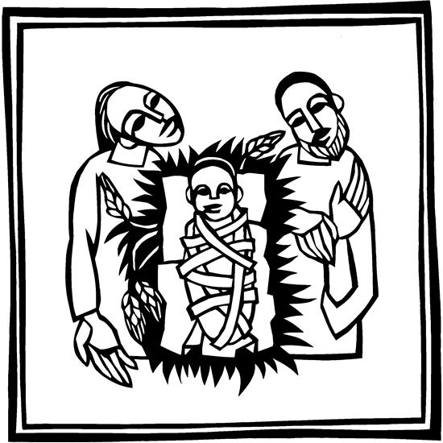

**Christmas Eve Worship**

**December 24th, 2022  
10:00 pm**

**Pastor Becky Sogge**

**Organist/Pianist:** Delores Knudson

**Acolyte:**

**Ushers: Bryan & Kimberly Odegaard**

**Special Music:**

### Prelude -Delores Knudson

### Welcome – Announcements

**Reading: Titus 3:4-7**

Word of God, word of life. **Thanks be to God.**

**Opening Hymn** *It Came Upon the Midnight Clear* ELW 282

### Prayer of the Day

**All-powerful and unseen God, the coming of your light into our world has brightened weary hearts with peace. Call us out of darkness, and empower us to proclaim the birth of your Son, Jesus Christ, our Savior and Lord, who lives and reigns with you and the Holy Spirit, one God, now and forever. Amen.**

**Special Music**

**Reading: Isaiah 62:6-12**

Word of God, word of life. **Thanks be to God.**

### Hymn *The First Noel* ELW 300

The holy gospel according to Luke. **Glory to you, O Lord.**

### Gospel: Luke 2:1-20

The gospel of the Lord. **Praise to you, O Christ.**

### Sermon *Pastor Becky Sogge*

### Hymn of the Day *Angels We Have Heard on High* ELW 289

### Prayers of Intercession

### Merciful God. Receive our prayer.

### Offering

### *Offering is received in the pews or electronically through Vanco*

### Words of Institution

**Lord’s Prayer p. 145**

**Invitation to Communion**

In Christ’s manger, at Christ’s table, come, see what God makes known for you.

**Distribution**

**Communion Blessing and Prayer**

**Candle Lighting**

***Tip the unlit candle to receive the flame from the lit candle***

**Hymn** *Silent Night* ELW 281

**Blessing**

**Extinguish Candles**

**Closing Hymn** *Joy to the World* ELW 267

**Dismissal**

Go in peace. Rejoice in Christ our Savior.

**Thanks be to God.**

### Postlude -Delores Knudson

Copyright © 2020 Augsburg Fortress. All rights reserved. Reprinted by permission under Augsburg Fortress Liturgies Annual License #SAS020622. Used by permission.

|  |  |  |  |
| --- | --- | --- | --- |
| **Weekly Calendar** | | | |
| Saturday, December 24 | | 4:30 pm | Christmas Eve Worship |
|  | 10:00 pm | | Christmas Eve Worship |
| Sunday, December 25 | 10:30 am | | Christmas Day Worship with Dinner to follow |
| Monday, December 26 |  | | Office Closed |
| Tuesday, December 27 | | 11:00 am | Staff Meeting |
|  | | 7:00 pm | AA-Al-Anon |
| Thursday, December 30 | | 8:30 am | Quilting |
|  | | 9:00 am | Prayer Group |
|  | | 6:30 pm | Taekwondo |
| Saturday, December 31 | |  | 6-8th Grade Lock In |
| Sunday, January 1 | | 9:00 am | Worship Service with H.C. |
|  | |  | No Sunday School |
|  | | 6:30 pm | J.H. Youth |

**Mission Project for December**

**Heifer International**

**Year End Offering**

You may leave your 2022-year end contribution in the mailbox attached to the office door if the offices are closed. Please have it in by December 31st if you would like it on your 2022 Contribution Statement.